Generations on Line
Easy Census Help
for Seniors
www.EasyCensusHelp.org

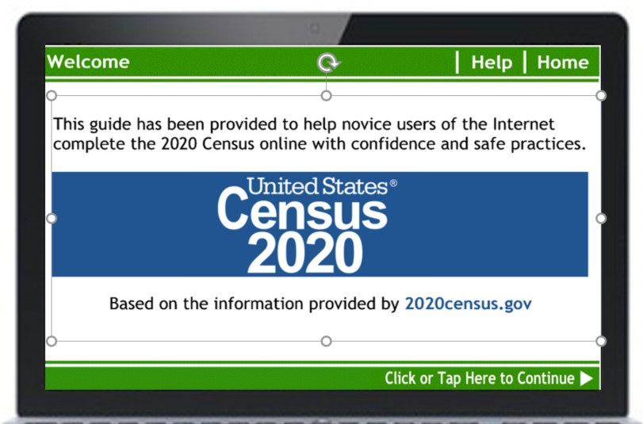

As you may have heard, this is the first time the Census is available online. We at Generations on Line know how important it is that all seniors are counted*. We want to help ensure all seniors are counted and that older adults feel capable, confident and secure enough to fill out the 2020 Census online. *The Older Americans Act uses Census counts for funding amounts to centers and service for the elderly.
From focus groups, we learned some seniors do not want to file online using their own internet for security reasons; others did not want to let a stranger (Census worker) ever come into their home. Although paper copies will be available, seniors must request one, or wait for three non-responses, adding another dimension to the Census. We saw the need to give older adults the confidence and skills to fill out the 2020 Census online.
Since you are already reaching out to older adults with technology, we know Sip & Swipe Café® locations are perfect for this outreach! There will be no surveys or paperwork collected. Of course we would love to hear an interesting story of a learner to share with funders!
- www.EasyCensusHelp.org is an interactive tutorial, teaching a new tablet user, or techno-timid current tablet user, to practice the specific skills needed for filling out the 2020 Census online.
- We have also made this program available for use on PC and laptops as well. In the tablet version there is some skill teaching for newbies; there is not on the PC version. In BOTH we provide education in the skills needed to fill out online forms.

- This is a free standing, web-based program. Seniors do not have to have taken part in
Sip & Swipe to use the tutorial. You can use coaches at your facilities to offer seniors support with the new tutorial (Note, by LAW no one can help someone else fill out the actual Census).
- NO downloading is required! We have made this a web-based tutorial. You can simply bookmark the website on each device or place it on the homepage of the device (Detailed information on how to do this will be provided).
- We are telling you now, to give you as much advance notice as possible for planning purposes for this program.
- On or between March 14-20 the majority of households will receive a letter invitation to respond to the 2020 Census online (or to respond by phone). Areas that are less likely to respond will receive a paper questionnaire along with the invitation; the invite will include information on how to respond online or by phone.
- When the learner completes the tutorial, it will lead them right into the actual Census. The tutorial may be used in advance but the actual census CANNOT be filled out until the invitation is receive.
- You can use your current (or prior) Sip & Swipe locations and/or choose to offer at new places or with new partners. There is no charge for this tutorial, so share it with others. You can even encourage folks to use it at home. Of course, being a nonprofit, we appreciate and welcome funding partnerships or contributions.
- Although some learners may be brand new to tablets, others may have completed the Sip & Swipe Café and want to practice using online forms. All are welcome! Just as in the Café, it remains important that the learner read the instructions and try to do it for themselves. By LAW no one is allowed to assist a person to fill out the actual Census; this safe practice site enables folks newer to technology to gain confidence and support BEFORE going onto the actual Census site.
- Please share the link! Share with your Sip & Swipe graduates, other groups/organizations you know, local newspapers, and post notices, so anyone who might need reassurance with form filling can use the tutorial at home on a computer or tablet…we want to assist as many people as possible.
- We will provide promotional flyers, in both publisher and pdf so you can edit it to fit your needs.
Together let’s:
- Tip the scale in favor of filling out online.
- Reassures the older adult they CAN use their skills for important tasks.
- Makes sure older adults are counted towards services in your area.
- Encourage newbies to return and participate in Sip & Swipe Café tablet training.

You can promote:
- As a “next level” program for Sip & Swipe Café graduates
- To help funnel folks into taking Sip & Swipe Café training after doing this tutorial.
- As a safe space to practice, no data is stored.
- To computer labs—although we do NOT teach HOW to use the computer, the tutorial may also be used on computers. It will help make sure computer users feel more confident in filling out the Census online.
Please let me know if you have any questions!
Katie Burke
215-222-6400
KBurke.GoL@comcast.net

