Medicare Outreach Idea of the Month
Partner with Volunteer Tax Preparers
January 2020

January is a great time to connect with Volunteer Income Tax Assistance (VITA) sites before the upcoming tax season. Volunteer income tax preparers are in a unique position to identify low income Medicare beneficiaries who may be eligible for financial assistance with Medicare costs and this provides another opportunity to share the message about programs that can help!
Reach out to your local VITA sites to educate them about the Medicare Savings Programs, Part D Extra Help, and SeniorCare. Let them know the impact these programs can have on Medicare beneficiaries with limited income. Provide copies of the Eligibility Quick Check shown below, customized with your local contact information, for use as a quick reference tool to help them identify those who are potentially eligible and make a referral to your agency.
Be sure to thank the tax preparers for helping to spread the word about these important programs that can make a significant difference in the lives of some of their clients.
Visit the AARP Foundation Tax-Aide Locator or call 1-888-227-7669 for information about VITA contacts and locations.
*Note that the income limits are based on the 2019 federal poverty guidelines. Once the 2020 federal poverty guidelines are released, the Eligibility Quick Check document will be revised and uploaded to the GWAAR website.
To view all the GWAAR Medicare Outreach and Assistance Resources, follow the link to our webpage:
https://gwaar.org/medicare-outreach-and-assistance-resources

By the GWAAR Medicare Outreach Team

For Reprint
2020 Eligibility Quick Check
Medicare Savings Programs, Extra Help and SeniorCare Level 1

SINGLE:
 | MSP | Extra Help | SeniorCare Level 1
Income* | $1,405 | $1,561 | $1,665
Assets | $7,860 | $13,110 | none

COUPLE:
 | MSP | Extra Help | SeniorCare Level 1
Income* | $1,902 | $2,113 | $2,254
Assets | $11,800 | $26,160 | none
*Income limits based on 2019 federal poverty guidelines.

Medicare Savings Plans: Covers the cost of Medicare Part B premium and possibly co-pays and deductible, depending on income. Enrollment in a Medicare Savings Program will automatically qualify you for Part D Extra Help.

Extra Help: Lowers the premium, deductible and copays for Medicare Part D plans.

SeniorCare: A Wisconsin program designed to help seniors with their prescription drug costs. (Must be 65 or older to enroll.)
<YOUR CONTACT INFORMATION HERE>
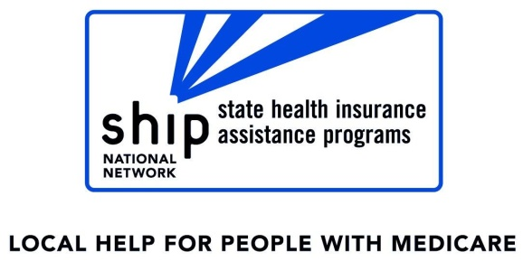
This project is supported in whole or in part by grant numbers 1701WIMSH, 1701WIMAA and 1701WIMDR from the U.S. Administration for Community Living, Department of Health and Human Services, Washington, D.C. 20201.

