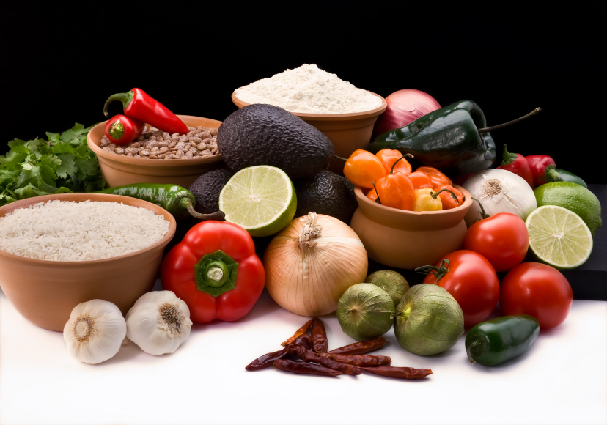
Recipe for: Glazed Turnips
2 lb small to medium (2-inch) turnips1 Tbsp sugar
1 ½ cup plus 3 Tbsp water½ tsp salt
2 Tbsp butterGarnish: Chopped Parsley

Peel turnips, then halve horizontally and quarter halves. Arrange turnips in 1 layer in a 12-inch heavy skillet and add enough water (about 1 ½ cups) to reach halfway up turnips. Add butter, sugar, and salt and boil over moderately high heat, covered, stirring occasionally, 10 minutes. Boil turnips, uncovered, stirring, until tender and water has evaporated, about 8 minutes.

Saute turnips over moderately high heat, stirring, until golden brown, about 5 minutes more. Add 3 Tbsp water and stir to coat turnips with glaze.
*Makes a nice side dish for roasted meats or poultry

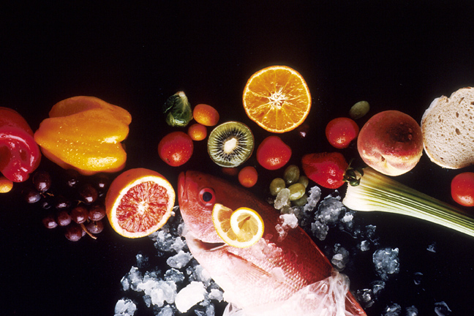
Recipe for: Mashed Turnips and Sage

4 large turnips, peeled and cubed2 Tbsp chopped fresh sage
1 large russet potato, peeled and cubed1 cup milk
3 Tbsp butterSalt and Pepper to taste
2 shallots, chopped

Add the turnips and potatoes to a large pot of cold salted water. Bring to a boil, then reduce to a simmer and cook until soft and tender, about 20 minutes.
In a small saucepan, add the butter over medium-high heat. Once melted and foamy, add the shallots and sage and sauté until the shallot is tender, the sage is fragrant, and the butter begins to brown. Season with salt and pepper. Add the milk and bring to a simmer.
Drain the turnips and potatoes in a colander. Add the turnips and potatoes back to the same pot. Add the hot milk and roughly mash the vegetables. For a smoother texture, use an immersion blender and puree until smooth and silky. Salt and Pepper to taste.
Recipe for: Roasted Turnips with Parmesan

2 lbs turnips (about 4 medium), peeled and cut into ½ inch wedges
¼ tsp ground nutmeg
Coarse salt and ground pepper
1/8 tsp cayenne pepper
2 Tbsp Extra-Virgin Olive Oil
¼ cup grated Parmesan (1/2 oz)

Preheat oven to 475 degrees. On a rimmed baking sheet combine turnips, cayenne, nutmeg, and oil. Season with salt and pepper and toss well to coat. Sprinkle with Parmesan and toss gently to combine. Arrange turnips in a single layer and roast until golden on both sides, 25-30 minutes, flipping halfway through.

Recipe for: Southern Turnip Greens

1 (14 oz) can chicken broth¼ tsp ground black pepper
1 ½ cups water1 lb turnip greens, chopped
3 Tbsp extra-virgin olive oil½ tsp white sugar
½ tsp salt

Bring chicken broth, water, oil, salt, and pepper to a boil in a stockpot. Add turnip greens and sugar and return to a boil; reduce heat to medium-low and simmer, stirring every 15 minutes, until greens are tender, at least 30 minutes or up to 2 hours.

