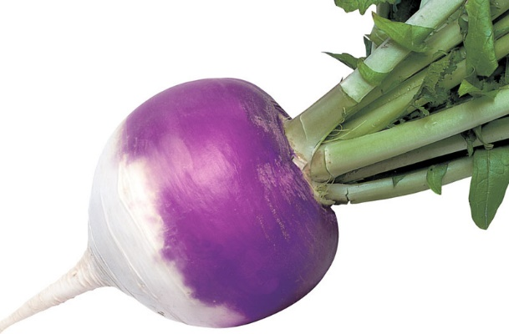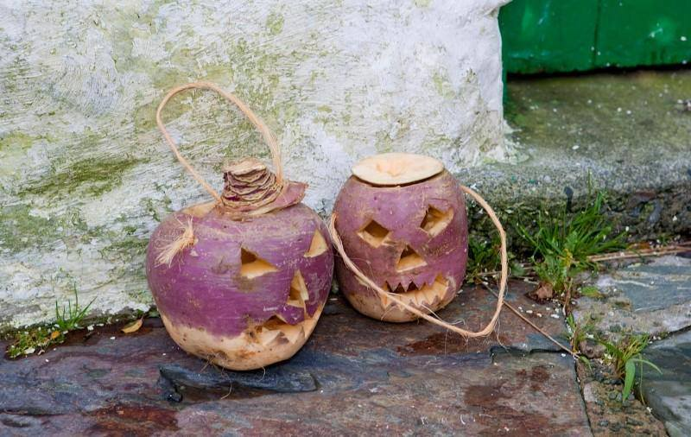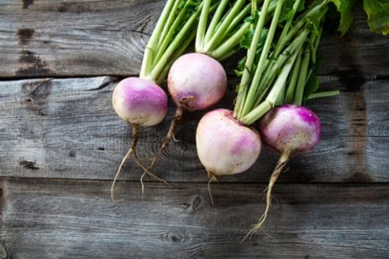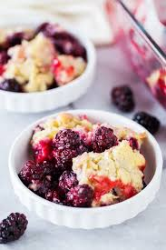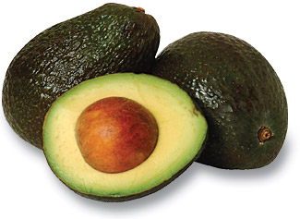

Even though this isn’t the most popular vegetable found in grocery stores and on the menu, it still carries numerous health benefits. Including turnips in your diet can help improve bone health, heart function, and may help prevent cancer. They are also a great choice to help with digestion!

Turnips can be eaten raw or cooked, however don’t just eat the white part. The turnip greens are also consumed, similar to mustard greens. The greens, however, because of their bitterness must be boiled down in order to be tasty. Chopped, sliced, diced, or left whole – you can enjoy this vegetable in a variety of ways using various cooking techniques.

**What is a creamy white vegetable but turns slightly purple when exposed to the sun? That would be the cruciferous vegetable – the Turnip.**

#### The Turnip

*September, 2018*

**Turnip Tidbits & Fun Facts:**

The first traditional “Jack-O-Lantern” in Ireland was a turnip, not a pumpkin that was used to ward off evil spirits.

Don’t throw away the leafy green tops – they are actually more nutritious than the roots, as they’re loaded with vitamins, minerals, and antioxidants.

The turnip can actually help your personal hygiene…turnip juice is actually effective in warding off body odor. Grate a turnip, squeeze out the juice, and apply to your underarms!

Turnips may help mend cracked and torn skin on your feet (must be because of the Vitamin C!) Try this one out – boil 12 turnips, including their greens, in water and before bedtime, soak your feet in the cooled solution for 10 minutes. It can help heal and prevent “odor”!

Because turnips are so hardy, they were often considered a food source for the poor and needy. Aristocrats refused to eat them. Even today, they’re considered a “humble” vegetable.

**Picking and Storing Turnips**

Turnips like cool weather and the sweetness is greatly enhanced by exposure to hard frosts. They like soil rich in potassium and phosphorus, but not nitrogen.

Turnips can be planted in the early spring for a spring crop and midsummer through early fall for a fall to winter crop. Harvest them early (30 days after seeding) when they are small for a sweet, mild flavor. Later harvests will result in larger, spicier flavors with a rough and woody texture.

When buying turnips in the stores, choose those that are small and heavy for their size. Choose ones that have smooth skin, sweet aroma, and crisp green tops.

Like potatoes, you can store in a cool, dim area and then just wash, trim, and peel before use. To freeze them, wash, peel, slice, and boil them, then blanch in cold water before draining. Store in freezer bag up to 6 months.

# Structuring Your Content

You have a nmber of alternatives for organizing the content of your brochure. You might choose to devote each column to a separate point or theme, such as quality and value. Remember, these points should tie in with your introductory text on the first page of the brochure.

# An Alternate Approach

On the other hand, you might want to organize your information as a continual stream of information broken up into smaller, “easy to chew” chunks. These smaller chunks can be separated by a descriptive subheading, like the one that begins this paragraph. If this is the approach you prefer, you can make use of linked text boxes, which allow text to flow from one column to the next.

A text box offers a flexible way of displaying text and graphics; it’s basically a container that you can resize and reposition. By linking a text box on one page with a text box on another, your article automatically flows from one page to another.

# Overview Headline

When readers open the brochure, this is the first text they will see, making this a good place to briefly but effectively summarize the products or services that you offer.

Make this text compelling and interesting so that readers will want to read the rest of the brochure. Be sure to keep the scope of this introduction narrow enough so that you can adequately cover the concepts you raise here in the limited space of the rest of the brochure.

Caption describing picture or graphic.