

**What is a creamy white vegetable but turns slightly purple when exposed to the sun? That would be the cruciferous vegetable – the Turnip.**

**What is a creamy white vegetable but turns slightly purple when exposed to the sun? That would be the cruciferous vegetable – the Turnip.**

**What is a creamy white vegetable but turns slightly purple when exposed to the sun? That would be the cruciferous vegetable – the Turnip.**

**Even though this isn’t the most popular vegetable found in grocery stores and on the menu, it still carries numerous health benefits. Including turnips in your diet can help improve bone health, heart function, and may help prevent cancer. They are also a great choice to help with digestion!**

**Turnips can be eaten raw or cooked, however don’t just eat the white part. The turnip greens are also consumed, similar to mustard greens. The greens, however, because of their bitterness must be boiled down in order to be tasty. Chopped, sliced, diced, or left whole – you can enjoy this vegetable in a variety of ways using various cooking techniques.**

#### The Turnip

#### Leaves

#### The Turnip

#### The Turnip



l Beneficial Bites

Bites

Bites

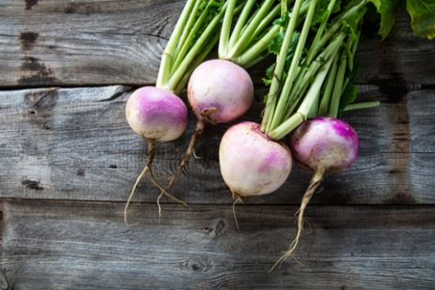

**Even though this isn’t the most popular vegetable found in grocery stores and on the menu, it still carries numerous health benefits. Including turnips in your diet can help improve bone health, heart function, and may help prevent cancer. They are also a great choice to help with digestion!**

**Turnips can be eaten raw or cooked, however don’t just eat the white part. The turnip greens are also consumed, similar to mustard greens. The greens, however, because of their bitterness must be boiled down in order to be tasty. Chopped, sliced, diced, or left whole – you can enjoy this vegetable in a variety of ways using various cooking techniques.**

**Even though this isn’t the most popular vegetable found in grocery stores and on the menu, it still carries numerous health benefits. Including turnips in your diet can help improve bone health, heart function, and may help prevent cancer. They are also a great choice to help with digestion!**

**Turnips can be eaten raw or cooked, however don’t just eat the white part. The turnip greens are also consumed, similar to mustard greens. The greens, however, because of their bitterness must be boiled down in order to be tasty. Chopped, sliced, diced, or left whole – you can enjoy this vegetable in a variety of ways using various cooking techniques.**



**Turnip Tidbits & Fun Facts:**

The first traditional “Jack-O-Lantern” in Ireland was a turnip, not a pumpkin that was used to ward off evil spirits.

Don’t throw away the leafy green tops – they are actually more nutritious than the roots, as they’re loaded with vitamins, minerals, and antioxidants.

The turnip can actually help your personal hygiene…turnip juice is actually effective in warding off body odor. Grate a turnip, squeeze out the juice, and apply to your underarms!

Turnips may help mend cracked and torn skin on your feet (must be because of the Vitamin C!) Try this one out – boil 12 turnips, including their greens, in water and before bedtime, soak your feet in the cooled solution for 10 minutes. It can help heal and prevent “odor”!

Because turnips are so hardy, they were often considered a food source for the poor and needy. Aristocrats refused to eat them. Even today, they’re considered a “humble” vegetable.

**Turnip Tidbits & Fun Facts:**

The first traditional “Jack-O-Lantern” in Ireland was a turnip, not a pumpkin that was used to ward off evil spirits.

Don’t throw away the leafy green tops – they are actually more nutritious than the roots, as they’re loaded with vitamins, minerals, and antioxidants.

The turnip can actually help your personal hygiene…turnip juice is actually effective in warding off body odor. Grate a turnip, squeeze out the juice, and apply to your underarms!

Turnips may help mend cracked and torn skin on your feet (must be because of the Vitamin C!) Try this one out – boil 12 turnips, including their greens, in water and before bedtime, soak your feet in the cooled solution for 10 minutes. It can help heal and prevent “odor”!

Because turnips are so hardy, they were often considered a food source for the poor and needy. Aristocrats refused to eat them. Even today, they’re considered a “humble” vegetable.

**Turnip Tidbits & Fun Facts:**

The first traditional “Jack-O-Lantern” in Ireland was a turnip, not a pumpkin that was used to ward off evil spirits.

Don’t throw away the leafy green tops – they are actually more nutritious than the roots, as they’re loaded with vitamins, minerals, and antioxidants.

The turnip can actually help your personal hygiene…turnip juice is actually effective in warding off body odor. Grate a turnip, squeeze out the juice, and apply to your underarms!

Turnips may help mend cracked and torn skin on your feet (must be because of the Vitamin C!) Try this one out – boil 12 turnips, including their greens, in water and before bedtime, soak your feet in the cooled solution for 10 minutes. It can help heal and prevent “odor”!

Because turnips are so hardy, they were often considered a food source for the poor and needy. Aristocrats refused to eat them. Even today, they’re considered a “humble” vegetable.

**Taste them on September’s Menu!:**

**Sept 21st Beef, Turnip, & Veggie Stew**

**Sept 26th Turnip & Potato Mash**

**Taste them on September’s Menu!:**

**Sept 21st Beef, Turnip, & Veggie Stew**

**Sept 26th Turnip & Potato Mash**

**Taste them on September’s Menu!:**

**Sept 21st Beef, Turnip, & Veggie Stew**

**Sept 26th Turnip & Potato Mash**