

The name “Rutabaga” is really only used in the United States. In the rest of the world, this vegetable is known as “Swede” or “Swedish Turnip.”

The name “Rutabaga” is really only used in the United States. In the rest of the world, this vegetable is known as “Swede” or “Swedish Turnip.”

Rutabagas are rich in complex-carbohydrates and fiber, but contain little fat or protein. They contain about ½ the amount of calories of potatoes and are high in Vitamin C and Potassium. One cup of fresh rutabagas contains over 35% of the daily recommended value of Vitamin C.

Yellow-flesh rutabagas also contain beta-carotene that is converted into Vitamin A and acts as an antioxidant in our bodies fighting against inflammation and cancer-causing free radicals.

Because of its nutritional content, clinical studies have shown that eating rutabagas along with its related cousin vegetables could help reduce the risk of colorectal and prostate cancers

#### Rutabaga

#### Rutabaga

#### Leaves

#### Rutabaga



l Beneficial Bites

Bites

Bites

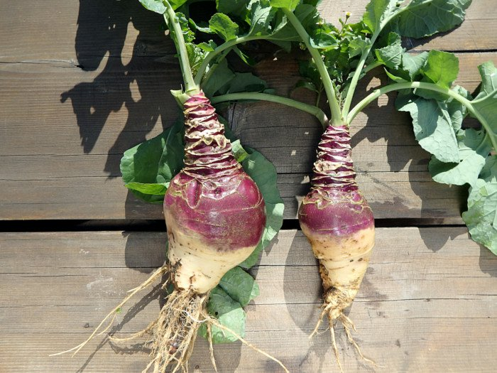

Rutabagas are rich in complex-carbohydrates and fiber, but contain little fat or protein. They contain about ½ the amount of calories of potatoes and are high in Vitamin C and Potassium. One cup of fresh rutabagas contains over 35% of the daily recommended value of Vitamin C.

Yellow-flesh rutabagas also contain beta-carotene that is converted into Vitamin A and acts as an antioxidant in our bodies fighting against inflammation and cancer-causing free radicals.

Because of its nutritional content, clinical studies have shown that eating rutabagas along with its related cousin vegetables could help reduce the risk of colorectal and prostate cancers

Rutabagas are rich in complex-carbohydrates and fiber, but contain little fat or protein. They contain about ½ the amount of calories of potatoes and are high in Vitamin C and Potassium. One cup of fresh rutabagas contains over 35% of the daily recommended value of Vitamin C.

Yellow-flesh rutabagas also contain beta-carotene that is converted into Vitamin A and acts as an antioxidant in our bodies fighting against inflammation and cancer-causing free radicals.

Because of its nutritional content, clinical studies have shown that eating rutabagas along with its related cousin vegetables could help reduce the risk of colorectal and prostate cancers

The name “Rutabaga” is really only used in the United States. In the rest of the world, this vegetable is known as “Swede” or “Swedish Turnip.”



**The Roots of the Rutabaga**

The first known printed reference to the rutabaga comes from the Swiss botanist, Gaspard Bauhin in 1620. It was noted it was growing in Sweden at the time.

It’s also noted to have originated in Scandinavia or Russia and there are contradictory accounts of how rutabagas arrived in England…some say by Germany and some support Swedish origins…tough to say!

Like the turnip, rutabagas were once considered a “food of last resort” during WW1 and WW11 when there were food shortages in Germany and in France.

Boiled stew with rutabaga and water as the only ingredients was a typical food in Germany during the famine between 1945 and 1949. As a result, many Germans have many “unhappy” memories of this food. And may be a reason it’s not a favorite for some!

During WWII a diary written by an anonymous young girl from the Lodz Ghetto wrote about food and hunger during that time and how it affected many people. In one of her writings she talks about how her father smuggled food for their family to survive and came home one evening with two stolen rutabagas. Each of the rutabagas were divided into 3 portions to feed the entire family.

**The Roots of the Rutabaga**

The first known printed reference to the rutabaga comes from the Swiss botanist, Gaspard Bauhin in 1620. It was noted it was growing in Sweden at the time.

It’s also noted to have originated in Scandinavia or Russia and there are contradictory accounts of how rutabagas arrived in England…some say by Germany and some support Swedish origins…tough to say!

Like the turnip, rutabagas were once considered a “food of last resort” during WW1 and WW11 when there were food shortages in Germany and in France.

Boiled stew with rutabaga and water as the only ingredients was a typical food in Germany during the famine between 1945 and 1949. As a result, many Germans have many “unhappy” memories of this food. And may be a reason it’s not a favorite for some!

During WWII a diary written by an anonymous young girl from the Lodz Ghetto wrote about food and hunger during that time and how it affected many people. In one of her writings she talks about how her father smuggled food for their family to survive and came home one evening with two stolen rutabagas. Each of the rutabagas were divided into 3 portions to feed the entire family.

**The Roots of the Rutabaga**

The first known printed reference to the rutabaga comes from the Swiss botanist, Gaspard Bauhin in 1620. It was noted it was growing in Sweden at the time.

It’s also noted to have originated in Scandinavia or Russia and there are contradictory accounts of how rutabagas arrived in England…some say by Germany and some support Swedish origins…tough to say!

Like the turnip, rutabagas were once considered a “food of last resort” during WW1 and WW11 when there were food shortages in Germany and in France.

Boiled stew with rutabaga and water as the only ingredients was a typical food in Germany during the famine between 1945 and 1949. As a result, many Germans have many “unhappy” memories of this food. And may be a reason it’s not a favorite for some!

During WWII a diary written by an anonymous young girl from the Lodz Ghetto wrote about food and hunger during that time and how it affected many people. In one of her writings she talks about how her father smuggled food for their family to survive and came home one evening with two stolen rutabagas. Each of the rutabagas were divided into 3 portions to feed the entire family.

**Taste them on October’s Menu!:**

**Oct 9th - Roasted Rutabagas**

**Taste them on October’s Menu!:**

**Oct 9th - Roasted Rutabagas**

**Taste them on October’s Menu!:**

**Oct 9th - Roasted Rutabagas**