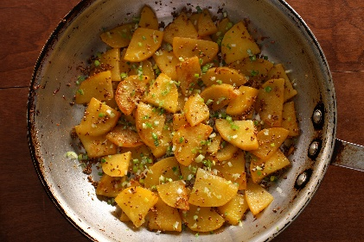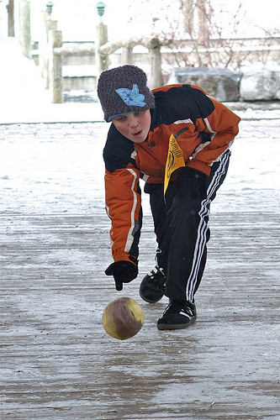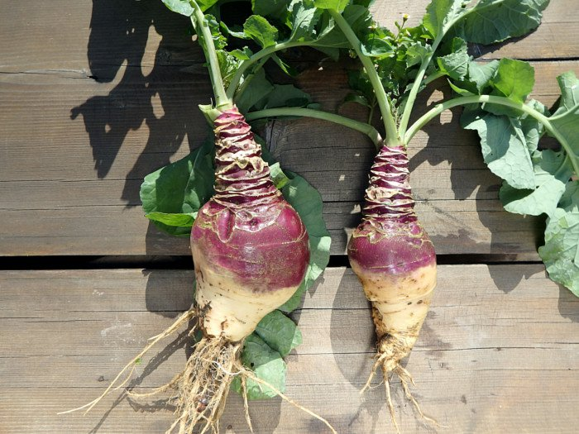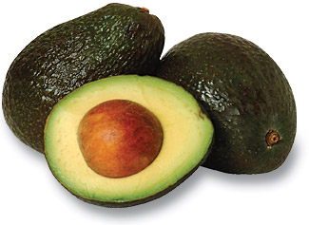

**The Roots of the Rutabaga**

The first known printed reference to the rutabaga comes from the Swiss botanist, Gaspard Bauhin in 1620. It was noted it was growing in Sweden at the time.

It’s also noted to have originated in Scandinavia or Russia and there are contradictory accounts of how rutabagas arrived in England…some say by Germany and some support Swedish origins…tough to say!

Like the turnip, rutabagas were once considered a “food of last resort” during WW1 and WW11 when there were food shortages in Germany and in France.

Boiled stew with rutabaga and water as the only ingredients was a typical food in Germany during the famine between 1945 and 1949. As a result, many Germans have many “unhappy” memories of this food. And may be a reason it’s not a favorite for some!

During WWII a diary written by an anonymous young girl from the Lodz Ghetto wrote about food and hunger during that time and how it affected many people. In one of her writings she talks about how her father smuggled food for their family to survive and came home one evening with two stolen rutabagas. Each of the rutabagas were divided into 3 portions to feed the entire family.

Rutabagas are rich in complex-carbohydrates and fiber, but contain little fat or protein. They contain about ½ the amount of calories of potatoes and are high in Vitamin C and Potassium. One cup of fresh rutabagas contains over 35% of the daily recommended value of Vitamin C.

Yellow-flesh rutabagas also contain beta-carotene that is converted into Vitamin A and acts as an antioxidant in our bodies fighting against inflammation and cancer-causing free radicals.

Because of its nutritional content, clinical studies have shown that eating rutabagas along with its related cousin vegetables could help reduce the risk of colorectal and prostate cancers

**The name “Rutabaga” is really only used in the United States. In the rest of the world, this vegetable is known as “Swede” or “Swedish Turnip.”**

*October, 2018*

**Rutabaga Curling!**

**Rutabaga Fun Facts:**

The International Rutabaga Curling Championship takes place annually at the Ithaca Farmer’s Market on the last day of the market season. This international event brings competitors from a variety of countries to compete in the “Turnip Toss” (Kids Division) and the “Rutabaga Curl” (Adult Division. No other vegetables are allowed to be used in the event, and the curler must bring their own.

Askov, MN is the former “Rutabaga Capital of the World” and was a hub of rutabaga cultivation until the rutabaga warehouse burned down in the 1970s. The city of Askov is currently home of the annual Askov Fair and Rutabaga Festival, held during the fourth weekend of August.

Of course, the local “Cumberland Rutabaga Festival” takes place every August and this year was the 86th year of the celebrations. This 4-day festival is filled with the Baga Olympics, Truck Pull, Food Stands, Live Entertainment, Golf Scramble, Arts & Crafts Fair, and much more!

#### Rutabaga

# Structuring Your Content

You have a nmber of alternatives for organizing the content of your brochure. You might choose to devote each column to a separate point or theme, such as quality and value. Remember, these points should tie in with your introductory text on the first page of the brochure.

# An Alternate Approach

On the other hand, you might want to organize your information as a continual stream of information broken up into smaller, “easy to chew” chunks. These smaller chunks can be separated by a descriptive subheading, like the one that begins this paragraph. If this is the approach you prefer, you can make use of linked text boxes, which allow text to flow from one column to the next.

A text box offers a flexible way of displaying text and graphics; it’s basically a container that you can resize and reposition. By linking a text box on one page with a text box on another, your article automatically flows from one page to another.

# Overview Headline

When readers open the brochure, this is the first text they will see, making this a good place to briefly but effectively summarize the products or services that you offer.

Make this text compelling and interesting so that readers will want to read the rest of the brochure. Be sure to keep the scope of this introduction narrow enough so that you can adequately cover the concepts you raise here in the limited space of the rest of the brochure.

Caption describing picture or graphic.