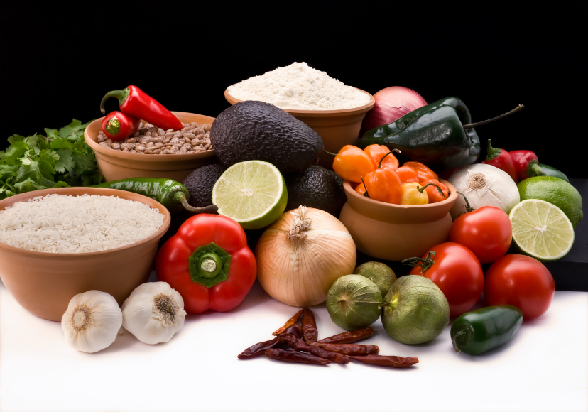
Recipe for: Banana, Wheat Germ, & Oats

3 ¾ cups water1 ½ cups sliced banana (about 2)
1 cup old fashioned rolled oats3 Tbsp brown sugar
2/3 cups toasted wheat germ1 Tbsp butter
¼ tsp salt

Combine the water, oats, wheat germ, and salt in a medium saucepan, and bring to a boil over high heat, stirring occasionally. Reduce heat to a medium-low, and cook for 6 minutes or until thick and thoroughly heated, stirring occasionally. Remove from heat. Divide cereal evenly among 3 bowls. Top each serving with ½ cup banana, 1 Tbsp brown sugar, and 1 tsp butter.


Recipe for: Wheat Germ Pancakes

1 cup all-purpose flour½ tsp salt½ tsp vanilla
½ cup whole wheat flour2 eggs6 tsp Wheat Germ
3 Tbsp sugar2 Tbsp vegetable oil
1 Tbsp baking powder1 banana mashed + enough milk to make 1 ¼ cups

Preheat griddle (350 degrees if electric)
Whisk flour, sugar, baking powder, and salt in a medium sized bowl. Mash banana in a large measuring cup. Add a little milk and stir them together, then add more milk until the measuring cup reads 1 ¼ cups. Whisk in oil, eggs, and vanilla. Then whisk the wet ingredients into the dry ingredients until just combined.
Spray griddle/frying pan with nonstick cooking spray. Ladle the pancakes one by one. Add ½ tsp of wheat germ to the top of each pancake and cook until the bottoms are brown. Flip and cook until golden on the bottom. Serve with syrup.
Pancakes can be frozen for up to one month. Simply heat in microwave to unfreeze for breakfast!

Recipe for: Crispy Cauliflower with Wheat Germ Twist

1 ½ lbs or small head cauliflower1/8 Tsp salt
3 Tbsp Olive Oil, divided3 Tbsp grated parmesan
2 cloves garlic3 Tbsp raisins
4 Tbsp Wheat GermFreshly ground pepper, to taste
Preheat oven to 400 degrees. In a medium bowl, toss cauliflower with 2 Tbsp olive oil. Place in 8-inch square dish and bake for 15 minutes. Meanwhile in the same bowl, mix together the remaining Tbsp olive oil, garlic, wheat germ, salt, parmesan, and raisins.

Once cauliflower has cooked for 15 minutes, stir and then sprinkle the crumb mixture evenly over the dish. Bake for 15 more minutes. Let dish cool for 10 minutes. Add pepper to taste and serve.

Recipe for: Momma’s Wheat Germ Cookies

1 cup butter, softened1 ½ cup rolled oats1 tsp salt
1 cup white sugar1 cup wheat germ1 cup flaked coconut
1 cup brown sugar1 cup all-purpose flour2 cups chopped pecans
2 eggs1 tsp baking powder1 cup chopped dates
1 ½ tsp vanilla1 tsp baking soda
Preheat oven to 325 degrees
In a large bowl, cream together the butter, white sugar, and brown sugar until smooth. Beat in the eggs, one at a time then stir in the vanilla. In a separate bowl, combine the oats, wheat germ, flour, baking powder, baking soda, and salt. Stir the dry ingredients into the creamed mixture. Finally, mix the coconut, pecans, and dates. Drop by rounded spoonfuls onto ungreased cookie sheets.
Bake for 8 to 10 minutes in the preheated oven. Allow cookies to cool on baking sheet for a couple minutes before removing to a wire rack to cool completely.

