

**Wheat germ has a nutty flavor and is sodium and cholesterol free, and dense in nutrients such as Vitamin E, Magnesium, Phosphorus, Zinc, and B Vitamins!**

**Wheat germ has a nutty flavor and is sodium and cholesterol free, and dense in nutrients such as Vitamin E, Magnesium, Phosphorus, Zinc, and B Vitamins!**

Wheat germ is a bountiful source of energy, fiber, protein, and complex carbohydrates, along with numerous vitamins and minerals. It also contains omega-3 fatty acids.

How can all of these benefit you?

Well, the proteins can help boost your immune system, the omega-3 can improve brain health, the fiber can help support digestive and heart health, and the vitamins and minerals can help improve cellular metabolism giving you more energy and helping you feel better overall!

Two tablespoons of wheat germ powder contains 65 calories, 6 grams of protein, 2 grams of unsaturated (healthy) fat and 2 grams of fiber.

#### Wheat Germ

#### Wheat Germ

#### Wheat Germ



l Beneficial Bites

Bites

Bites

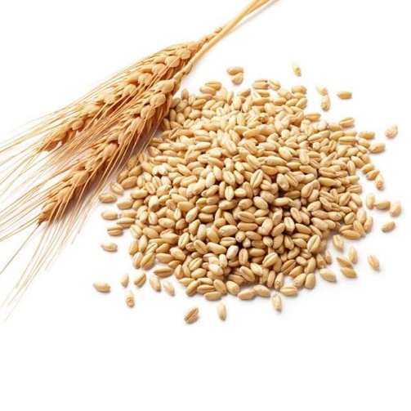

**Wheat germ has a nutty flavor and is sodium and cholesterol free, and dense in nutrients such as Vitamin E, Magnesium, Phosphorus, Zinc, and B Vitamins!**

Wheat germ is a bountiful source of energy, fiber, protein, and complex carbohydrates, along with numerous vitamins and minerals. It also contains omega-3 fatty acids.

How can all of these benefit you?

Well, the proteins can help boost your immune system, the omega-3 can improve brain health, the fiber can help support digestive and heart health, and the vitamins and minerals can help improve cellular metabolism giving you more energy and helping you feel better overall!

Two tablespoons of wheat germ powder contains 65 calories, 6 grams of protein, 2 grams of unsaturated (healthy) fat and 2 grams of fiber.

Wheat germ is a bountiful source of energy, fiber, protein, and complex carbohydrates, along with numerous vitamins and minerals. It also contains omega-3 fatty acids.

How can all of these benefit you?

Well, the proteins can help boost your immune system, the omega-3 can improve brain health, the fiber can help support digestive and heart health, and the vitamins and minerals can help improve cellular metabolism giving you more energy and helping you feel better overall!

Two tablespoons of wheat germ powder contains 65 calories, 6 grams of protein, 2 grams of unsaturated (healthy) fat and 2 grams of fiber.



**What the heck is Wheat Germ?**

Wheat germ is the small little part of the wheat kernel that is considered the “storehouse” of the nutrients in wheat. The wheat kernel has 3 parts – the Bran, the Germ, and the Endosperm.

The Bran makes up about 14% of the kernel and is the outer “roughage” part. Bran contains many B vitamins but also is full of insoluble fiber.

The Endosperm makes up about 83% of the kernel and is the main source for white flour and has the greatest amount of carbohydrates.

The Germ makes up only about 3% of the kernel and is the part that feeds the plant. It is packed with many vitamins, minerals, and healthy fats.

When white flour is made, the bran and germ are removed in order to make a longer shelf life. 70% of nutrients are lost during this process, so many companies “add back in” some of the essential vitamins such as B vitamins and folate.

100% whole wheat products still contain the bran and germ, so that’s why it’s recommended to make sure half of your days’ worth of grains are 100% whole grain.

You can purchase wheat germ in powder or oil form and add to many dishes to still reap its benefits.

**What the heck is Wheat Germ?**

Wheat germ is the small little part of the wheat kernel that is considered the “storehouse” of the nutrients in wheat. The wheat kernel has 3 parts – the Bran, the Germ, and the Endosperm.

The Bran makes up about 14% of the kernel and is the outer “roughage” part. Bran contains many B vitamins but also is full of insoluble fiber.

The Endosperm makes up about 83% of the kernel and is the main source for white flour and has the greatest amount of carbohydrates.

The Germ makes up only about 3% of the kernel and is the part that feeds the plant. It is packed with many vitamins, minerals, and healthy fats.

When white flour is made, the bran and germ are removed in order to make a longer shelf life. 70% of nutrients are lost during this process, so many companies “add back in” some of the essential vitamins such as B vitamins and folate.

100% whole wheat products still contain the bran and germ, so that’s why it’s recommended to make sure half of your days’ worth of grains are 100% whole grain.

You can purchase wheat germ in powder or oil form and add to many dishes to still reap its benefits.

**What the heck is Wheat Germ?**

Wheat germ is the small little part of the wheat kernel that is considered the “storehouse” of the nutrients in wheat. The wheat kernel has 3 parts – the Bran, the Germ, and the Endosperm.

The Bran makes up about 14% of the kernel and is the outer “roughage” part. Bran contains many B vitamins but also is full of insoluble fiber.

The Endosperm makes up about 83% of the kernel and is the main source for white flour and has the greatest amount of carbohydrates.

The Germ makes up only about 3% of the kernel and is the part that feeds the plant. It is packed with many vitamins, minerals, and healthy fats.

When white flour is made, the bran and germ are removed in order to make a longer shelf life. 70% of nutrients are lost during this process, so many companies “add back in” some of the essential vitamins such as B vitamins and folate.

100% whole wheat products still contain the bran and germ, so that’s why it’s recommended to make sure half of your days’ worth of grains are 100% whole grain.

You can purchase wheat germ in powder or oil form and add to many dishes to still reap its benefits.

**Taste it on November’s Menu!:**

**Nov 8th – Oatmeal Wheat Germ Cookie**

**Taste it on November’s Menu!:**

**Nov 8th – Oatmeal Wheat Germ Cookie**

**Taste it on November’s Menu!:**

**Nov 8th – Oatmeal Wheat Germ Cookie**