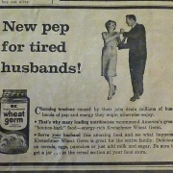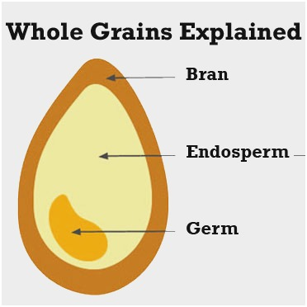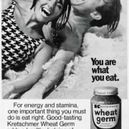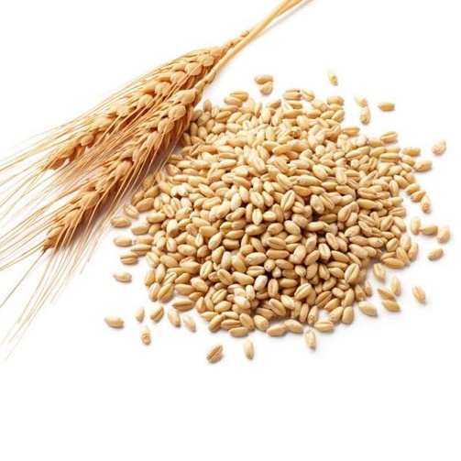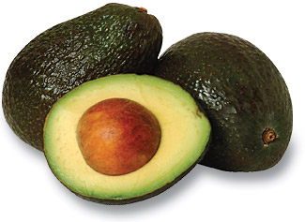

**What the heck is Wheat Germ?**

Wheat germ is the small little part of the wheat kernel that is considered the “storehouse” of the nutrients in wheat. The wheat kernel has 3 parts – the Bran, the Germ, and the Endosperm.

The Bran makes up about 14% of the kernel and is the outer “roughage” part. Bran contains many B vitamins but also is full of insoluble fiber.

The Endosperm makes up about 83% of the kernel and is the main source for white flour and has the greatest amount of carbohydrates.

The Germ makes up only about 3% of the kernel and is the part that feeds the plant. It is packed with many vitamins, minerals, and healthy fats.

When white flour is made, the bran and germ are removed in order to make a longer shelf life. 70% of nutrients are lost during this process, so many companies “add back in” some of the essential vitamins such as B vitamins and folate.

100% whole wheat products still contain the bran and germ, so that’s why it’s recommended to make sure half of your days’ worth of grains are 100% whole grain.

You can purchase wheat germ in powder or oil form and add to many dishes to still reap its benefits.

Wheat germ is a bountiful source of energy, fiber, protein, and complex carbohydrates, along with numerous vitamins and minerals. It also contains omega-3 fatty acids.

How can all of these benefit you?

Well, the proteins can help boost your immune system, the omega-3 can improve brain health, the fiber can help support digestive and heart health, and the vitamins and minerals can help improve cellular metabolism giving you more energy and helping you feel better overall!

Two tablespoons of wheat germ powder contains 65 calories, 6 grams of protein, 2 grams of unsaturated (healthy) fat and 2 grams of fiber.

**Wheat germ has a nutty flavor and is sodium and cholesterol free, and dense in nutrients such as Vitamin E, Magnesium, Phosphorus, Zinc, and B Vitamins!**

*November, 2018*

**Wheat Germ History:**

The Kretschmer brand of wheat germ has been around since the 1930s.

In the 1960s and 1970s, they had a big advertising campaign focused on the importance of eating right. They used the slogan, “You are what you eat.” And stated this on their wheat germ ad: “For energy and stamina one important thing you must do is eat right!” (See ad above)

These ads also stated that wheat germ would give stamina back to husbands whose tensions at work were wearing them out. “Serve your husbands this amazing food and see what happens!

#### Wheat Germ

# Structuring Your Content

You have a nmber of alternatives for organizing the content of your brochure. You might choose to devote each column to a separate point or theme, such as quality and value. Remember, these points should tie in with your introductory text on the first page of the brochure.

# An Alternate Approach

On the other hand, you might want to organize your information as a continual stream of information broken up into smaller, “easy to chew” chunks. These smaller chunks can be separated by a descriptive subheading, like the one that begins this paragraph. If this is the approach you prefer, you can make use of linked text boxes, which allow text to flow from one column to the next.

A text box offers a flexible way of displaying text and graphics; it’s basically a container that you can resize and reposition. By linking a text box on one page with a text box on another, your article automatically flows from one page to another.

# Overview Headline

When readers open the brochure, this is the first text they will see, making this a good place to briefly but effectively summarize the products or services that you offer.

Make this text compelling and interesting so that readers will want to read the rest of the brochure. Be sure to keep the scope of this introduction narrow enough so that you can adequately cover the concepts you raise here in the limited space of the rest of the brochure.

Caption describing picture or graphic.