

Beneficial Bites

A legend states that a courtier (an advisor of the king and queen) in Babylonia 5000 BC “discovered” wine formed from unattended grape juice, leading to the eventual discovery of vinegar and its use as a food preservative.

Some medical research shows that ingesting apple cider vinegar can help with acid reflux, lower blood pressure, improve diabetes and support some or small weight loss due to its ingredients: acetic acid, potassium, magnesium, probiotics, and enzymes.

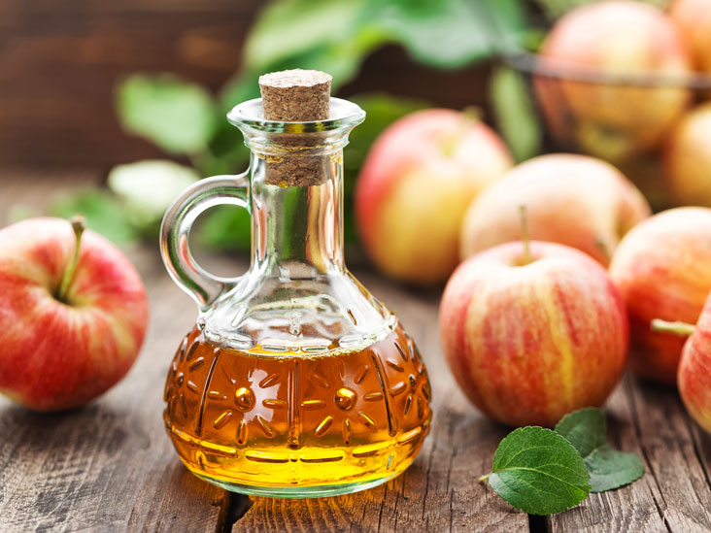

*Vinegar is produced when a group of bacteria (called “Acetobacter”) converts the alcohol portion to acid that forms vinegar.*

Fun Facts:

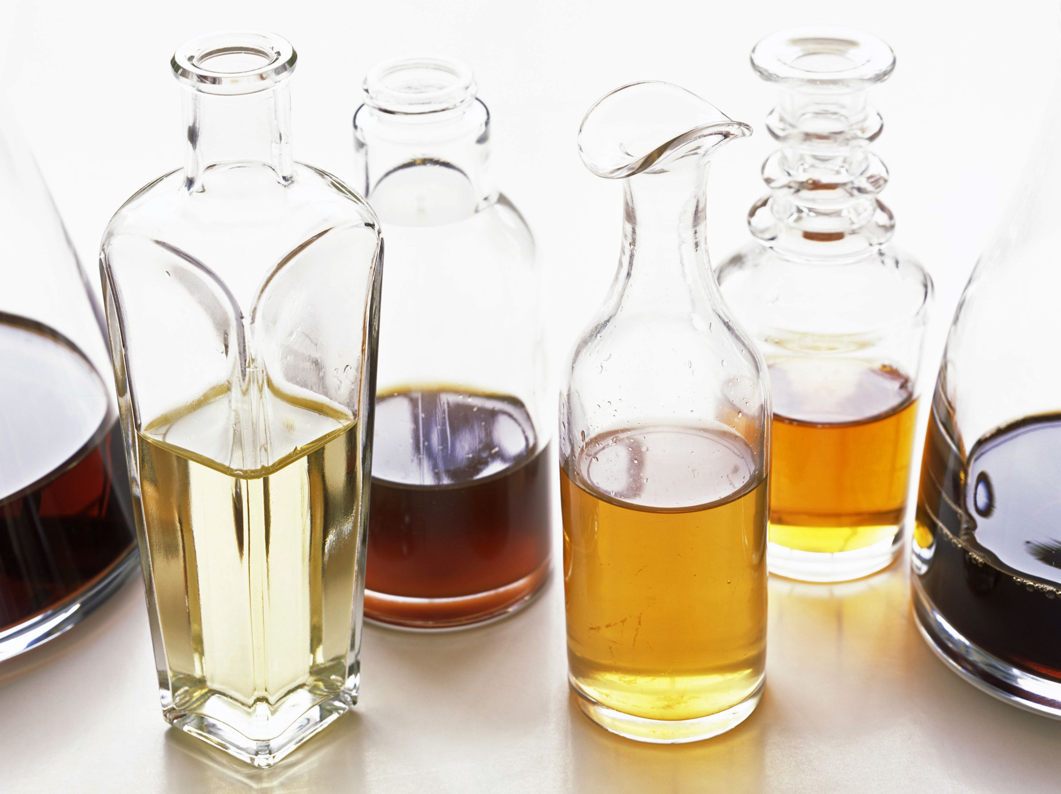

* Did you know that Vinegar was discovered over **10,000** years ago?
* Each vinegar type has a distinct flavor ranging from mildly sour rice wine vinegar to sweet Italian balsamic which has a bold sweet taste.
* The name vinegar comes from the French, **“vin aigre”** which means sour wine.
* Did you know that National Vinegar day is on November 1st?
* White vinegar is said to help treat **sunburn** by placing a tissue over the sunburned skin and lightly spraying the vinegar over the burned area. The vinegar is said to help restore skin.
* Vinegar contains **5-20% acetic acid** depending on the type of vinegar.

Tips for use:

* Marinades
* Salad Dressings
* Soups
* Canning/ Pickling
* Household Cleaning- making a paste with baking soda and white vinegar can remove a **wine stain.**
* Research found that when people with Type 2 diabetes consumed 30 milliliters (roughly 1 fluid ounce of) vinegar mixed with 20 milliliters water before a meal, their blood glucose, insulin and triglyceride levels were **lower** for up to **five hours after** the meal than when they consumed a placebo.

#### Vinegar

Sailboat

This area can be used to give the reader clear instructions for the next steps that you hope they will take. It may be a number you want them to call, a Web site you want them to visit, or information you want them to fill out. Whatever the case, this information should be clear, brief and engaging enough to motivate the reader to make that small decision to move forward.

# Structuring Your Content

You have a nmber of alternatives for organizing the content of your brochure. You might choose to devote each column to a separate point or theme, such as quality and value. Remember, these points should tie in with your introductory text on the first page of the brochure.

# An Alternate Approach

On the other hand, you might want to organize your information as a continual stream of information broken up into smaller, “easy to chew” chunks. These smaller chunks can be separated by a descriptive subheading, like the one that begins this paragraph. If this is the approach you prefer, you can make use of linked text boxes, which allow text to flow from one column to the next.

A text box offers a flexible way of displaying text and graphics; it’s basically a container that you can resize and reposition. By linking a text box on one page with a text box on another, your article automatically flows from one page to another.

# Overview Headline

When readers open the brochure, this is the first text they will see, making this a good place to briefly but effectively summarize the products or services that you offer.

Make this text compelling and interesting so that readers will want to read the rest of the brochure. Be sure to keep the scope of this introduction narrow enough so that you can adequately cover the concepts you raise here in the limited space of the rest of the brochure.

Caption describing picture or graphic.