**Recipe for:** Mushroom and Wild Rice Soup

1 TBSP Olive Oil 1 large Yellow Onion, Diced

4 Celery Stalks, Diced 1 lb mixed mushrooms, chopped (shiitake, oyster and cremini)

6 C Vegetable Broth/ Stock 1 C Wild Rice

1 ½ tsp Dried Thyme 1 tsp of sea salt

¼ tsp black pepper 1 TBSP Red Wine Vinegar

Add olive oil to a large pot on medium-high heat. Add onions and sauté until translucent (about 5 min). Add celery and cook for another min before adding mushrooms. Let mushrooms cook for about 10 min or until they have reduced in size. They will appear as if they are sweating. Add vegetable broth, wild rice, thyme, sea salt, and pepper and bring to a boil. Lower heat to a simmer and cover, let simmer for 30 min or until rice is fully cooked. Remove top, add vinegar and simmer for 10 min. Serve warm.



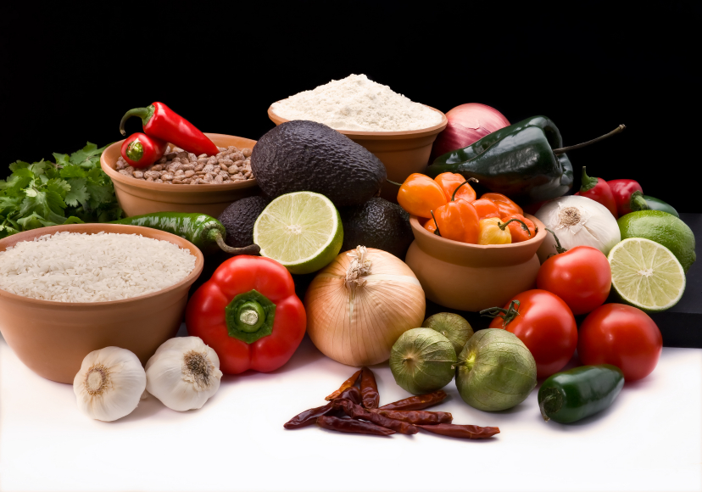

**Recipe for:** Crispy Salt and Vinegar Smashed Potatoes

2 lbs Mixed Baby Potatoes 1 TBSP Salt

2 TBSP Unsalted Butter 2 TBSP Olive Oil

2 TBSP White Vinegar 2 TBSP Chopped Chives

Ground Pepper to sprinkle

Preheat oven to 450 degrees F. Line a baking sheet with parchment paper. Add potatoes and 1 TBSPof salt to a medium sauce pan. Cover with water and bring to a boil. Reduce heat and simmer until potatoes are tender (about 20 min). Drain and place potatoes back into saucepan. Add butter and coat the potatoes, then place onto cookie sheet and spread out. Use a heavy mug or glass and smash each potato leaving a ½ inch thickness. Bake for 20 min and remove and turn each one with a spatula, drizzle with olive oil and bake another 20 min. Next, remove potatoes from oven sprinkle with vinegar, chopped chives, salt and pepper.





**Recipe for:** Apple Cider Vinegar Chicken

1. 1 ¼ lbs boneless, skinless chicken breasts ¼ C Apple Cider Vinegar

2 TBSP Italian Seasoning 1 TBSP Olive Oil

1 TBSP Sea Salt ½ TSP Ground Pepper

Whisk vinegar, Italian seasoning, oil, salt, and pepper in a bowl until well combined. Place chicken in a shallow dish or 1 gallon sealable plastic bag. Add the marinade, toss to coat and refrigerate for 1-12 hours. Remove chicken from marinade, shake off excess marinade and place chicken on a grill or pan. Cook for about 5 min each side or until chicken is completely cooked. Enjoy!





**Recipe for:** Roasted Butternut Squash

with Rosemary and Balsamic Vinegar

6 C Butternut Squash Cubed 2 TBSP Olive Oil

3 TBSP balsamic Vinegar 1 TSP finely Chopped Rosemary

Sea Salt to taste Black Pepper to taste

Pre-heat oven to 400 degrees, mix together the olive oil, 1 TBSP balsamic vinegar and rosemary, then toss squash cubes with the mixture. Arrange the squash on a cookie sheet spread out into a single layer. Roast for 20 min, or until squash is tender. Remove from oven and toss squash with 1 TBSP of balsamic vinegar sea salt, and pepper. Serve warm.



