



Beneficial Bites

* By adding a splash of vinegar can brighten flavors of almost any dish.
* Vinegar contains **5-20% acetic acid** depending on the type of vinegar.
* The acid level in vinegar is what makes it such a great cleaner. It counteracts some buildups like dirt, grease, soap scum, brines from hard water, and glue from stickers.
* The acetic acid can interact with starch-digesting enzymes, which will help keep blood sugar down [after a meal] in the short term.

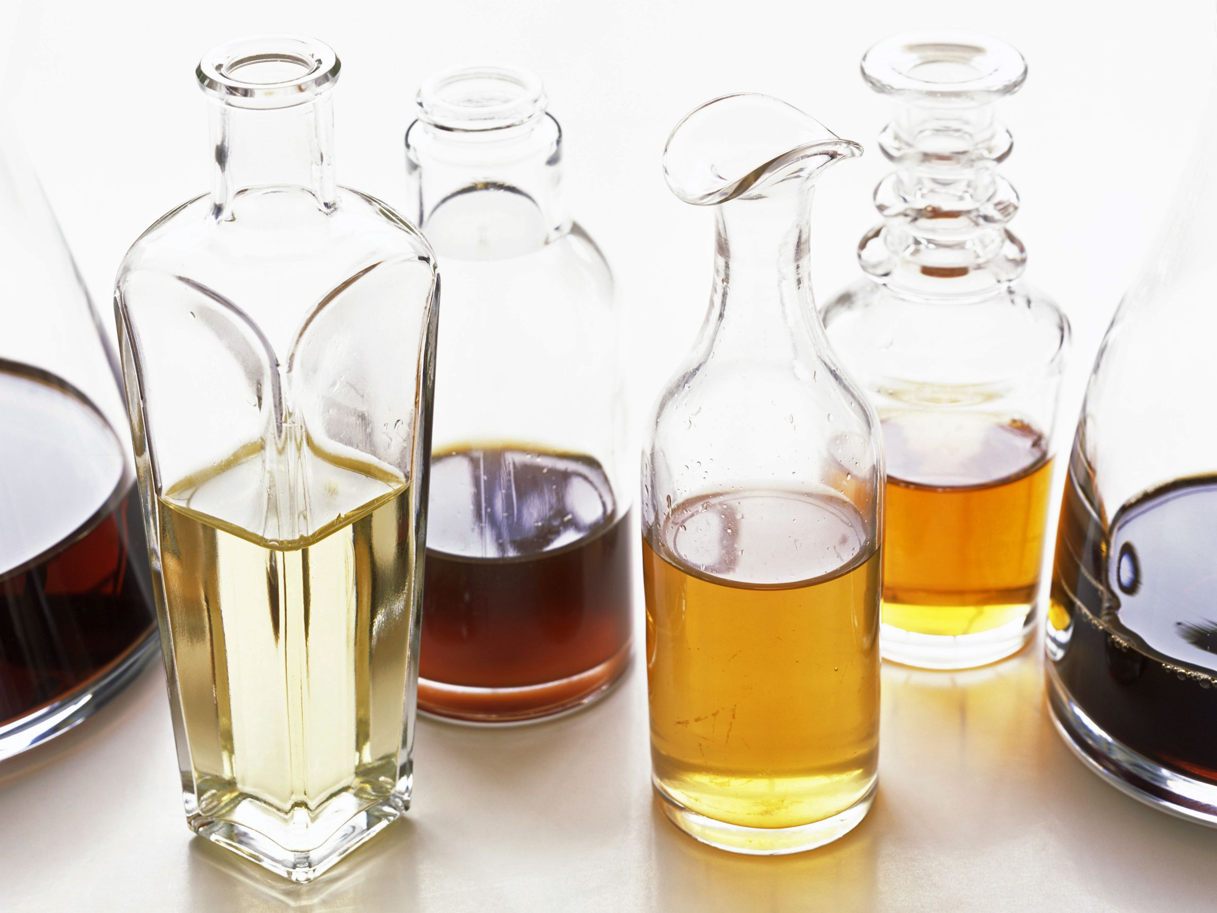

Vinegar is produced when a group of bacteria (called “Acetobacter”) converts the alcohol portion to acid. This is the acetic, or acid fermentation that forms vinegar.



Beneficial Bites

* By adding a splash of vinegar can brighten flavors of almost any dish.
* Vinegar contains **5-20% acetic acid** depending on the type of vinegar.
* The acid level in vinegar is what makes it such a great cleaner. It counteracts some buildups like dirt, grease, soap scum, brines from hard water, and glue from stickers.
* The acetic acid can interact with starch-digesting enzymes, which will help keep blood sugar down [after a meal] in the short term.





l Beneficial Bites

Bites

Bites

* By adding a splash of vinegar can brighten flavors of almost any dish.
* Vinegar contains **5-20% acetic acid** depending on the type of vinegar.
* The acid level in vinegar is what makes it such a great cleaner. It counteracts some buildups like dirt, grease, soap scum, brines from hard water, and glue from stickers.
* The acetic acid can interact with starch-digesting enzymes, which will help keep blood sugar down [after a meal] in the short term.



Beneficial Bites

#### Vinegar

#### Leaves

#### Vinegar

#### Vinegar

Vinegar is produced when a group of bacteria (called “Acetobacter”) converts the alcohol portion to acid. This is the acetic, or acid fermentation that forms vinegar.

Vinegar is produced when a group of bacteria (called “Acetobacter”) converts the alcohol portion to acid. This is the acetic, or acid fermentation that forms vinegar.

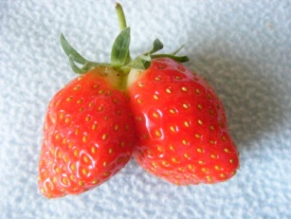



Beneficial Bites

**Fun Facts:**

* Some medical research shows that ingesting apple cider vinegar can help acid reflux, lower blood pressure, improve diabetes and support some or small weight loss due to its ingredients: acetic acid, potassium, magnesium, probiotics, and enzymes.
* Vinegar was discovered over 10,000 years ago.
* November 1st is National Vinegar day
* A legend states that a courtier in Babylonia 5000 BC “discovered” wine formed from unattended grape juice, leading to the eventual discovery of vinegar

**March Menu Items**

**Garden Salad with**

**Balsamic Vinaigrette**

**Vinegar Coleslaw**

**Fun Facts:**

* Some medical research shows that ingesting apple cider vinegar can help acid reflux, lower blood pressure, improve diabetes and support some or small weight loss due to its ingredients: acetic acid, potassium, magnesium, probiotics, and enzymes.
* Vinegar was discovered over 10,000 years ago.
* November 1st is National Vinegar day
* A legend states that a courtier in Babylonia 5000 BC “discovered” wine formed from unattended grape juice, leading to the eventual discovery of vinegar

**March Menu Items**

**Garden Salad with**

**Balsamic Vinaigrette**

**Vinegar Coleslaw**

**Fun Facts:**

* Some medical research shows that ingesting apple cider vinegar can help acid reflux, lower blood pressure, improve diabetes and support some or small weight loss due to its ingredients: acetic acid, potassium, magnesium, probiotics, and enzymes.
* Vinegar was discovered over 10,000 years ago.
* November 1st is National Vinegar day
* A legend states that a courtier in Babylonia 5000 BC “discovered” wine formed from unattended grape juice, leading to the eventual discovery of vinegar

**March Menu Items**

**Garden Salad with**

**Balsamic Vinaigrette**

**Vinegar Coleslaw**



Beneficial Bites



Beneficial Bites