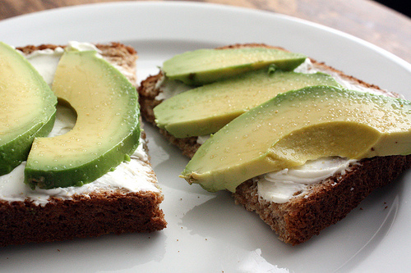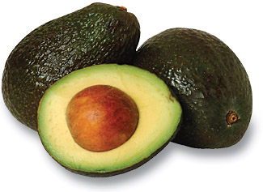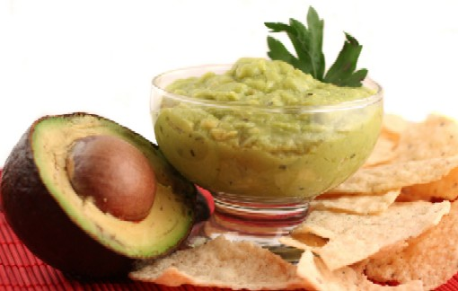

Picking and Storing an Avocado

An avocado is ripe and ready for immediate use when you can gently squeeze it in the palm of your hand.

Hass avocados will turn dark green or black as it ripens, but other varieties retain their light-green skin when ripe.

To speed up the ripening process, place the fruit in a plain brown bag and store at room temperature (usually 2-5 days).

*Include an apple or banana to speed it up even more!

Avocados turn brown within 6 hours after being cut open. If you are only using ¼ or ½ of the avocado, keep the pit in what’s remaining and use lemon or lime juice on it to preserve for another day and keep in air tight container. Wrapping in plastic wrap may help as well.

#### Avocados

A legend states that a courtier (an advisor of the king and queen) in Babylonia 5000 BC “discovered” wine formed from unattended grape juice, leading to the eventual discovery of vinegar and its use as a food preservative.

Some medical research shows that ingesting apple cider vinegar can help with acid reflux, lower blood pressure, improve diabetes and support some or small weight loss due to its ingredients: acetic acid, potassium, magnesium, probiotics, and enzymes.

***Eating avocados provides more benefits for you besides tasting good! An avocado is actually a fat even though it lands in the fruit food group. However, this type of monounsaturated fat is good for you!***

**Fun Facts:**

* Avocados are also known as Alligator Pears because of the leather like appearance of their dark green skins.
* They can vary in weight from 8 oz to 3 lbs depending on the variety.
* Today, the most popular variety is Hass. The mother tree of all Hass Avocados was born in the backyard in La Habra Heights, California.
* Some interesting ways of enjoying in avocado include adding it to your ice cream like Brazilians do or pureeing avocados with sugar and milk for a dessert drink like Filipinos might have.
* Health-conscious bakers can substitute avocado for many traditional baking ingredients including butter or shortening.

**Try this unique way of fitting avocados into your dessert:**

**June 19th Menu Item:**

**Avocado Chocolate Brownie**

This area can be used to give the reader clear instructions for the next steps that you hope they will take. It may be a number you want them to call, a Web site you want them to visit, or information you want them to fill out. Whatever the case, this information should be clear, brief and engaging enough to motivate the reader to make that small decision to move forward.

# Structuring Your Content

You have a nmber of alternatives for organizing the content of your brochure. You might choose to devote each column to a separate point or theme, such as quality and value. Remember, these points should tie in with your introductory text on the first page of the brochure.

# An Alternate Approach

On the other hand, you might want to organize your information as a continual stream of information broken up into smaller, “easy to chew” chunks. These smaller chunks can be separated by a descriptive subheading, like the one that begins this paragraph. If this is the approach you prefer, you can make use of linked text boxes, which allow text to flow from one column to the next.

A text box offers a flexible way of displaying text and graphics; it’s basically a container that you can resize and reposition. By linking a text box on one page with a text box on another, your article automatically flows from one page to another.

# Overview Headline

When readers open the brochure, this is the first text they will see, making this a good place to briefly but effectively summarize the products or services that you offer.

Make this text compelling and interesting so that readers will want to read the rest of the brochure. Be sure to keep the scope of this introduction narrow enough so that you can adequately cover the concepts you raise here in the limited space of the rest of the brochure.

Caption describing picture or graphic.