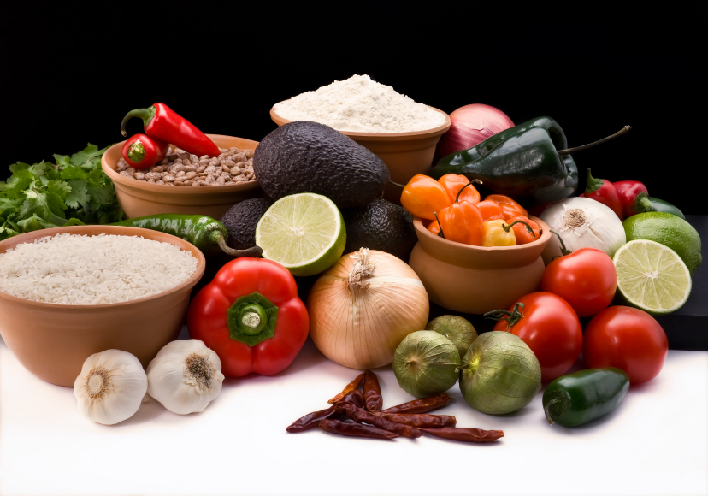
Recipe for: Healthy Avocado Brownies
1 large avocado½ cup coconut flour
½ cup unsweetened applesauce½ dutch-processed cocoa powder
½ cup maple syrup¼ tsp salt
1 tsp vanilla extract1 tsp baking soda
3 large eggs

Preheat oven to 350 degrees then blend avocado, applesauce, maple syrup, and vanilla put in a large bowl and whisk in eggs. Add coconut flour, cocoa powder, salt, and baking soda and stir until well-combined. Grease an 8x8 baking dish with coconut oil and add batter. Bake for 25 minutes (less for a more fudgy texture), cool for about 20 minutes. Makes about 16 servings. Keep them in an air-tight container at room-temperature up for to 2 days on the counter or in the fridge for a longer shelf-life.

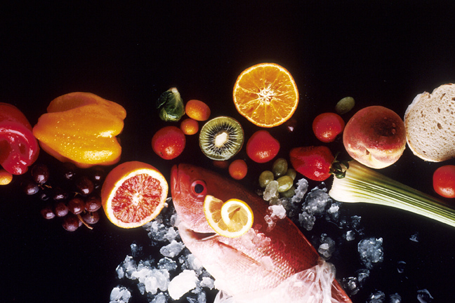
Recipe for: Avocado Melon Smoothie

1 large, ripe avocado
1 cup honeydew melon chunks (about 1 slice)
½ fresh lime, juiced (or 1 ½ tsp lime juice)
1 cup 8 oz skim or 1% milk
1 cup fat-free plain yogurt
½ cup 100% apple juice or white grape juice
1 Tbsp honey

Cut avocado in half, remove pit. Scoop our flesh, place in blender and add remaining ingredients, blend well. Serve cold. Keeps well in fridge up to 24 hours.

Recipe for: Bess’ Favorite Guacamole

2 ripe avocados, peeled and mashed
1 clove garlic, mashed
Juice of 1 lime
1-2 ripe Roma tomatoes, seeded & chopped
Up to 1 bunch green onions, finely chopped

Mix all ingredients together and serve with tortilla chips, use as a sandwich spread or in a taco/taco salad.

Recipe for: Pineapple Avocado Chicken Salad

1 avocado (divided)1 large red bell pepper (chopped)
2 Tbsp non-fat plain Greek yogurt½ cup shredded cabbage
1 Tbsp rice vinegar1 green onion, sliced
½ tsp salt2 cups cooked, cubed chicken breast (8 oz)
1/8 tsp black pepper4 – 6 ½ whole wheat pita pockets
1 cup fresh or canned (drained) pineapple chunks

Mash ½ avocado in a small dish, add yogurt, rice vinegar, salt and pepper to make dressing. Cut remaining avocado into small chunks and mix together with pineapple, bell pepper, carrots, cabbage, green onion, and chicken. Add dressing and mix gently. Fill pita pockets and serve.

