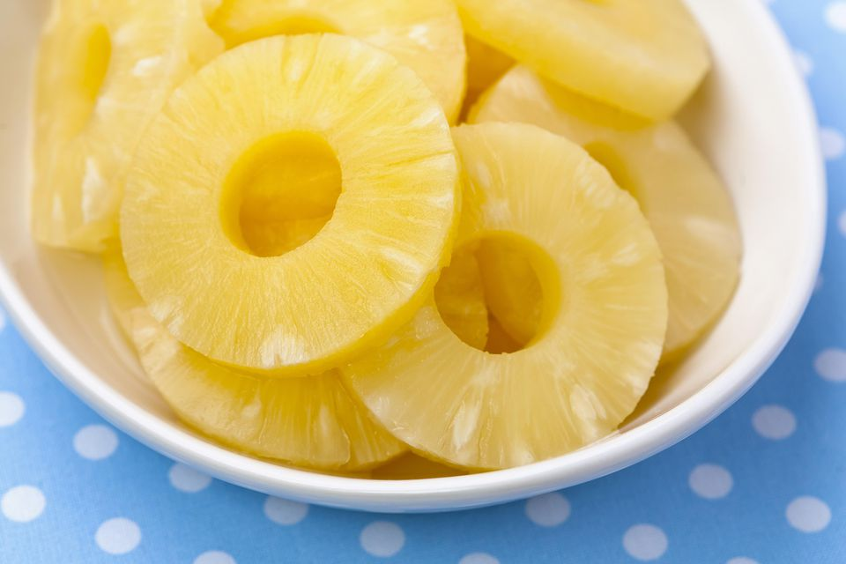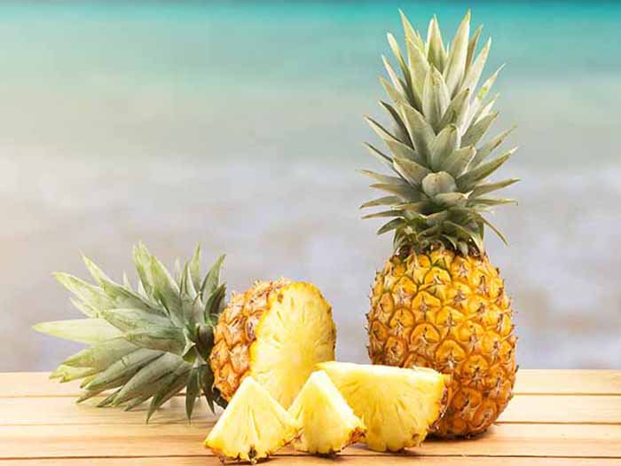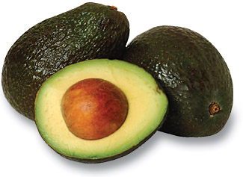

Picking and Storing Pineapple

Look for pineapples heavy in size. There are no quality differences between large and small pineapples.

Pineapples stop ripening as soon as they are picked, so choose one with a sweet fragrant at the stem of the fruit.

You can leave an uncut pineapple at room temperature up to 2 days, but they are very perishable, so after that make sure to refrigerate to prevent spoiling!

After the pineapple is cut, store it in the refrigerator in an airtight container. To keep it sweet and juicy add a liquid such as pineapple juice.

Freezing pineapple will greatly affect its flavor.

The golden color and sweet flavor of pineapple work wonderfully in both desserts and savory dishes. This fruit is very versatile and summer is the perfect time to dive into this tropical fruit!

Looking at getting your daily dose of Vitamin C? One cup of fresh pineapple contains 105% of what you need daily and only 83 calories, but 2 grams of fiber!

Pineapple is packed with the mineral Manganese and vitamin Thiamin (B1) which helps with the body’s energy production.

With being high in the enzyme, Bromelain, pineapple can help with inflammation, ulcerative colitis, pulmonary edema, muscle relaxation, slowing down blood clotting, prevent cancer, and help with arthritis.

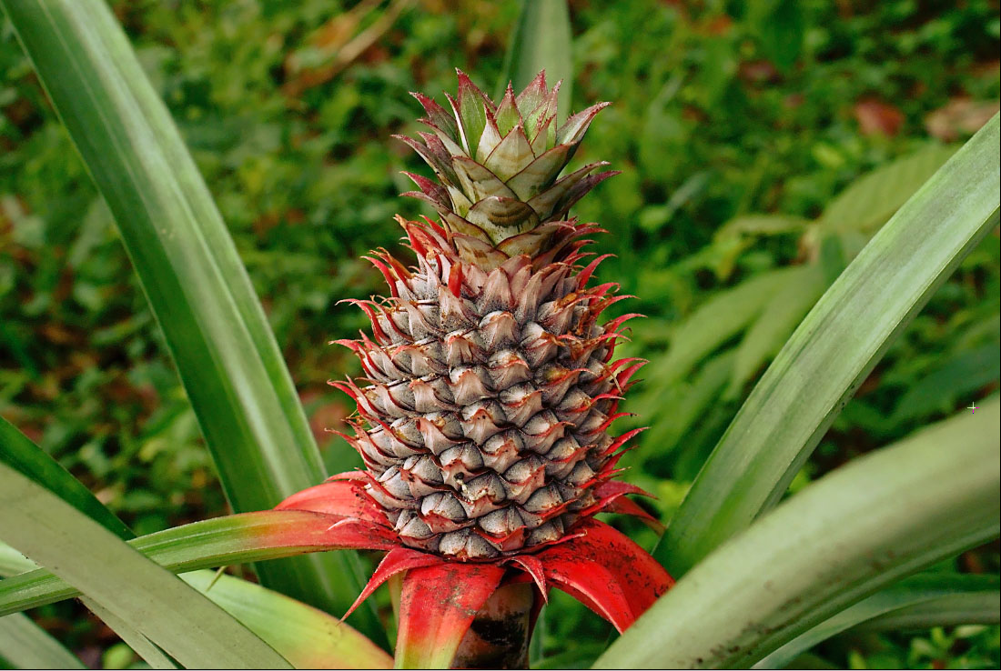

**Fun Facts:**

* After its cut, the nutrients will last up to 6 days – so enjoy it all week long!
* In the wild, pineapples are primarily pollinated by hummingbirds and some are pollinated by bats at night.
* Costa Rica, Brazil, and the Philippines account for 1/3 of world’s production of pineapples.
* When European explorers first encountered the fruit, they name it the pineapple because of the resemblance of the pine cone.
* The difference in the color of pineapples at the grocery store just depend on where they are grown, not how ripe they are, so a green one may be just as juicy as a golden brown one!
* When it drizzles on a sunny day in Hawaii, the locals call it “pineapple juice.”

#### Pineapple

# Structuring Your Content

You have a nmber of alternatives for organizing the content of your brochure. You might choose to devote each column to a separate point or theme, such as quality and value. Remember, these points should tie in with your introductory text on the first page of the brochure.

# An Alternate Approach

On the other hand, you might want to organize your information as a continual stream of information broken up into smaller, “easy to chew” chunks. These smaller chunks can be separated by a descriptive subheading, like the one that begins this paragraph. If this is the approach you prefer, you can make use of linked text boxes, which allow text to flow from one column to the next.

A text box offers a flexible way of displaying text and graphics; it’s basically a container that you can resize and reposition. By linking a text box on one page with a text box on another, your article automatically flows from one page to another.

# Overview Headline

When readers open the brochure, this is the first text they will see, making this a good place to briefly but effectively summarize the products or services that you offer.

Make this text compelling and interesting so that readers will want to read the rest of the brochure. Be sure to keep the scope of this introduction narrow enough so that you can adequately cover the concepts you raise here in the limited space of the rest of the brochure.

Caption describing picture or graphic.