**The Pineapple – Sweet, Juicy Goodness**

*July 2018*

1. **What is a Pineapple**
2. The Pineapple (*Ananas comosus)* is a tropical plant with edible multiple fruit consisting of coalesced berries, also known as pineapples. The name Ananas means “excellent fruit.”
3. In 2016, Costa Rica, Brazil, and the Philippines accounted for nearly 1/3 of the word’s production of pineapples.
4. 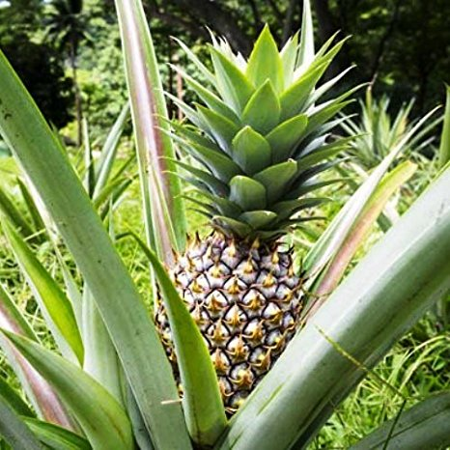The word “pineapple” in English first described the reproductive organs of conifer trees (now termed pine cones). Europeans explorers encountered this tropical fruit in American and name them pineapples – first referenced in 1664.
5. The pineapple plant is a herbaceous perennial and grows to 1 to 1.5 m tall.
6. They have a wide cylindrical shape, a scaly green, brown, or yellow skin, and regal crown of spiny, blue-green waxy leaves. The fibrous flesh of pineapple is yellow in color and has a sweet and tart flavor. The area closer to the base of the fruit has more sugar content and therefore a sweeter taste and more tender texture.
7. In the wild, pineapples are primarily pollinated by hummingbirds. Some are pollinated by bats at night.
8. **History of the Pineapple**
9. Although thought to have originated in South America, pineapples were first discovered by Europeans in 1493 on the Caribbean island that came to be known as Guadalupe.
   1. Columbus and other discovers tried to bring it back to Europe to cultivate the sweet, juicy fruit until it was discovered it needed a tropical climate to thrive.
10. Because they are very perishable, it was difficult to transport fresh pineapples from the Caribbean Islands to other parts of the world.
    1. Fresh pineapples were a rarity that became coveted by the early American Colonists.
    2. It was the fresh pineapple itself that became the sought after true symbol of prestige and social class.
    3. It became such a status item that all a party hostess had to do was display the fruit as part of decorative centerpiece and she would be awarded more than just a modicum of social awe and recognition.
11. It has said the pineapple first reached the America when the Spanish introduced it to Hawaii as early as the 1500s.
12. James Dole, moved to Hawaii in 1899 – he is one the most famous pineapple industrialists. He started a pineapple plantation in 1900.
13. The companies Dole and Del Monte began growing pineapples on the island of Oahu in 1901 and 1917. The Dole Food company grew widely after the acquisition of 60 acres of land in 1901 to grow pineapples.
14. Del Monte stopped its pineapple growing in Hawaii in 2008. By 2013, only the Dole Company on Oahu grew pineapples in a volume of about 0.1 percent of the world’s population.
15. Other countries that commercially grow pineapples include Thailand, the Philippines, China, Brazil, and Mexico.
16. **Nutrition & Health Benefits of Pineapple**
17. Vitamins and minerals highlights
18. Looking at getting your daily does of Vitamin C? One cup of fresh pineapple has about 105% of what you need daily an only about 83 calories and 2 grams of fiber. This would make an excellent dessert that’s nutritious and meets your sweet tooth!
    1. As a reminder, Vitamin C is the body’s primary water-soluble antioxidant that fights against free radicals which can lead to heart disease, diabetes, and cancer. Vitamin C is also vital for proper immune which makes it a go-to for cold and flu prevention.
19. Would you like to increase your energy? Pineapples are also high in the mineral manganese and the vitamin thiamin (vitamin B1). Manganese is used in the body to help produce energy and also plays a part in antioxidant defense. Thiamin also plays a role in central body energy production.
20. More Health Benefits
    1. Pineapples are high in the enzyme bromelain. This enzyme when used as a medicine, has been known to help with inflammation due to sinuses or injury, ulcerative colitis (bowel inflammation), pulmonary edema, muscle relaxation, slowing blood clotting, preventing cancer, and helping arthritis.
21. **Selection, Storage, Handling of Pineapple**
22. How to select the best pineapple
23. Look for pineapples that are heavy for their size. There are usually no quality differences between large and small pineapples.
24. They should be free of soft spots, bruises and darkened “eyes”
25. Since pineapples stop ripening as soon as they are picked, pick fruit with a fragrant, sweet smell at the stem end and avoid any that smell musty, sour, or fermented.
26. How to store a pineapple
27. Uncut pineapple can be left at room temperature for only one or two days before serving. This time can allow the pineapple to soften and become juicier. However, they are very perishable, so you should still watch them closely during this period so they don’t spoil!
    1. If after 2 days, you are still not ready to eat the pineapple, wrap it in a plastic bag and store it in the refrigerator where it will keep for a maximum of 3 to 5 more days.
28. After the pineapple is cut into, it should be stored in the refrigerator in an airtight container.
    1. A tip to keep the cut pineapple fresh and maintain its sweet taste – place some liquid, preferably the juice from the pineapple, in the container as well.
29. Freezing pineapple will greatly affect its flavor.
30. Handling Pineapples
    1. Pineapples can be cut and peeled in a variety of ways. Regardless of how you proceed, the very first step is always remove the crown and the base with a knife.
    2. To peel the pineapple, place it base side down and carefully slice off the skin, carving out any remaining “eyes” with the tip of your knife.
       1. You can also cut the pineapple into quarters, remove the core if desired, and make slices into the quarters cutting from the flesh towards the rind, and then use your knife to separate the fruit from the rind. Once the rind is removed, cut the pineapples into the desired shape and size.
    3. 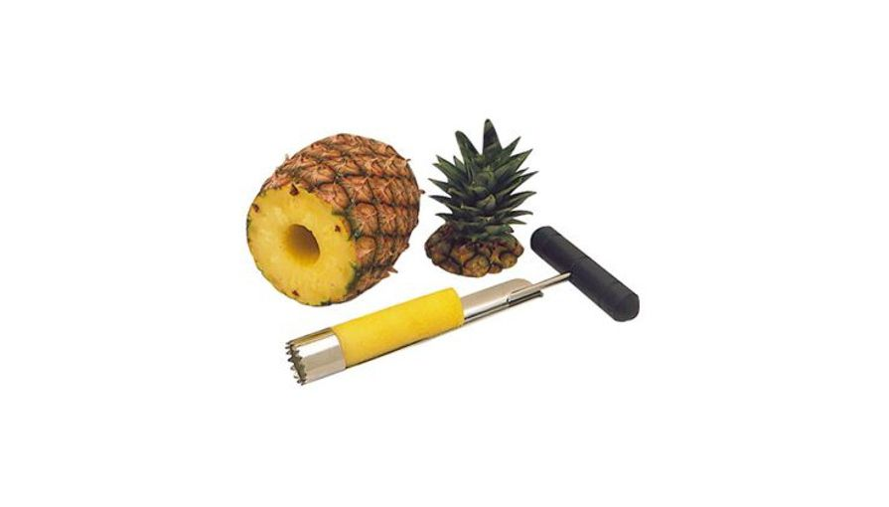Pineapple corers are also available to use and can be purchased at kitchen stores. (see picture) Even though they may be quick & convenient, they could result in a lot of wasted flesh of the pineapple.
    4. A study done by the Journal of Agriculture and Food Chemistry has found that minimal processing of fruit such as cutting, packaging, and chilling does not significantly affect its nutritional content – even up to 6 to 9 days! Pineapple showed only a 10% decrease in Vitamin C content after cutting it and storing it for 6 days. So you can feel better about doing your prep one day a week and the enjoy cut up fruit all week long and still receive great benefit!
    5. Pineapples are an excellent tenderizer for meats. The Bromelain enzyme found in pineapple help break down the proteins. This is why you can use pineapple in different meat dishes – such as Ham or Chicken!
31. Ways to Enjoy Pineapple
    1. Combine dined pineapple with chopped shrimp, grated ginger, and a little olive oil. Season to taste and serve this fragrant shrimp salad on a bed of romaine lettuce.
    2. Mix diced pineapple and chill peppers for an easy to prepare salsa – goes great with fish like halibut, tuna, or salmon!
    3. Drizzle maple syrup on pineapple slices and broil until brown…serve plain for with yogurt! Yum!
    4. Combine chopped pineapple, grated fennel, and cashews – a great side dish with chicken.
    5. It’s a wonderful addition to any fruit salad – a great pairing with papaya, kiwi, and mango.
32. **Pineapple Fun Facts**
33. It takes almost 3 years for a single pineapple to reach maturation which makes the price tag a bit more understandable.
34. When European explorers first encountered this fruit in America, they called them “pineapples” because of their resemblance to the pine cones.
35. Pineapple plants look like the tops of pineapples that are buried in the ground.
36. You could technically plant your own pineapple by cutting off the top and planting it in soil…..a giant pineapple however, will not grow underneath!
37. Baby pineapples are the most adorable fruit you’ve ever seen! ☺
38. Once pineapples are harvested, they don’t continue to ripen, so every single pineapple in the grocery store is as ripe as it will ever be so don’t just buy one and save it for a week thinking it will ripen.
39. The differences in color of pineapples in the stores just depend on where they are grown, not how ripe they are. So a green pineapple can be just as delicious as a golden brown one.
40. Besides fruit salads and tropical drinks, pineapples are also used to make wine…in Maui at least!
41. Have you ever tried making a Jack-O-Lantern out of a pineapple? Pretty scary!
42. When it drizzles on a sunny day in Hawaii, the locals call it “pineapple juice.”

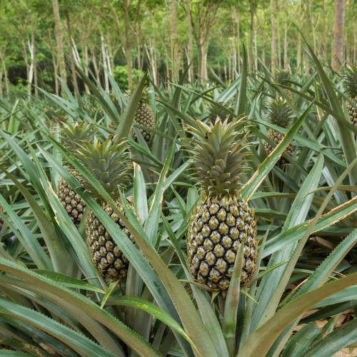**What a pineapple plant looks like:**