

The golden color and sweet flavor of pineapple work wonderfully in both desserts and savory dishes. This fruit is very versatile and summer is the perfect time to dive into this tropical fruit!

The golden color and sweet flavor of pineapple work wonderfully in both desserts and savory dishes. This fruit is very versatile and summer is the perfect time to dive into this tropical fruit!

#### Pineapple

#### Leaves

#### Pineapple

The golden color and sweet flavor of pineapple work wonderfully in both desserts and savory dishes. This fruit is very versatile and summer is the perfect time to dive into this tropical fruit!

* Looking at getting your daily dose of Vitamin C? One cup of fresh pineapple contains 105% of what you need daily and only 83 calories, but 2 grams of fiber!
* Pineapple is packed with the mineral Manganese and vitamin Thiamin (B1) which helps with the body’s energy production.
* With being high in the enzyme, Bromelain, pineapple can help with inflammation, ulcerative colitis, pulmonary edema, muscle relaxation, slowing down blood clotting, prevent cancer, and help with arthritis.

#### Pineapple



l Beneficial Bites

Bites

Bites

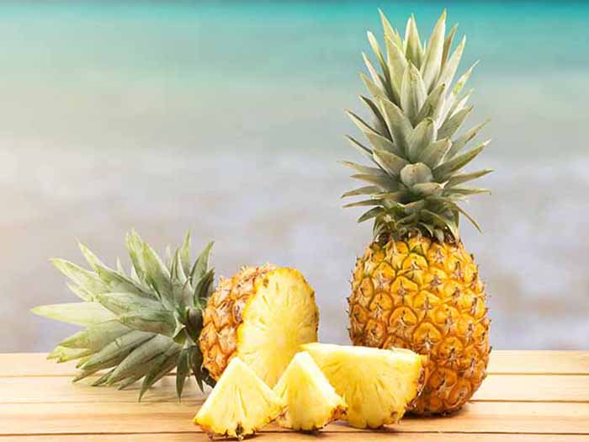

* Looking at getting your daily dose of Vitamin C? One cup of fresh pineapple contains 105% of what you need daily and only 83 calories, but 2 grams of fiber!
* Pineapple is packed with the mineral Manganese and vitamin Thiamin (B1) which helps with the body’s energy production.
* With being high in the enzyme, Bromelain, pineapple can help with inflammation, ulcerative colitis, pulmonary edema, muscle relaxation, slowing down blood clotting, prevent cancer, and help with arthritis.
* Looking at getting your daily dose of Vitamin C? One cup of fresh pineapple contains 105% of what you need daily and only 83 calories, but 2 grams of fiber!
* Pineapple is packed with the mineral Manganese and vitamin Thiamin (B1) which helps with the body’s energy production.
* With being high in the enzyme, Bromelain, pineapple can help with inflammation, ulcerative colitis, pulmonary edema, muscle relaxation, slowing down blood clotting, prevent cancer, and help with arthritis.

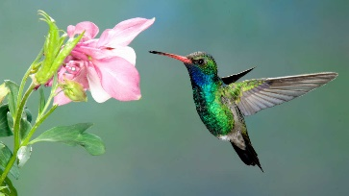

**Fun Facts:**

* After its cut, the nutrients will last up to 6 days – so it all week long!
* In the wild, pineapples are primarily pollinated by hummingbirds and some are pollinated by bats at night.
* Costa Rica, Brazil, and the Philippines account for 1/3 of world’s production of pineapples.
* When European explorers first encountered the fruit, they name it the pineapple because of the resemblance of the pine cone.
* The difference in the color of pineapples at the grocery store just depend on where they are grown, not how ripe they are, so a green one may be just as juicy as a golden brown one!
* When it drizzles on a sunny day in Hawaii, the locals call it “pineapple juice.”

**Fun Facts:**

* After its cut, the nutrients will last up to 6 days – so it all week long!
* In the wild, pineapples are primarily pollinated by hummingbirds and some are pollinated by bats at night.
* Costa Rica, Brazil, and the Philippines account for 1/3 of world’s production of pineapples.
* When European explorers first encountered the fruit, they name it the pineapple because of the resemblance of the pine cone.
* The difference in the color of pineapples at the grocery store just depend on where they are grown, not how ripe they are, so a green one may be just as juicy as a golden brown one!
* When it drizzles on a sunny day in Hawaii, the locals call it “pineapple juice.”

Taste It on July’s Menu!:

July 3rd Pineapple Whip Dessert

July 19th Hawaiian Pineapple Chicken

July 31st Pineapple Chunks

Taste It on July’s Menu!:

July 3rd Pineapple Whip Dessert

July 19th Hawaiian Pineapple Chicken

July 31st Pineapple Chunks

**Fun Facts:**

* After its cut, the nutrients will last up to 6 days – so it all week long!
* In the wild, pineapples are primarily pollinated by hummingbirds and some are pollinated by bats at night.
* Costa Rica, Brazil, and the Philippines account for 1/3 of world’s production of pineapples.
* When European explorers first encountered the fruit, they name it the pineapple because of the resemblance of the pine cone.
* The difference in the color of pineapples at the grocery store just depend on where they are grown, not how ripe they are, so a green one may be just as juicy as a golden brown one!
* When it drizzles on a sunny day in Hawaii, the locals call it “pineapple juice.”

Taste It on July’s Menu!:

July 3rd Pineapple Whip Dessert

July 19th Hawaiian Pineapple Chicken

July 31st Pineapple Chunks