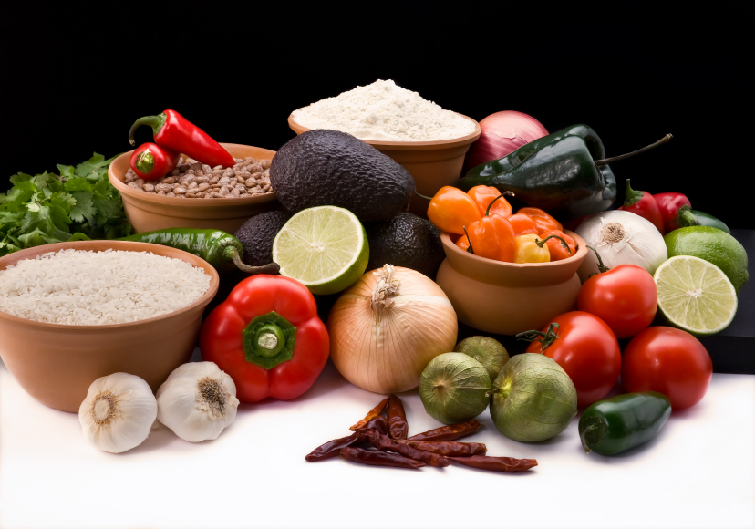
Recipe for: Crunchy Hawaiian Chicken Wrap
¼ cup light Mayo1 ½ tsp onion powder
1/8 cup white vinegar1 ½ tsp chili powder
¼ cup sugar2 cups fresh broccoli, shredded1 cup fresh spinach
1 tsp poppy seeds1 ½ cups fresh carrots, peeled, shredded3 cups cooked chicken
1 ½ tsp garlic powder¼ cup canned, crushed pineapple6 whole wheat tortillas

In a small mixing bowl, combine mayo, vinegar, sugar, poppy seeds, garlic powder, onion powder, and chili powder for the dressing. Mix well. Cover and refrigerate.
Combine broccoli, carrots, pineapple, and spinach is a large bowl. Stir in dressing and chicken. Mix well. Serve immediately or cover and refrigerate.
For each wrap, place 2/3 cup filling on the bottom half of the tortilla and roll in the form of a burrito. Please seam side down. Cut diagonally. Serve immediately.

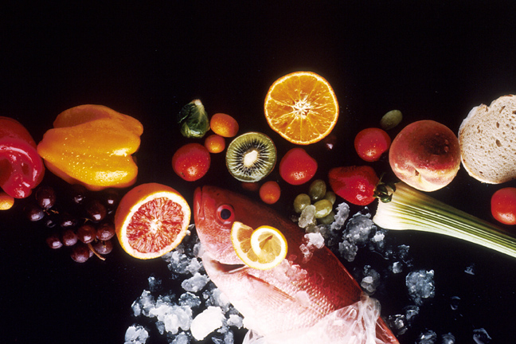
Recipe for: Fresh Pineapple Slaw

½ cup greek plain yogurt2 tsp apple cider vinegar
2 Tbsp pineapple juicezest of 1 lime
1 Tbsp brown sugar1 bag coleslaw mix (cabbage and carrots)
1 Tbsp lime juice1 cup fresh pineapple diced
¼ cup green onion, chopped2 Tbsp fresh cilantro

Combine yogurt, pineapple juice, brown sugar, lime juice, vinegar, and salt and pepper to taste in a small bowl, whisking vigorously until completely combined. In a large bowl combine coleslaw mix, pineapple, cilantro, and green onion. Pour yogurt base over vegetables and gently toss to coat. Cover and refrigerate at least one hour before serving.
*Pair with pork or fish tacos!

Recipe for: Skinny Pineapple Cheesecake Bars
For the Filling:
6 oz brick-style light cream cheese, softened1 tsp vanilla extract
¾ cup plain nonfat Greek Yogurt, room tempPineapple/cherries (optional)
2 large eggs, plus 1 large egg yolkFor the Crust:
¼ cup sugar¾ cup graham cracker crumbs
1/3 cup pineapple juice2 Tbsp butter, melted

Preheat oven to 300 degrees. Line bottom of 9x9 pan with parchment paper. Set aside
Make crust: Mix crust ingredients in a medium bowl until combined, then evenly press mixture into prepared baking pan and bake for 8 minutes and set aside.
Make filling: Beat cream cheese and high until smooth, beat in yogurt until completely combined then add eggs. Beat in sugar, pineapple juice, and vanilla until no lumps
Pour filling onto crust, bake for about 30 min, cool, and refrigerate at least 4 hours. Garnish with pineapple and cherries if desired.

Recipe for: Pineapple Upside Down Fudge

1 (14 oz) can sweetened condensed milk
½ cup yellow cake mix
2 ½ cup white chocolate chips
½ cup chopped canned pineapple, drained, patted dry
16 maraschino cherries, stems removed

Line 8x8 baking dish with parchment paper and spray with nonstick cooking spray. Pour sweetened condensed milk and cake mix into a large bowl, stirring to combine.
Add white chocolate chips, then microwave in 1 minute intervals, stirring in between, until fully melted. Fold in pineapple and pour into prepared baking dish.
Place cherries on top of fudge and place in the refrigerator to harden about 2 hours. Cut into squares and serve.

