

Beneficial Bites

* Hulled Barley- the kernels are minimally processed to remove only the tough inedible outer hull. It may be purchased in kernels, cut, and ground.
* Barley is the highest in fiber out of all the whole grains, with common varieties:
  + Barley: 17 % fiber
  + Brown rice: 3.5 % fiber
  + Corn: 7 % fiber
  + Oats: 10 % fiber
  + Wheat: 12 % fiber
* Barley originated in Ethiopia and Southeast Asia, where it has been cultivated for more than 10,000 years.
* Barley was used by ancient civilizations as a food for humans and animals, as well as to make alcoholic beverages; the first known recipe for barley wine dates back to 2800 BC in Babylonia.

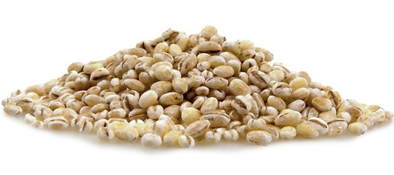

*Barley is a versatile cereal grain with a rich nut-like flavor and a chewy pasta-like texture. Specific types of barley are considered whole grain;*

#### Barley

**Suggestions for Use:**

* Barley Pilaf
* Barley Bread
* Barley Porridge for breakfast
* Add to soups
* Barley flour to make cookies
* Make a large batch, freeze or refrigerate for later use to save time.
* Mix barley flour with wheat flour to make breads and muffins that have a uniquely sweet and earthy taste.

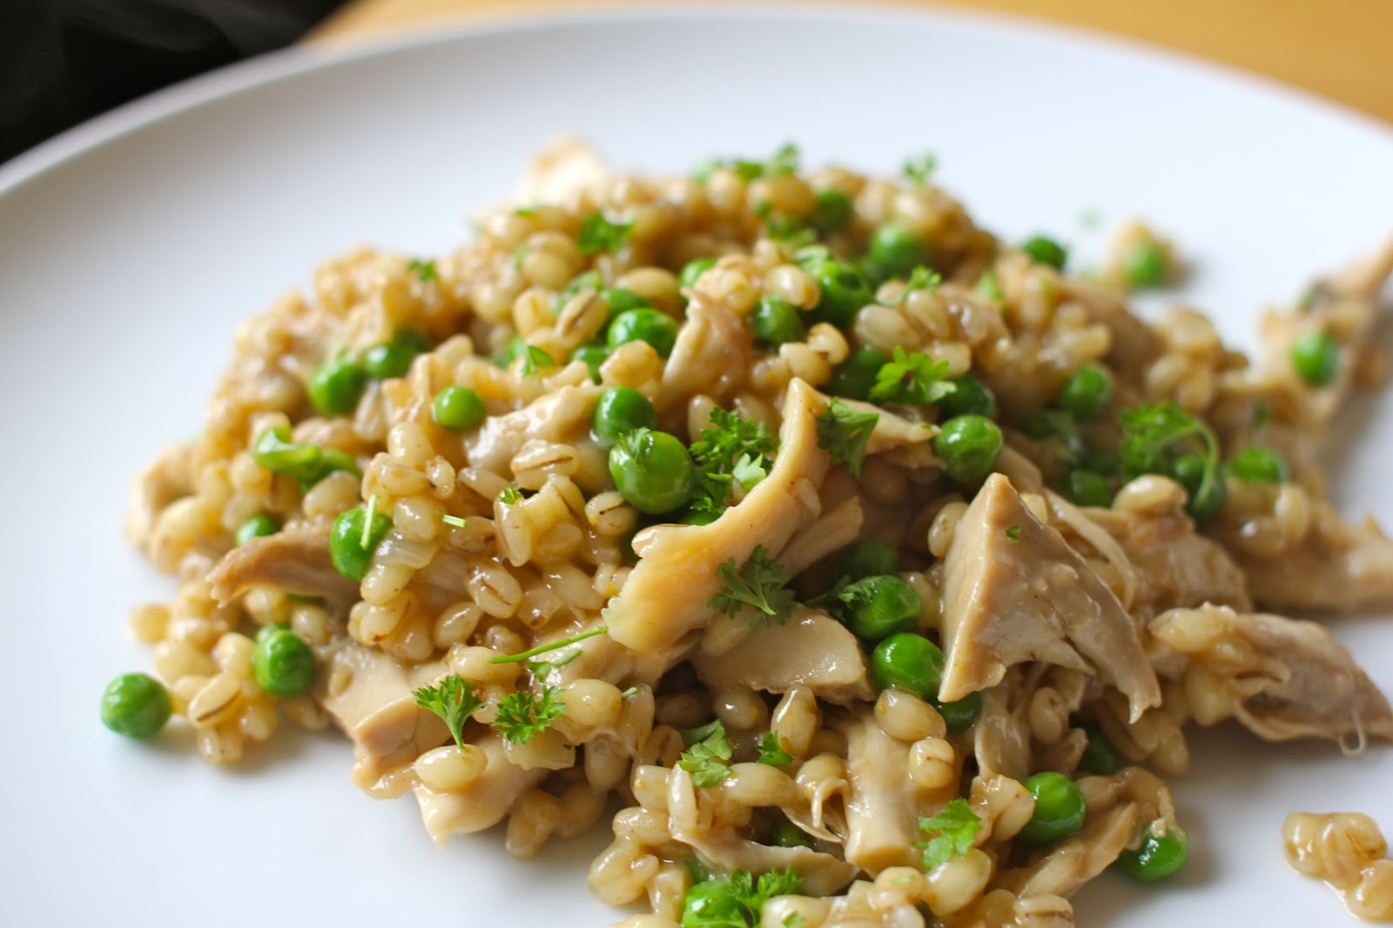

**Keep in Mind:**

* Before cooking barley, rinse it thoroughly and remove any dirt or debris that you may find. After rinsing, add one part barley to three and a half parts boiling water or broth. After the liquid has returned to a boil, turn down the heat, cover and simmer

Fun Facts about Barley:

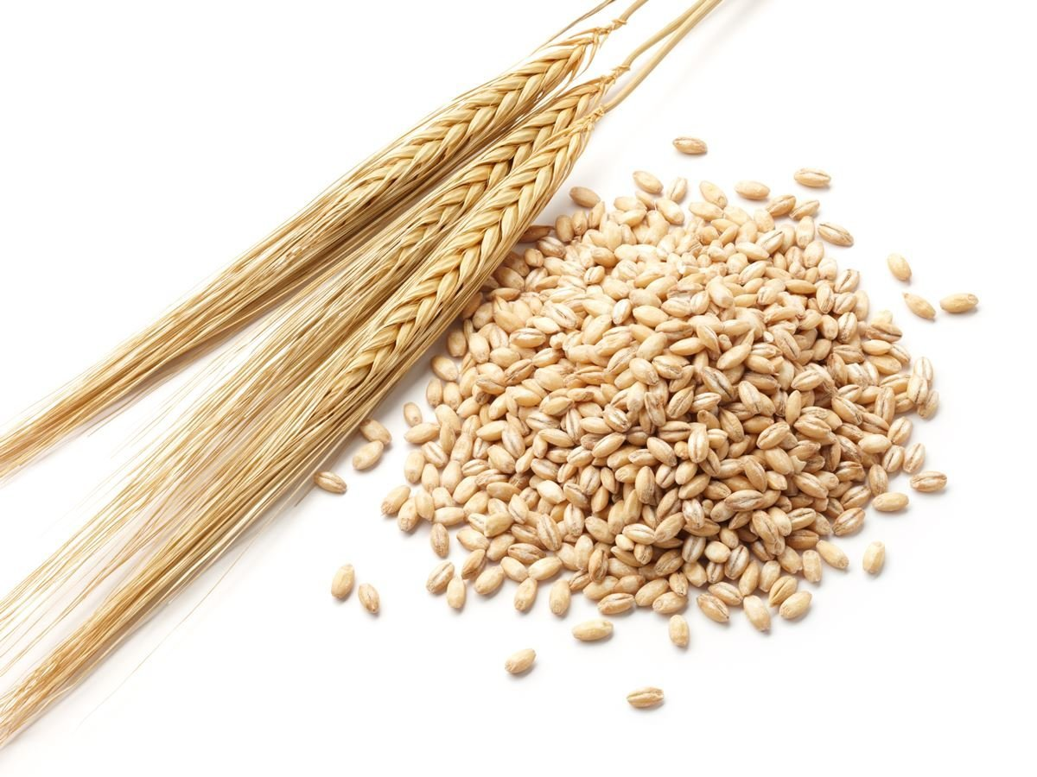

* 99% of the barley grown in the United States will never make it into your soup! Instead, barley is refined to make barley malt- a key ingredient in beer. It is also used as food for livestock.
* Barley is a highly-adaptable crop, growing in places as disparate as north of the Arctic Circle, in tropical Ethiopia, and at high altitudes in the Andes mountains of South America. Barley is the world’s fourth most important cereal crop after wheat, rice, and corn.
* Today, the largest commercial producers of barley are Canada, the United States, the Russian Federation, Germany, France and Spain.

Sailboat

This area can be used to give the reader clear instructions for the next steps that you hope they will take. It may be a number you want them to call, a Web site you want them to visit, or information you want them to fill out. Whatever the case, this information should be clear, brief and engaging enough to motivate the reader to make that small decision to move forward.

# Structuring Your Content

You have a nmber of alternatives for organizing the content of your brochure. You might choose to devote each column to a separate point or theme, such as quality and value. Remember, these points should tie in with your introductory text on the first page of the brochure.

# An Alternate Approach

On the other hand, you might want to organize your information as a continual stream of information broken up into smaller, “easy to chew” chunks. These smaller chunks can be separated by a descriptive subheading, like the one that begins this paragraph. If this is the approach you prefer, you can make use of linked text boxes, which allow text to flow from one column to the next.

A text box offers a flexible way of displaying text and graphics; it’s basically a container that you can resize and reposition. By linking a text box on one page with a text box on another, your article automatically flows from one page to another.

# Overview Headline

When readers open the brochure, this is the first text they will see, making this a good place to briefly but effectively summarize the products or services that you offer.

Make this text compelling and interesting so that readers will want to read the rest of the brochure. Be sure to keep the scope of this introduction narrow enough so that you can adequately cover the concepts you raise here in the limited space of the rest of the brochure.

Caption describing picture or graphic.