

Beneficial Bites

* The bay leaf is native to the Mediterranean countries.
* Bay Laurel can be a small tree or it can grow up to 60 feet tall in parts of Greece.
* Bay Leaves contain vitamins A and C. In addition it also contains magnesium, calcium, potassium, iron and antioxidants.
* Some studies show that the topical use of bay leaf can help alleviate inflammation and pain from arthritis. The bay leaves contains a phytonutrient called parthenolide which helps aid pain.
* Despite popular belief, bay leaves are not poisonous. It is important to remove them from the food because they are a choking hazard due to their tough texture.

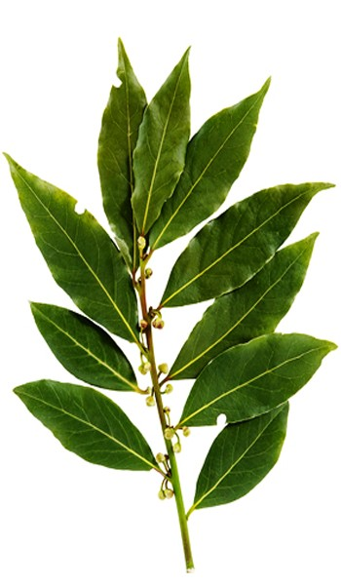

*Bay leaves have an herbal aromatic scent with a hint of floral. Bay leaves taste bitter and pungent on its own but compliments other foods well. The leaves are usually dried and simmered with food to give it flavor.*

#### Bay Leaves

Suggestions for Use:

* Soups
* Tea
* Roast
* Fish
* Pasta dishes
* Place Bay Leaf into the sauce or broth and let simmer. Don’t forget to remove the leaf before serving.
* ¼ TSP crushed bay leaf= 1 whole bay leaf

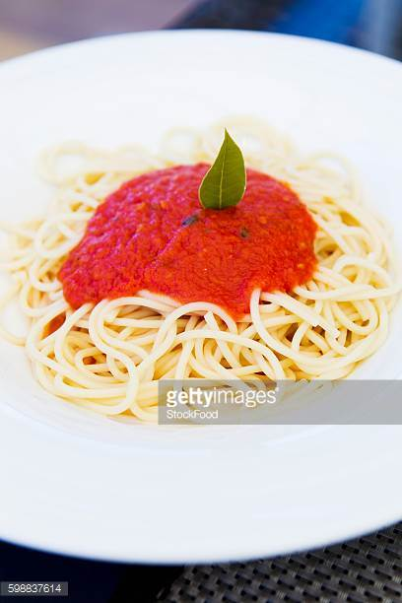

**Keep in Mind:**

* Dried bay leaves have a storage life of a year or more as long as they are stored in an airtight container.
* The freezer is the best place to store bay leaves in order to retain its flavor and aroma.

Fun Facts:

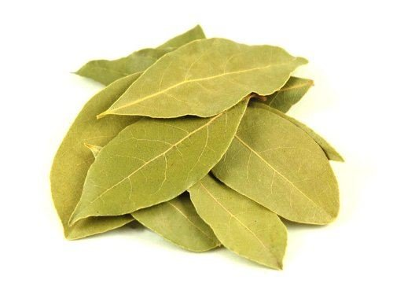

* Bay leaves have been used since ancient Roman times, to symbolize victory and greatness, it was used to crown emperors, and champions in the Olympic Games.
* The term Baccalaureate and Bachelor for academic degrees is derived from Baccalaures, because of the ancient Greek and Roman practice of honoring scholars and poets with garlands of bay branches. Roman Generals were crowned with bay leaves when they returned from victorious battles.
* Bay leaves have been used as a cockroach deterrent. Place whole leaves behind appliances, near entry points, in pantries and other corners of the home. A bay leaf can be burned in the home to give off a nice natural smell while providing extra cockroach protection.

Sailboat

This area can be used to give the reader clear instructions for the next steps that you hope they will take. It may be a number you want them to call, a Web site you want them to visit, or information you want them to fill out. Whatever the case, this information should be clear, brief and engaging enough to motivate the reader to make that small decision to move forward.

# Structuring Your Content

You have a nmber of alternatives for organizing the content of your brochure. You might choose to devote each column to a separate point or theme, such as quality and value. Remember, these points should tie in with your introductory text on the first page of the brochure.

# An Alternate Approach

On the other hand, you might want to organize your information as a continual stream of information broken up into smaller, “easy to chew” chunks. These smaller chunks can be separated by a descriptive subheading, like the one that begins this paragraph. If this is the approach you prefer, you can make use of linked text boxes, which allow text to flow from one column to the next.

A text box offers a flexible way of displaying text and graphics; it’s basically a container that you can resize and reposition. By linking a text box on one page with a text box on another, your article automatically flows from one page to another.

# Overview Headline

When readers open the brochure, this is the first text they will see, making this a good place to briefly but effectively summarize the products or services that you offer.

Make this text compelling and interesting so that readers will want to read the rest of the brochure. Be sure to keep the scope of this introduction narrow enough so that you can adequately cover the concepts you raise here in the limited space of the rest of the brochure.

Caption describing picture or graphic.