**Recipe for:** Bay Leaf Mashed Potatoes

3 pounds russet potatoes, peeled and quartered 1/4 TSP white pepper

2 Bay Leaves 2/3 Cup hot milk

1 TSP salt 1/4 cup stick butter cut into chunks

Place potatoes and bay leaves in 4- quart saucepan. Add water to cover. Bring to boil.

Reduce heat to low; cover and simmer 15 to 20 min. or until potatoes are fork tender.

Drain and return potatoes to pan. *Remove bay leaves*, add salt and white pepper. Mash with potato mashers, gradually adding milk, then butter. Serve immediately.



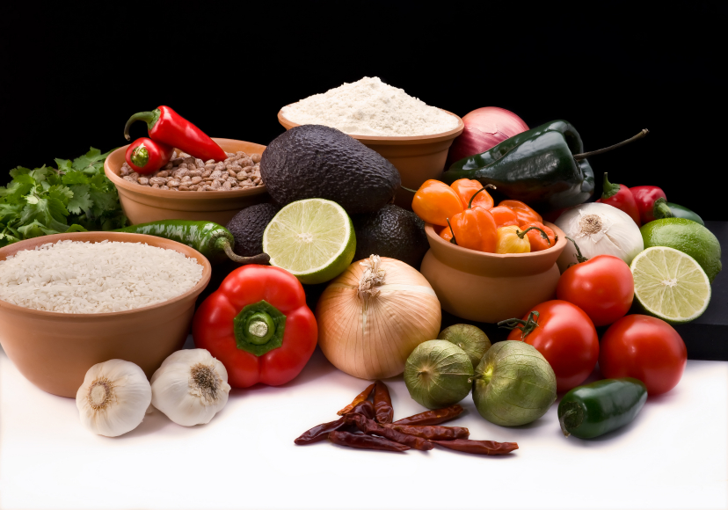

**Recipe for:** Onion and Bay Leaf Rice

2 TBSP Butter 2 TBSP finely minced onion

1Ssmall garlic clove, finely minced 1 ½ cups rice

2 1/4 cups chicken broth 1 Bay leaf

Melt 1 TBSP of the butter in a saucepan, and add the onion and garlic. Cook, stirring, until the onion is yellow. Add the rice, and stir to coat the grains.

Add the broth and bay leaf.

Bring to a boil and cover. Cook for 15-20 minutes. Remove the bay leaf, and stir in the remaining 1 TBSP of butter.





**Recipe for: Chicken Noodle Soup**

8 cups of water or chicken broth 4-6 ounces of Egg Noodles

1/2 pound of skinless boneless chicken Black Pepper to taste

1 Small Onion- peeled and halved 2-3 Bay leaves

1/8 cup of chicken bouillon powder 1/3 bunch of celery, 1 cup carrots

Place chicken and water in a large pot over high heat and bring to a boil. Reduce heat, cover and simmer, about 30 minutes. Place the halved onion, bay leaves, pepper, whole celery, whole carrots in to the pot and simmer, covered 1 hour. Strain broth and remove vegetables and chicken. Place broth back into pan. Discard bay leaves. When chicken is cool enough cut into bite-size pieces, chop celery and carrots and add back into pot. Add the chicken bouillon. Cover and simmer for 20 minutes. Add the egg noodles and simmer until noodles are cooked. Heat to desired temperature and enjoy.





**Recipe for: Bay Leaf Tea**

4-5 Dried Bay Leaves 1 Cinnamon Stick

1 Liter of Water

Add 1 liter of water to a pot. Add bay leaves and cinnamon stick to the water. Add heat, simmer for 20 minutes and enjoy. Be sure to remove the bay leaves and cinnamon stick before adding to a coffee cup to enjoy.



