



Beneficial Bites

* The bay leaf is native to the Mediterranean countries.
* Bay Laurel can be a small tree or it can grow up to 60 feet tall in parts of Greece.
* Bay Leaves contain vitamins A and C. In addition it also contains magnesium, calcium, potassium, iron and antioxidants.
* Some studies show that the topical use of bay leaf can help alleviate inflammation and pain from arthritis. The bay leaves contains a phytonutrient called parthenolide which helps aid pain.

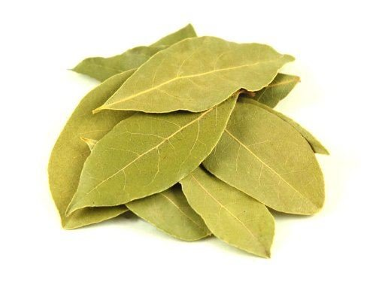

*Bay leaves have an herbal aromatic scent with a hint of floral. Bay leaves taste bitter and pungent on its own but compliments other foods well. The leaves are usually dried and simmered with food to give it flavor.*



Beneficial Bites

* The bay leaf is native to the Mediterranean countries.
* Bay Laurel can be a small tree or it can grow up to 60 feet tall in parts of Greece.
* Bay Leaves contain vitamins A and C. In addition it also contains magnesium, calcium, potassium, iron and antioxidants.
* Some studies show that the topical use of bay leaf can help alleviate inflammation and pain from arthritis. The bay leaves contains a phytonutrient called parthenolide which helps aid pain.





l Beneficial Bites

Bites

Bites

* The bay leaf is native to the Mediterranean countries.
* Bay Laurel can be a small tree or it can grow up to 60 feet tall in parts of Greece.
* Bay Leaves contain vitamins A and C. In addition it also contains magnesium, calcium, potassium, iron and antioxidants.
* Some studies show that the topical use of bay leaf can help alleviate inflammation and pain from arthritis. The bay leaves contains a phytonutrient called parthenolide which helps aid pain.



Beneficial Bites

#### Bay Leaves

#### Bay Leaves

#### Bay Leaves

*Bay leaves have an herbal aromatic scent with a hint of floral. Bay leaves taste bitter and pungent on its own but compliments other foods well. The leaves are usually dried and simmered with food to give it flavor.*

*Bay leaves have an herbal aromatic scent with a hint of floral. Bay leaves taste bitter and pungent on its own but compliments other foods well. The leaves are usually dried and simmered with food to give it flavor.*

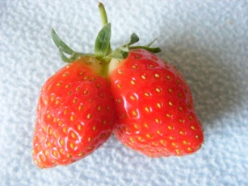



Beneficial Bites

**Fun Facts:**

* Bay leaves have been used since ancient Roman times, to symbolize victory and greatness, it was used to crown emperors, and champions in the Olympic Games.
* The term Baccalaureate and Bachelor for academic degrees is derived from Baccalaures, because of the ancient Greek and Roman practice of honoring scholars and poets with garlands of bay branches. Roman Generals were crowned with bay leaves when they returned from victorious battles.
* Bay leaves have been used as a cockroach deterrent. Place whole leaves behind appliances, near entry points, in pantries and other corners of the home. A bay leaf can be burned in the home to give off a nice natural smell while providing extra cockroach protection.
* Despite popular belief, bay leaves are not poisonous. It is important to remove them from the food because they are a choking hazard due to their tough texture.

**February Menu Items**

Spaghetti with Bay Leaf Sauce

Chicken Dumpling Soup

with Bay Leaf

**Fun Facts:**

* Bay leaves have been used since ancient Roman times, to symbolize victory and greatness, it was used to crown emperors, and champions in the Olympic Games.
* The term Baccalaureate and Bachelor for academic degrees is derived from Baccalaures, because of the ancient Greek and Roman practice of honoring scholars and poets with garlands of bay branches. Roman Generals were crowned with bay leaves when they returned from victorious battles.
* Bay leaves have been used as a cockroach deterrent. Place whole leaves behind appliances, near entry points, in pantries and other corners of the home. A bay leaf can be burned in the home to give off a nice natural smell while providing extra cockroach protection.
* Despite popular belief, bay leaves are not poisonous. It is important to remove them from the food because they are a choking hazard due to their tough texture.

**February Menu Items**

Spaghetti with Bay Leaf Sauce

Chicken Dumpling Soup

with Bay Leaf

**Fun Facts:**

* Bay leaves have been used since ancient Roman times, to symbolize victory and greatness, it was used to crown emperors, and champions in the Olympic Games.
* The term Baccalaureate and Bachelor for academic degrees is derived from Baccalaures, because of the ancient Greek and Roman practice of honoring scholars and poets with garlands of bay branches. Roman Generals were crowned with bay leaves when they returned from victorious battles.
* Bay leaves have been used as a cockroach deterrent. Place whole leaves behind appliances, near entry points, in pantries and other corners of the home. A bay leaf can be burned in the home to give off a nice natural smell while providing extra cockroach protection.
* Despite popular belief, bay leaves are not poisonous. It is important to remove them from the food because they are a choking hazard due to their tough texture.

**February Menu Items**

Spaghetti with Bay Leaf Sauce

Chicken Dumpling Soup

with Bay Leaf



Beneficial Bites



Beneficial Bites