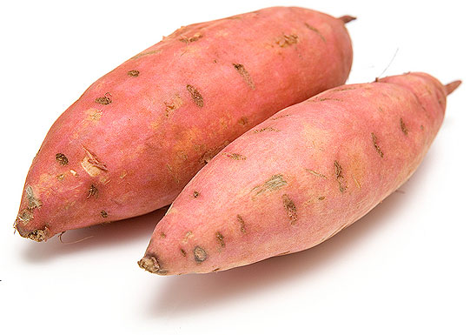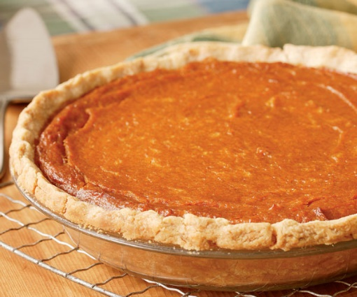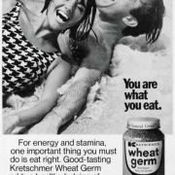 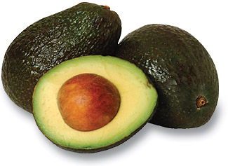

**Sweet Nutrition Facts:**

Sweet potatoes provide many beneficial nutrients such as vitamin A, vitamin C, manganese, copper, pantothenic acid, and vitamin B6. Vitamin A promotes good eye health and vision. Vitamin C supports the immune system and repairs tissues in our bones and teeth.

The orange-fleshy color provides many antioxidants protecting the body against heart disease, cancer, arthritis, diabetes, cataracts and macular degenerations, Alzheimer’s, Parkinson’s, and others. They also help with inflammation and successful blood clotting. The complex carbohydrates and high dietary fiber make them a great source of carbohydrates for people with diabetes.

One cup of sweet potatoes has 180 calories, no fat, 4 grams protein, 41 grams carbohydrate, and 7 grams of fiber.

**What are Sweet Potatoes?**

Researchers believe the word potato originated from the Incans calling sweet potatoes “batata.” They originated from Central or South America and come in a variety of colors: yellow, orange, red, brown, purple, and beige.

Sweet potatoes may be mistaken as yams, although they are very different. Yams are larger, have white flesh, and have more starch.

Sweet potatoes are started from slips and are planted in hills and the plant roots become potatoes and grow underground. Did you know you can eat the leaves of the plant as well?

They are called sweet potato greens and have more nutrients and fiber than spinach.

As the sweet potato plant grows, the starch is converted to sugar, making them a great addition to desserts or savory dishes.

*December, 2018*

**Sweet Potato History:**

Sweet potatoes have a long history dating back to 1492 during Christopher Columbus’ first voyage. He brought sweet potatoes back to Europe.   
During the 16th Century, they were known to comfort, strengthen, and nourish the body. In 1880, Americans started seeing candied sweet potatoes in popular cookbooks.

#### Sweet Potato

# Structuring Your Content

You have a nmber of alternatives for organizing the content of your brochure. You might choose to devote each column to a separate point or theme, such as quality and value. Remember, these points should tie in with your introductory text on the first page of the brochure.

# An Alternate Approach

On the other hand, you might want to organize your information as a continual stream of information broken up into smaller, “easy to chew” chunks. These smaller chunks can be separated by a descriptive subheading, like the one that begins this paragraph. If this is the approach you prefer, you can make use of linked text boxes, which allow text to flow from one column to the next.

A text box offers a flexible way of displaying text and graphics; it’s basically a container that you can resize and reposition. By linking a text box on one page with a text box on another, your article automatically flows from one page to another.

# Overview Headline

When readers open the brochure, this is the first text they will see, making this a good place to briefly but effectively summarize the products or services that you offer.

Make this text compelling and interesting so that readers will want to read the rest of the brochure. Be sure to keep the scope of this introduction narrow enough so that you can adequately cover the concepts you raise here in the limited space of the rest of the brochure.

Caption describing picture or graphic.