**Sweet, Sweet, Sweet Potatoes**

*December, 2018*

1. **What are sweet potatoes**
2. The botanical name for sweet potato is Ipomoea Batatas and is a root vegetable growing underground. They are members of the morning glory family. Sweet potatoes originated from Central or South America. Sweet potatoes come in a variety of colors: yellow, orange, red, brown, purple, and beige. **Show picture of sweet potato plant with variety of colors.**
3. Why are sweet potatoes actually sweet? As the plant grows, an enzyme converts starch into sugar.
4. You may have heard the orange fleshy potatoes being called yams. The orange- fleshy potatoes you see in the grocery stores are actually sweet potatoes, as yams are the starchy edible root of a plant imported to American from the Caribbean. Yams are low in beta-carotene, which is the orange fleshy color.
   1. Yams are larger and can weigh up to 120 pounds and measure 2 meters long.
   2. When you are looking in the grocery store, the orange-flesh potatoes are most likely sweet potatoes, not yams.
   3. If you are looking for a true yam, you may need to visit a grocery store offering international foods from tropical countries.
   4. 80 million tons of sweet potatoes are grown in China per year, 14 million tons in Africa, 2 million from Central and South America, and 1 million tons in the U.S. These are mostly from the Southern states such as North Carolina.
5. Sweet potato plants are started from slips which are sprouts from a potato. They are planted in hills and the plants vine out as the potatoes grow underground. The leaves are heart-shaped. They are done growing when the leaves dry out and can be left in the ground up until the first fall frost.
   1. The leaves and tender shoots are also edible, called sweet potato greens. They have more nutrients and fiber than spinach.

**Show picture of sweet potato shoot beginning to root and sweet potato farm.**

**\*\* Has anyone grown sweet potatoes?**

1. Sweet potatoes taste sweeter than white potatoes and can be used in desserts such as sweet potato pie or in savory dishes such as roasted or mashed sweet potatoes.
   1. You can boil, roast, bake, microwave, or grill sweet potatoes to add more nutrition to your meal.

**\*\* Who has tried sweet potatoes in either a sweet or savory dish?**

1. **History of Sweet Potatoes**
   1. Sweet potatoes have a sweet, rich history in the world. It is predicted sweet potatoes were discovered before the Irish potato. It was not growing wild like corn and has been cultivated by the Incan and pre-Incan for thousands of years. In Latin American countries, sweet potatoes are called camote, and Incans called it batata, which is the origin of potato.
   2. After Christopher Columbus’s first voyage to the Amercias in 1492, he brought sweet potatoes back home to Europe. It is one of the oldest vegetables known to mankind.
   3. They became very popular in England during the 16th Century, as they comfort, strengthen, and nourish the body.
   4. In 1880, Americans started seeing candied sweet potatoes in popular cookbooks.
2. **Nutrition & Health Benefits of Sweet potatoes**
3. Not only are sweet potatoes sweet in your dessert, they also provide many health benefits. They contain antioxidants, anti-inflammatory nutrients, and can help regulate blood sugar.
   1. Vitamin A promotes good eye health and vision as well as the immune system.
   2. Vitamin C helps grow and repair tissues such as skin, tendons, ligaments, and blood vessels as well as bones and teeth.
   3. Manganese helps with fat and carbohydrate breakdown in the body as well as maintain blood sugar and builds strong bones.
   4. Copper helps your body make red blood cells which carry oxygen throughout your body, as well as building strong bones.
   5. Pantothenic Acid is used in many reactions in your body as food is used for energy.
   6. Vitamin B6 helps the body make antibodies which help deter diseases. It also helps distribute oxygen throughout the body via red blood cells.
4. 1 cup of sweet potatoes has 180 calories, no fat, 4 grams protein, 41 grams carbohydrate, and 7 grams of fiber.
   1. The calories are mostly due to the starch content but are complex carbohydrates and are nutritious for people with diabetes.
   2. Of course, the nutrition information depends on the toppings and dish the sweet potato is used in.

**Show picture of sweet potato pie**

1. The orange flesh of sweet potatoes provides us with many antioxidants. They are more concentrated in the potato skin. Antioxidants help protect the body against heart disease, cancer, arthritis, diabetes, cataracts and macular degenerations, Alzheimer’s, Parkinson’s, and others.
2. The color also helps with inflammation and successful blood clotting. It is important to have three proteins in the blood to prevent blood loss but too much can cause unwanted blood clotting.
3. Sweet potatoes may actually improve blood glucose levels and maintenance. The matrix of complex carbohydrates and high dietary fiber can help stabilize blood glucose.
4. According to Mayo Clinic, people with a history of kidney stones may want to avoid eating too many sweet potatoes as they contain oxalate which contributes to the formation of kidney stones.
5. **Preparation, Storage, and Consumption of Sweet Potatoes.**
6. Only wash sweet potatoes right before you are going to prepare them so they will stay fresher longer. Wash the root vegetable in cold water.
   1. You can eat sweet potatoes raw
   2. Or you can bake them in water, peeling the skin away before eating.
   3. Today we see a variety of sweet potato chips in the grocery stores.
7. Boiling sweet potatoes has a more favorable impact on blood sugar regulation.
8. Stir-frying the sweet potatoes helps with vitamin absorption from the vitamin A. It is a fat-soluble vitamin, which means it needs fat in the diet to be more readily absorbed.
9. When shopping in the grocery store, choose sweet potatoes that are firm, do not have any cracks, bruises, or soft spots. Avoid the sweet potatoes that are in the refrigerated section, as this can negatively alter their taste. Store potatoes in a cool, dark, and well-ventilated place and they will stay fresh for up to 10 days. Keep your sweet potatoes in a loose bag for good ventilation away from excess heat.
10. Here are a few ways you can prepare sweet potatoes at home. Bake sweet potatoes and put a little butter make a great addition to your meal. For dessert, try pureeing sweet potatoes with bananas, maple syrup, and cinnamon and top with walnuts. Both of these ways incorporate a little fat for better absorption.
11. **Sweet Potato Fun Facts**
12. Before George Washington became the first President, he was a sweet potato farmer.
13. While George Washington Carver was revolutionizing Southern agriculture, he developed 118 different products made from sweet potatoes: flour, ink, glue for postage stamps, tapioca, vinegar, and dye.
14. There was a shortage of wheat flour during WW1, so sweet potato flour was added to baked goods.
15. An annual Yambilee sweet potato festival occurs every October in Opelousas, Louisiana.
16. The average American consumes 4.5 pounds of sweet potatoes per year. Now that is sweet!

**Show sweet potato ad pictures.**

**\*\* Do this ad sound familiar?**

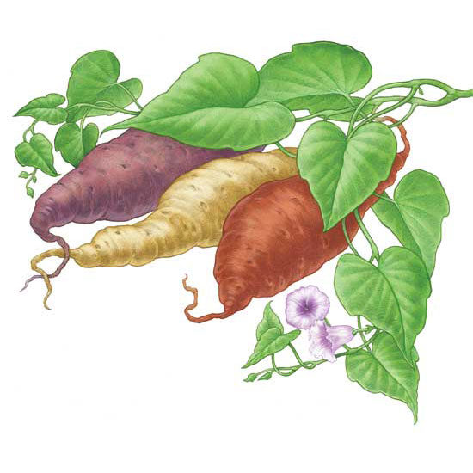

Sweet potato plant and variety of colors to choose from.



Sweet potato shoots beginning to root.



Sweet potato farm



Sweet potato pie



Sweet potato ad