

Sweet potatoes have a long history dating back to 1492 on Christopher Columbus’ first voyage he brought sweet potatoes back to Europe.

Do you know the difference between sweet potatoes and yams? Sweet potatoes are orange in color and yams have more starch, are larger, and have white flesh.

Sweet potatoes are sweet in flavor because when they are growing the starch is converted into sugar. The complex carbohydrates and high dietary fiber make them beneficial for people with diabetes.

One cup of sweet potatoes has 180 calories, no fat, 4 grams protein, 41 grams carbohydrate, and 7 grams of fiber.

Sweet potatoes have a long history dating back to 1492 on Christopher Columbus’ first voyage he brought sweet potatoes back to Europe.

Do you know the difference between sweet potatoes and yams? Sweet potatoes are orange in color and yams have more starch, are larger, and have white flesh.

Sweet potatoes are sweet in flavor because when they are growing the starch is converted into sugar. The complex carbohydrates and high dietary fiber make them beneficial for people with diabetes.

One cup of sweet potatoes has 180 calories, no fat, 4 grams protein, 41 grams carbohydrate, and 7 grams of fiber.

l Beneficial Bites

Bites

Bites

#### Sweet Potato

Sweet potatoes have a long history dating back to 1492 on Christopher Columbus’ first voyage he brought sweet potatoes back to Europe.

Do you know the difference between sweet potatoes and yams? Sweet potatoes are orange in color and yams have more starch, are larger, and have white flesh.

Sweet potatoes are sweet in flavor because when they are growing the starch is converted into sugar. The complex carbohydrates and high dietary fiber make them beneficial for people with diabetes.

One cup of sweet potatoes has 180 calories, no fat, 4 grams protein, 41 grams carbohydrate, and 7 grams of fiber.

#### Sweet Potato

#### Sweet Potato

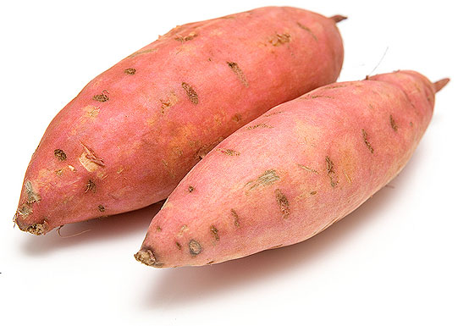

Can help regulate blood sugar

Vitamin A for good eye health

Full of antioxidants



Can help regulate blood sugar

Vitamin A for good eye health

Full of antioxidants

Can help regulate blood sugar

Vitamin A for good eye health

Full of antioxidants





**Taste it on December’s Menu!:**

**Dec 11th– Roasted Sweet Potatoes**

**Dec 17th- Sweet Potato Grain Salad**

**Dec 28th- Candied Sweet Potatoes**

**Taste it on December’s Menu!:**

**Dec 11th– Roasted Sweet Potatoes**

**Dec 17th- Sweet Potato Grain Salad**

**Dec 28th- Candied Sweet Potatoes**

**Taste it on December’s Menu!:**

**Dec 11th– Roasted Sweet Potatoes**

**Dec 17th- Sweet Potato Grain Salad**

**Dec 28th- Candied Sweet Potatoes**

**Sweet, sweet, sweet Potatoes**

With the sweet history, sweet potatoes provide many nutrients such as vitamin A, vitamin C, manganese, copper, pantothenic acid, and vitamin B6. The vitamin A promotes good eye health. Vitamin C helps grow and repair tissues in the skin, tendons, ligaments, and blood vessels, bones, and teeth.

The antioxidants available in sweet potatoes may help protect against heart disease, cancer, arthritis, diabetes, cataracts and macular degenerations, Alzheimer’s, Parkinson’s, and others. They also provide anti-inflammatory agents and promote successful blood clotting.

Did you know?

Before George Washington became the first President, he was a sweet potato farmer?

The average American consumes 4.5 pounds of sweet potatoes per year?

There was a shortage of wheat flour during WW1, so sweet potato flour was added to baked goods?

80 million tons of sweet potatoes are grown in China each year?

**Sweet, sweet, sweet Potatoes**

With the sweet history, sweet potatoes provide many nutrients such as vitamin A, vitamin C, manganese, copper, pantothenic acid, and vitamin B6. The vitamin A promotes good eye health. Vitamin C helps grow and repair tissues in the skin, tendons, ligaments, and blood vessels, bones, and teeth.

The antioxidants available in sweet potatoes may help protect against heart disease, cancer, arthritis, diabetes, cataracts and macular degenerations, Alzheimer’s, Parkinson’s, and others. They also provide anti-inflammatory agents and promote successful blood clotting.

Did you know?

Before George Washington became the first President, he was a sweet potato farmer?

The average American consumes 4.5 pounds of sweet potatoes per year?

There was a shortage of wheat flour during WW1, so sweet potato flour was added to baked goods?

80 million tons of sweet potatoes are grown in China each year?

**What the heck is Wheat Germ?**

With the sweet history, sweet potatoes provide many nutrients such as vitamin A, vitamin C, manganese, copper, pantothenic acid, and vitamin B6. The vitamin A promotes good eye health. Vitamin C helps grow and repair tissues in the skin, tendons, ligaments, and blood vessels, bones, and teeth.

The antioxidants available in sweet potatoes may help protect against heart disease, cancer, arthritis, diabetes, cataracts and macular degenerations, Alzheimer’s, Parkinson’s, and others. They also provide anti-inflammatory agents and promote successful blood clotting.

Did you know?

Before George Washington became the first President, he was a sweet potato farmer?

The average American consumes 4.5 pounds of sweet potatoes per year?

There was a shortage of wheat flour during WW1, so sweet potato flour was added to baked goods?

80 million tons of sweet potatoes are grown in China each year?