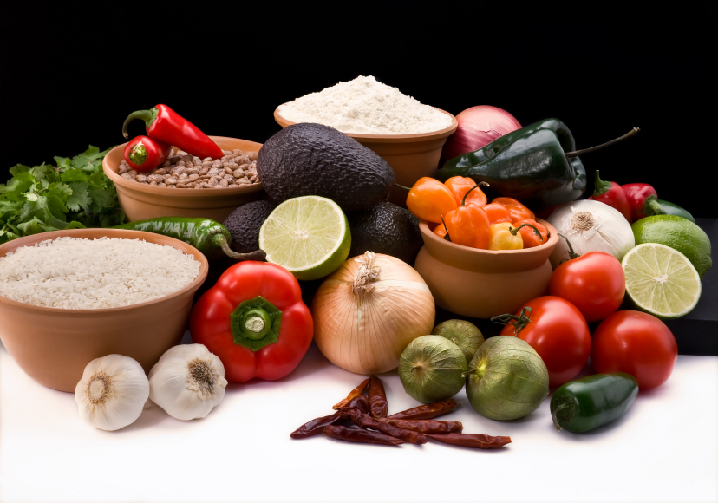
Recipe for: Healthy Sweet Potato Casserole
w/ Crunchy Oat Topping
8 c sweet potatoes, peeled/chopped1 large egg, beaten1 Tbsp canola oil
½ c 2% reduced fat milk1 c old-fashioned rolled oats3 Tbsp almond meal
2 Tbsp unsalted butter, melted2/3 c chopped pecans3 Tbsp maple syrup
½ tsp tsp vanilla extract¾ tsp kosher salt, divided

Preheat oven to 375 degrees. Bring potatoes to boil in a large saucepan then reduce heat and simmer for 6 minutes or until tender. Drain and return to saucepan. Add milk, 1 Tbsp butter, vanilla, and mas to desired consistency. Stir in ½ tsp salt and egg. Spread potato mixture in bottom of 11x7 in glass or ceramic baking dish coated with cooking spray.
Combine remaining tsp salt, oats, pecans, almond meal, and 2 Tbsp syrup in a bowl. Add remaining 1 Tbsp butter and canola oil; toss to coat. Sprinkle oat mixture over potatoes. Bake for 18 minutes or until surface is golden. Remove from oven; drizzle with remaining 1 Tbsp maple syrup.


Recipe for: Savory Sweet Potato Mash

1 ½ lbs sweet potatoes, peeled/cubed¼ cup 1% low fat milk
1 ½ Tbsp butter½ tsp kosher salt
1 Tbsp extra-virgin olive oil3/8 tsp black pepper
2 tsp finely chopped fresh thyme

Place sweet potatoes in a large saucepan; cover with water to 2 inches about potatoes. Bring to a boil over high; reduce heat to medium-low, and simmer until tender, about 18 minutes. Remove from heat. Drain and return potatoes to saucepan.
Combine butter and olive oil in a small skillet over medium; cook until browned and fragrant, about 3 minutes. Remove from heat; stir in thyme.
Add milk, salt, and pepper to sweet potatoes; mash with a potato masher to desired consistency. Drizzle with butter mixture; gently stir once or twice. Garnish with thyme leaves.
Recipe for: Oven Baked Sweet Potato Fries

2 large sweet potatoes, peeled½ tsp black pepper
Cut into 1x3-in wedges¼ tsp paprika
3 Tbsp soybean oil (vegetable oil)¼ tsp garlic powder
½ tsp sea salt
1) Position rack in upper third of oven and preheat to 425 degrees. Spray baking sheet with non-stick spray.
2) Place sweet potatoes and soybean oil in large bowl, toss lightly. Sprinkle with salt, pepper, and paprika.
3) Arrange potatoes in a single layer on prepared baking sheet, be sure not to overcrowd.
4) Bake until tender and golden brown, turning occasionally. Cooking time is 18-24 minutes. Cool 5 minutes before serving.

Recipe for: Sweet Potato Pudding

2 large eggs2 c baked, peeled, mashed sweet potato2 Tbsp chopped pecans
¼ c honey, divided1 tsp vanilla extract2 Tbsp chopped crystalized
¼ c 1% low fat milk½ tsp ground cinnamonginger
1 slice whole wheat bread¼ tsp ground allspice¼ c plain low fat Greek
yogurt
Preheat oven to 350 degrees. Coat a 1 1/2-quart baking dish with cooking spray.
Combine eggs, 3 Tbsp honey, milk, and bread (crustless) in a large bowl. Beat with a mixer at low speed until smooth. Add sweet potato, vanilla, cinnamon, and allspice; beat until smooth. Pour into prepared baking dish. Scatter pecans and ginger over top. Bake for 25 minutes until pudding is set and slightly puffy (it will sink slightly as the pudding cools).
While pudding bakes, combine yogurt and remaining 1 Tbsp honey; stir until smooth. Divide pudding among 4 bowls, and top evenly with yogurt mixture.

