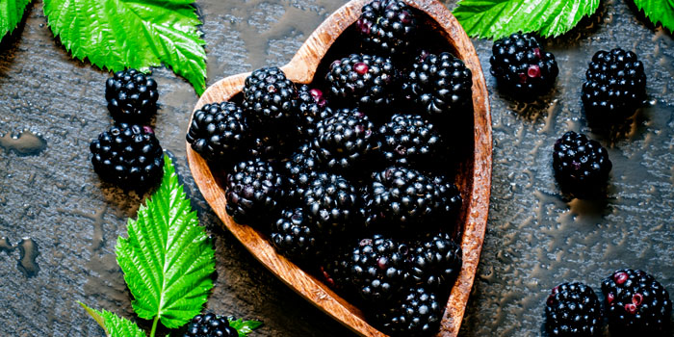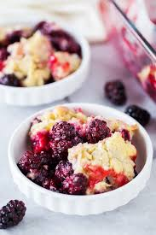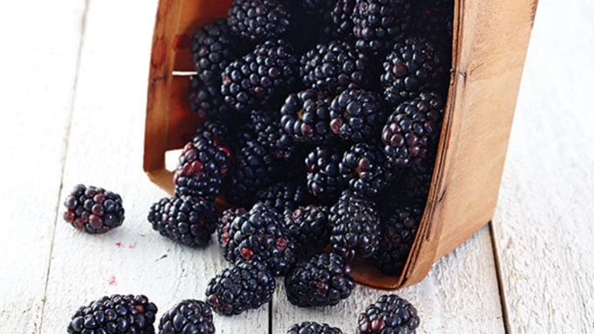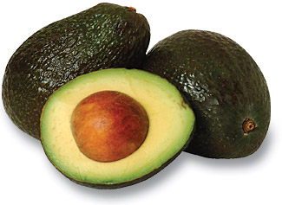

#### Blackberries

**Picking and Storing Blackberries**

There are two types of blackberries to know about: thorny and thornless! When picking the thorny plants, you want to reach into the plant in the gaps, avoiding the thorns.

A ripe blackberry is deep black with a plump, full feel. It will pull free from the plant with only a slight tug.

Don’t wash the berries until you are ready to eat them or freeze them to avoid spoiling too early. Blackberries are less perishable compared to raspberries or blueberries, but refrigerate them as soon as possible after picking or purchasing.

Even under ideal conditions, blackberries will keep for only about one week in the refrigerator. Use them sooner than later for best flavor and quality! Excellent additions to breakfast foods, smoothies, salads, or just eaten as is. Enjoy! ☺

The dark blue-black color of the blackberry is an indicator that it is packed with many antioxidants which are known for decreasing your risk of certain cancers.

Much like spinach, raisins, apples, plums, and grapes, blackberries are rich in antioxidants, Vitamin C, and iron. Plus these have only 62 calories per cup.

Blackberries also contain tannins which provide health benefits such as reducing stomach inflammation, alleviating hemorrhoids, and soothing bowel movements.

Like other berries, these are loaded with fiber – good for the heart, brain, and weight loss! 3.5 oz of this fruit contains 5.3 grams of fiber. Older adults should be getting at least 21 grams of fiber per day.

**Blackberry Fun Facts:**

* The berries are also known as brambleberries, bramble, dewberry, thimbleberry, and “lawers.”
* Native to north temperate regions, wild blackberries are particularly abundant in eastern North American and pacific coast.
* Traditionally, the leaves and barks of the plant have also been consumed. The leaves have been known to treat mild inflammation of the gums and sometimes soot
* If you grow your own blackberries, and the bush has turned orange, destroy it. This is a serious fungal disease that cannot be cured.
* According to botanists, the blackberry is not an actual berry, but is instead an aggregate fruit that has numerous drupelets that ripen into black or dark purple fruits.
* Some researchers claim that the juice extracts of the fruit can be used as an herbal medicine to protect skin from infections and reduce premature aging of the skin.

# Structuring Your Content

You have a nmber of alternatives for organizing the content of your brochure. You might choose to devote each column to a separate point or theme, such as quality and value. Remember, these points should tie in with your introductory text on the first page of the brochure.

# An Alternate Approach

On the other hand, you might want to organize your information as a continual stream of information broken up into smaller, “easy to chew” chunks. These smaller chunks can be separated by a descriptive subheading, like the one that begins this paragraph. If this is the approach you prefer, you can make use of linked text boxes, which allow text to flow from one column to the next.

A text box offers a flexible way of displaying text and graphics; it’s basically a container that you can resize and reposition. By linking a text box on one page with a text box on another, your article automatically flows from one page to another.

# Overview Headline

When readers open the brochure, this is the first text they will see, making this a good place to briefly but effectively summarize the products or services that you offer.

Make this text compelling and interesting so that readers will want to read the rest of the brochure. Be sure to keep the scope of this introduction narrow enough so that you can adequately cover the concepts you raise here in the limited space of the rest of the brochure.

Caption describing picture or graphic.