

The dark blue-black color of the blackberry is an indicator that it is packed with many antioxidants which are known for decreasing your risk of certain cancers.

Much like spinach, raisins, apples, plums, and grapes, blackberries are rich in antioxidants, Vitamin C, and iron. Plus these have only 62 calories per cup.

Blackberries also contain tannins which provide health benefits such as reducing stomach inflammation, alleviating hemorrhoids, and soothing bowel movements.

Like other berries, these are loaded with fiber – good for the heart, brain, and weight loss! 3.5 oz of this fruit contains 5.3 grams of fiber. Older adults should be getting at least 21 grams of fiber per day.

The dark blue-black color of the blackberry is an indicator that it is packed with many antioxidants which are known for decreasing your risk of certain cancers.

The dark blue-black color of the blackberry is an indicator that it is packed with many antioxidants which are known for decreasing your risk of certain cancers.

#### Blackberries

#### Leaves

#### Blackberries

#### Blackberries



l Beneficial Bites

Bites

Bites

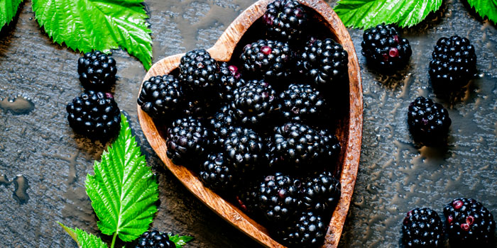

Much like spinach, raisins, apples, plums, and grapes, blackberries are rich in antioxidants, Vitamin C, and iron. Plus these have only 62 calories per cup.

Blackberries also contain tannins which provide health benefits such as reducing stomach inflammation, alleviating hemorrhoids, and soothing bowel movements.

Like other berries, these are loaded with fiber – good for the heart, brain, and weight loss! 3.5 oz of this fruit contains 5.3 grams of fiber. Older adults should be getting at least 21 grams of fiber per day.

Much like spinach, raisins, apples, plums, and grapes, blackberries are rich in antioxidants, Vitamin C, and iron. Plus these have only 62 calories per cup.

Blackberries also contain tannins which provide health benefits such as reducing stomach inflammation, alleviating hemorrhoids, and soothing bowel movements.

Like other berries, these are loaded with fiber – good for the heart, brain, and weight loss! 3.5 oz of this fruit contains 5.3 grams of fiber. Older adults should be getting at least 21 grams of fiber per day.

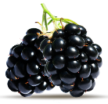

**Blackberry Fun Facts:**

* The berries are also known as brambleberries, bramble, dewberry, thimbleberry, and “lawers.”
* Native to north temperate regions, wild blackberries are particularly abundant in eastern North American and pacific coast.
* Traditionally, the leaves and barks of the plant have also been consumed. The leaves have been known to treat mild inflammation of the gums and sometimes soot
* If you grow your own blackberries, and the bush has turned orange, destroy it. This is a serious fungal disease that cannot be cured.
* According to botanists, the blackberry is not an actual berry, but is instead an aggregate fruit that has numerous drupelets that ripen into black or dark purple fruits.
* Some researchers claim that the juice extracts of the fruit can be used as an herbal medicine to protect skin from infections and reduce premature aging of the skin.

**Taste It on August’s Menu!:**

**August 7th Blackberry Cobbler**

**August 24th Blackberry Glazed Salmon**

**Taste It on August’s Menu!:**

**August 7th Blackberry Cobbler**

**August 24th Blackberry Glazed Salmon**

**Taste It on August’s Menu!:**

**August 7th Blackberry Cobbler**

**August 24th Blackberry Glazed Salmon**

**Blackberry Fun Facts:**

* The berries are also known as brambleberries, bramble, dewberry, thimbleberry, and “lawers.”
* Native to north temperate regions, wild blackberries are particularly abundant in eastern North American and pacific coast.
* Traditionally, the leaves and barks of the plant have also been consumed. The leaves have been known to treat mild inflammation of the gums and sometimes soot
* If you grow your own blackberries, and the bush has turned orange, destroy it. This is a serious fungal disease that cannot be cured.
* According to botanists, the blackberry is not an actual berry, but is instead an aggregate fruit that has numerous drupelets that ripen into black or dark purple fruits.
* Some researchers claim that the juice extracts of the fruit can be used as an herbal medicine to protect skin from infections and reduce premature aging of the skin.

**Blackberry Fun Facts:**

* The berries are also known as brambleberries, bramble, dewberry, thimbleberry, and “lawers.”
* Native to north temperate regions, wild blackberries are particularly abundant in eastern North American and pacific coast.
* Traditionally, the leaves and barks of the plant have also been consumed. The leaves have been known to treat mild inflammation of the gums and sometimes soot
* If you grow your own blackberries, and the bush has turned orange, destroy it. This is a serious fungal disease that cannot be cured.
* According to botanists, the blackberry is not an actual berry, but is instead an aggregate fruit that has numerous drupelets that ripen into black or dark purple fruits.
* Some researchers claim that the juice extracts of the fruit can be used as an herbal medicine to protect skin from infections and reduce premature aging of the skin.