

Beneficial Bites

Chickpeas are full of great nutrition! They’re packed with…

* Fiber
* Protein
* Folate
* Iron
* Antioxidants

Chickpeas are incredibly versatile to cook with and are inexpensive.

Chickpeas are known by many different names all over the world…

* Garbanzo beans
* Bengal grams
* Egyptian peas
* Ceci beans
* Kabuli chana

Chickpeas are legume. There are many different shapes and colors other than the usual beige variety.

#### Chickpeas

Typical uses for chickpeas includes:

* Cold in salads
* Cooked in stews
* Ground into flour
* Fried falafel
* Pureed into hummus
* Roasted and spiced

[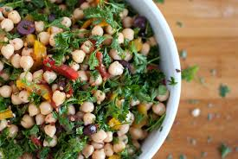](https://www.google.com/imgres?imgurl=https://cookieandkate.com/images/2010/12/chickpea-salad-17.jpg&imgrefurl=https://cookieandkate.com/2010/chickpea-salad-recip/&docid=9tyH6JaXzDwqnM&tbnid=hAmogAYYWnBx4M:&vet=10ahUKEwiJ68SB7ezZAhXH6oMKHfeDAVcQMwifAig5MDk..i&w=1000&h=669&bih=911&biw=1920&q=chickpea%20images&ved=0ahUKEwiJ68SB7ezZAhXH6oMKHfeDAVcQMwifAig5MDk&iact=mrc&uact=8)

Chickpeas are available year round sold as dried or canned. They have a nutty flavor and a buttery texture. They are featured extensively in the healthy Mediterranean diet and Middle-Eastern food.

Fun Facts:

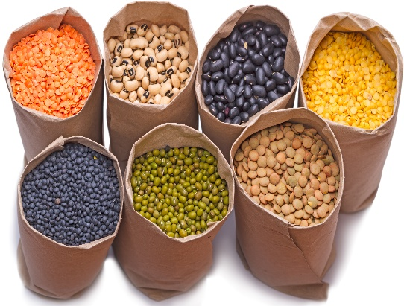

**Did you know??**

People can also consume chickpea plant leaves.

Ground chickpeas have been used as a coffee substitute since the 18th century.

Chickpeas are a fantastic alternative to meat for vegetarians.

Over 12 million tons are grown worldwide annually, with India as the largest producer.

Chickpeas are one of the oldest foods known to man.

Chickpeas are thought to have originated in southeast Turkey.

Sailboat

This area can be used to give the reader clear instructions for the next steps that you hope they will take. It may be a number you want them to call, a Web site you want them to visit, or information you want them to fill out. Whatever the case, this information should be clear, brief and engaging enough to motivate the reader to make that small decision to move forward.

# Structuring Your Content

You have a nmber of alternatives for organizing the content of your brochure. You might choose to devote each column to a separate point or theme, such as quality and value. Remember, these points should tie in with your introductory text on the first page of the brochure.

# An Alternate Approach

On the other hand, you might want to organize your information as a continual stream of information broken up into smaller, “easy to chew” chunks. These smaller chunks can be separated by a descriptive subheading, like the one that begins this paragraph. If this is the approach you prefer, you can make use of linked text boxes, which allow text to flow from one column to the next.

A text box offers a flexible way of displaying text and graphics; it’s basically a container that you can resize and reposition. By linking a text box on one page with a text box on another, your article automatically flows from one page to another.

# Overview Headline

When readers open the brochure, this is the first text they will see, making this a good place to briefly but effectively summarize the products or services that you offer.

Make this text compelling and interesting so that readers will want to read the rest of the brochure. Be sure to keep the scope of this introduction narrow enough so that you can adequately cover the concepts you raise here in the limited space of the rest of the brochure.

Caption describing picture or graphic.