**Recipe for:** Chopped Chickpea Greek Salad

1 can chickpeas, rinsed 4oz feta cheese crumbles

1 red bell pepper, chopped Dressing:

1 yellow bell pepper, chopped 1 T olive oil

1 green bell pepper, chopped 2 T lemon juice

½ small red onion, chopped 2 tsp minced garlic

15 grape tomatoes, halved 1 tsp dried oregano

1/3 cup olives Salt and Pepper to taste

1 cucumber, cubed

Place all salad ingredients in a large bowl and toss to combine. For dressing, whisk together ingredients and pour over salad and toss. Refrigerate for 1 hour to marinate.



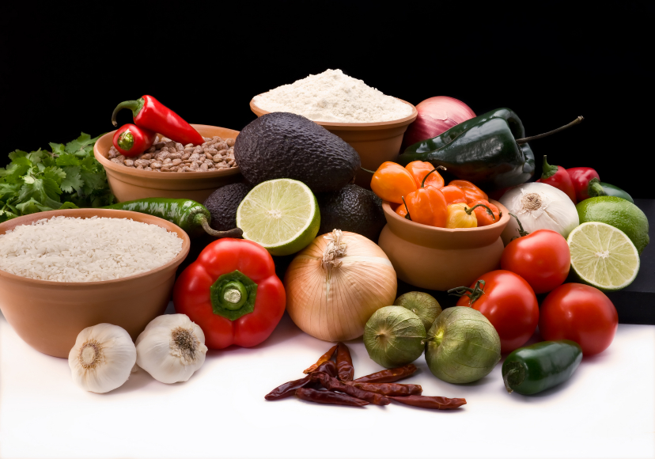

**Recipe for:** Spicy Roasted Chickpeas

2 cups cooked chickpeas, or 1 can

2 tsp olive oil

¼ tsp salt

¼ tsp pepper

¾ tsp chili powder

¼ tsp paprika

¼ tsp garlic powder

Dash of cayenne pepper

Heat oven to 425 degrees. Pat the chickpeas dry with paper towel. Line a baking sheet with parchment paper. Coat chickpeas with olive oil, then toss with seasoning mix. Bake 25 minutes.





**Recipe for:** Peanut Butter Chocolate Chip

Chickpea Cookies

1 can chickpeas, rinsed

½ cup peanut butter

¼ cup maple syrup

1 tsp baking powder

2 tsp vanilla

Pinch of Salt

½ cup chocolate chips

Heat oven to 350 degrees. Blend all ingredients except chocolate chips in a food processor until smooth. Fold chocolate chips into the batter. Roll balls and slightly flatten on baking sheet. Bake for 10 minutes.





**Recipe for:** Risotto with Onions, Mushrooms

and Chickpeas

1 T olive oil 1/3 cup dry white wine

1 onion, sliced 6 cups chicken broth

1 cup mushrooms ½ cup chickpeas, rinsed

1 tsp minced garlic Salt & Pepper to taste

1 cup Arborio rice Fresh Herbs, optional

Heat oil in pan, add onion and cook until starting to caramelize. Add mushrooms, cook until soft. Stir in garlic and rice, pour in wine and simmer until evaporated. Begin adding broth, 1 cup at a time until each cup is absorbed. The rice should be creamy but not mushy. Add chickpeas once you’re happy, warm until chickpeas are heated. Add salt and pepper and fresh herbs as desired.



