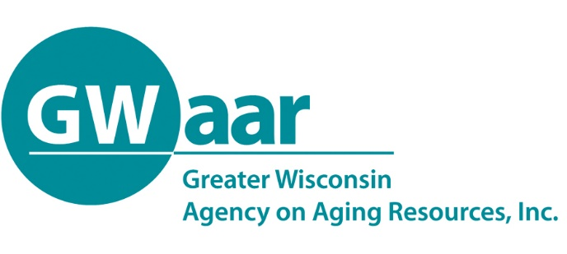

November 1, 2019

Dear Aging Unit and ADRC Directors:

As you may be aware, GWAAR has been working on process improvements that will ensure that our State's Fiscal and SAMS data are in compliance with the Federal and State requirements that pertain to the reporting of our data. On a recent review of the fiscal data being supplied to GWAAR in 2019, it has become clear that there are a variety of methods that the EBS fiscal data is being reported on both the ADRC CARS reports and the GWAAR claim form. To improve the reliability and consistency of this data, GWAAR is requiring that all EBS claims submitted on your monthly claim forms include the information requested in the attached “EBS claiming tool”. All Aging Units must complete this table in full. As well, we are also required to receive a copy of your EBS’s 100% time reporting Summary/Adder sheet for our records. If your agency also claims Indirect and or AMSO, we are required to receive a copy of the official AMSO letter for your agency as well has a copy of how you have allocated out your Indirect and AMSO costs across your agency. If you have any questions, regarding this requirement, please call Patrick Metz at 608-228-8089.

- If you are not affiliated with or do not have an MOU with an ADRC and your EBS does not do 100%-time reporting, please enter in your monthly fiscal data into the attached spreadsheet as follows:
  - Fill in all the YELLOW boxes that pertain to your claim. (i.e. if you do not claim Indirect and/or AMSO costs, leave those blank.)
  - Enter 100% in the "Non-MA" box. This shows that you are not claiming MA match and that 100% of the expenses submitted are coming off your annual EBS contract. Once the monthly amounts fully expend your EBS contract allocation, use the “Monthly Cash Match”, and the other available funding sources to show how you are paying for the EBS expenses (i.e. if you have paying for the balance of the EBS with Tax Levy, add the full amount in the “Monthly Expense” box into “Monthly Cash Match” and that will zero out the “Monthly Expense” box automatically).

- If your EBS is affiliated with or you have an MOU with an ADRC and they do 100%-time reporting, then:
  - To begin claiming Federal MA, each Aging Unit must first request a Title III-B waiver from the State, unless you have previously received one (if you are unsure that you have a waiver, please call GWAAR Fiscal staff). This waiver allows you to claim less than the required 5% in Title III-B funds and draw down Federal MA dollars.
  - To begin entering your data into the attached table:
    - For each contract begin with the contract start month to back enter information for the year – see the schedule below. Follow the instructions below to complete each month of expenses that you are backdating.
    - Within the current month you are claiming, enter in your “Total EBS Monthly Costs” and then how much of that is to be allocated to Title III-B, SHIP and MIPPA. This ensures that the amount of EBS expense being claimed for MA Match does not include any Federal funds.
    - If you claim Indirect and/or AMSO with your EBS please add those numbers into the appropriate boxes. These will add to your direct EBS expenses and be included into the MA Match.
    - Enter the percentages that are drawn from the summary sheet of the "Individual Time and Task Workbook" that your EBS uses to complete their 100%-time reporting. If your time reporting doesn’t include SPAP, please manually enter your claim in Column B on the SPAP lines.
    - The spreadsheet will automatically calculate your claim splits and place the amounts into the appropriate boxes in the EBS, and related claim forms.
This data will be compared against the data already submitted to ensure that we have appropriately claimed and paid out all EBS claims YTD in 2019. If you have over claimed, we will work with each County to revise their claim forms to facilitate a return of any excess MA claims received. If you have under claimed, GWAAR will also work with you to facilitate a catch-up payment.

When claiming on the form, as we are significantly into the year, please follow these guidelines to complete information for each contract.

EBS will start in Jan to report month by month information (do not include SHIP or SPAP until the below mentioned dates - or it will over-report those contracts). Prior to the below mentioned dates (prior contract periods), if you expensed any EBS funds through the SHIP or SPAP contracts decrease your monthly EBS expense by this amount.

SHIP - start reporting in April when the contract started

SPAP - start reporting in July when the contract started

MIPPA - In Jan include Oct, Nov, and Dec expenses so the YTD against the contract is correct – also add these expenses from Oct, Nov and Dec into the monthly EBS expense field by this amount.

During this transition time if the only Compliance Issues you have to correct are within these contracts please submit your claim form and we will work to adjust as needed.

If you should have any questions, please feel free to call me at (608) 228-8089. I thank you in advance for your cooperation in providing this important data that supports our Aging Network.

Patrick Metz
Fiscal Manager
Greater Wisconsin Agency on Aging Resources
1414 MacArthur Rd, Suite A
Madison, WI 53714
patrick.metz@gwaar.org

__________________________________________________________________________________________________
Main Office:1414 MacArthur Road, Suite A ∙ Madison, WI 53714 ∙ Phone: 608.243.5670 ∙ Fax: 866.813.0974 ∙www.gwaar.org

