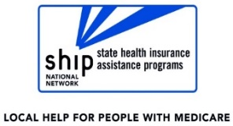
THANK YOU!

Dear <Insert Name>,
Thank you for the opportunity to work with you on <Insert appropriate phrase such as “your Medicare Savings Program application” >. I hope you will return to our office if we can be of assistance in the future. Here are some other things we can help with:
- Understanding and applying for benefits
- Reading and organizing paperwork
- Appealing denials of benefits
- Reviewing Medicare prescription drug plans
- And more!
Do you know of other people who could benefit from our services? Please tell them about us or share the enclosed brochure!
Sincerely,
<YOUR NAME>
<YOUR AGENCY CONTACT INFORMATION HERE>

THANK YOU!

Dear <Insert Name>,
Thank you for the opportunity to work with you on <Insert appropriate phrase such as “your Medicare Savings Program application” >. I hope you will return to our office if we can be of assistance in the future. Here are some other things we can help with:
- Understanding and applying for benefits
- Reading and organizing paperwork
- Appealing denials of benefits
- Reviewing Medicare prescription drug plans
- And more!
Do you know of other people who could benefit from our services? Please tell them about us or share the enclosed brochure!
Sincerely,
<YOUR NAME>
<YOUR AGENCY CONTACT INFORMATION HERE>

