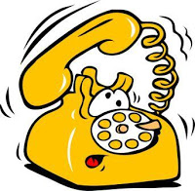

Friend

YOUR AGENCY CONTACT HERE
555-123-4567
About Open Enrollment for Medicare

How may we help you?
TELL
a

Friend

YOUR AGENCY CONTACT HERE
555-123-4567
About Open Enrollment for Medicare

How may we help you?
TELL
a

Medicare Open Enrollment
October 15 – December 7
Why check your Medicare Prescription Drug Plan?
Plans change their coverage details each year, which means the cost of your drugs may change.
Your plan may not cover all your medications in the same way.
You might be taking new medications.

For help with plan comparisons and to see if you may qualify for money saving programs call:
<YOUR AGENCY CONTACT INFO HERE>

Medicare Open Enrollment
October 15 – December 7
Why check your Medicare Prescription Drug Plan?
Plans change their coverage details each year, which means the cost of your drugs may change.
Your plan may not cover all your medications in the same way.
You might be taking new medications.
For help with plan comparisons and to see if you may qualify for money saving programs call:
<YOUR AGENCY CONTACT INFO HERE>

