Medicare open enrollment is your opportunity to review your Medicare Part D (prescription drug) plan or Medicare Advantage (HMO or PPO) plan. Take this time to determine whether your current plan remains the best choice for the upcoming year.

October 15 – December 7

MEDICARE

OPEN ENROLLMENT

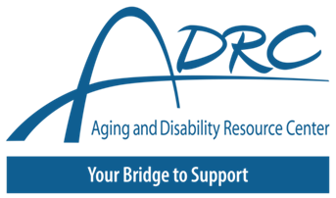

**Remember, every year Medicare** **plans can change** their coverage and costs, so even if you like your current plan, it’s important to review your plans details for the coming year.

**Understand**

**Costs and Coverage**

This project was supported by the Administration for Community Living (ACL), U.S. Department of Health and Human Services (HHS) as part of a financial assistance award totaling $1,061,673 with 100 percent funding by ACL/HHS. The contents are those of the author(s) and do not necessarily represent the official views of, nor an endorsement, by ACL/HHS, or the U.S. Government.

**<Insert contact information here>**

**For free, unbiased help contact:**

**Enroll**

**Compare**

**Plan Options**

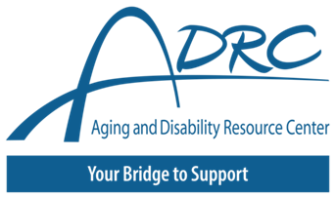



**MEDICARE**

**OPEN ENROLLMENT**

**October 15 – December 7**

**<Insert contact information here>**

This project was supported by the Administration for Community Living (ACL), U.S. Department of Health and Human Services (HHS) as part of a financial assistance award totaling $1,061,673 with 100 percent funding by ACL/HHS. The contents are those of the author(s) and do not necessarily represent the official views of, nor an endorsement, by ACL/HHS, or the U.S. Government.

**For free, unbiased help contact:**

**Remember, every year Medicare** **plans can change** their coverage and costs, so even if you like your current plan, it’s important to review your plans details for the coming year.

**Medicare open enrollment is your opportunity to review your Medicare Part D (prescription drug) plan or Medicare Advantage (HMO or PPO) plan. Take this time to determine whether your current plan remains the best choice for the upcoming year.**