Providing important information for first responders in Rock County for those impacted by dementia.
Call 608-741-3600 for more information

Thank you for your interest in the Rock County Purple Tube Project. This project is a collaboration between law enforcement, EMS and our county wide Dementia Friendly Community Network. As the number of people with Alzheimer’s disease and related dementia grows, so does the need for positive emergency interventions. The Rock County Purple Tube Project assists families coping with dementia to develop a crisis/safety plan which includes information such as contact people, brief medical history, healthcare powers of attorney and also ways to best interact with the person with dementia.
The information will be completed/gathered and placed inside a Purple Tube which will then be placed in your primary refrigerator. A small purple sticker will be placed on your door (we will show you where) to alert first responders that a Purple Tube is available. First responders (law enforcement, Emergency Medical Services, Crisis Workers, etc.) will refer to the contents in the purple tube to assist them is helping your loved one.
It is difficult in a time of crisis or a time of feeling overwhelmed to figure out what to do next. When a medical or behavioral emergency occurs we want you to feel confident in your response and the information you have ready to share with those that first respond (Law Enforcement, Emergency Medical Services, etc.
We will work with you to complete the Person Centered Information Tool, provide you a tube to keep the information safe and ask that you store that information in your refrigerator so the first responders know where to look for the information.
You will be provided with a purple sticker for each door that is a point of entry in your house to alert first responders that you have a purple tube available. They will be able to locate the purple tube in your refrigerator and review the information provided. If your loved requires transport to the hospital, they will take the contents of the tube with them to share with the local emergency room.
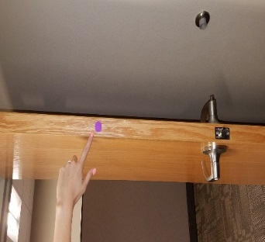
- Complete two sided Safety Plan
- Add additional items such as photo and/or Power of Attorney paperwork.
- Place information in Purple tube (Roll it up to fit)
- Place Tube in your primary refrigerator
- Place purple sticker on door as depicted to the left
- Update/review contents every six months or after a significant change.
Our hope is you will never need to use the purple tube, but want you to be confident that in a “crisis” helpful information is available quickly.

Please call 608-741-3600 for more information or assistance with the purple tube project.

