Medicare Outreach Idea of the Month
January 2019

It’s time to make plans for an important annual outreach opportunity—connecting with local tax preparers before the upcoming tax season. Both AARP and VITA tax volunteers will be working with Medicare beneficiaries in your communities and this provides another way to reach people who you might not otherwise come into contact with. These tax preparers are in a unique position to observe the income for all the people they assist. So, the idea of the month for January is to make the most of that situation.
Free tax help is available through AARP Tax Aides to people of all ages with low and middle income, with special attention to those age 60 and older. Visit www.aarp.org/findtaxhelp or call 1-888-227-7669 for more information about AARP Tax Aide locations and contacts. Free tax help is also available to people with low to moderate income, seniors and members of the military through Volunteer Income Tax Assistance (VITA). For information about VITA sites in your area go to https://www.revenue.wi.gov/Pages/VITA/ .
Reach out to your local AARP and VITA tax prepares to educate them about the low-income benefit programs; Medicare Savings Programs, Low Income Subsidy (Extra Help) and SeniorCare. Let them know how these programs can help Medicare beneficiaries that they may be working with. See if there is an opportunity to present to a group of their volunteers at once to educate them about Medicare related programs and share your materials.
Consider sharing the Eligibility Quick Check* shown below to make it easier for them to see if someone is near the eligibility limits. Be sure to customize it with your local contact information. Encourage them to keep it at their desk/table as a quick reference. That way, if they see a client who may be struggling financially, they can refer them to your agency.
Be sure to thank the tax preparers for helping to spread the word about these important programs that can make a difference in the lives of some of their clients!
*Note that the income limits are based on the 2018 federal poverty guidelines. Once the 2019 federal poverty guidelines are released, the Eligibility Quick Check document will be revised and uploaded to the GWAAR website.
To view all the GWAAR Medicare Outreach and Assistance Resources, follow the link to our webpage:
https://gwaar.org/medicare-outreach-and-assistance-resources

By the GWAAR Medicare Outreach Team

For Reprint
2019 Eligibility Quick Check
Medicare Savings Programs, Extra Help and SeniorCare Level 1

SINGLE:
 | MSP | Extra Help | SeniorCare Level 1
Income* | $1,366 | $1,518 | $1,619
Assets | $7,730 | $12,890 | none

COUPLE:
 | MSP | Extra Help | SeniorCare Level 1
Income* | $1,852 | $2,058 | $2,195
Assets | $11,600 | $25,720 | none
*Income limits based on 2018 federal poverty guidelines.

Medicare Savings Plans: Covers the cost of Medicare Part B premium and possibly co-pays and deductible, depending on income. Enrollment in a Medicare Savings Program will automatically qualify you for Part D Extra Help.

Extra Help: Lowers the premium, deductible and copays for Medicare Part D plans.

SeniorCare: A Wisconsin program designed to help seniors with their prescription drug costs. (Must be 65 or older to enroll.)
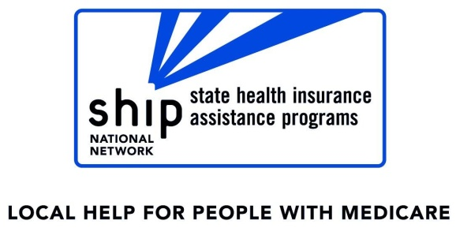
<YOUR CONTACT INFORMATION HERE>

This project is supported in whole or in part by grant numbers 1701WIMSH, 1701WIMAA and 1701WIMDR from the U.S. Administration for Community Living, Department of Health and Human Services, Washington, D.C. 20201. Grantees undertaking this project with government sponsorship are encouraged to express freely their findings and conclusions. Points of view or opinions do not, therefore, necessarily represent official ACL.

