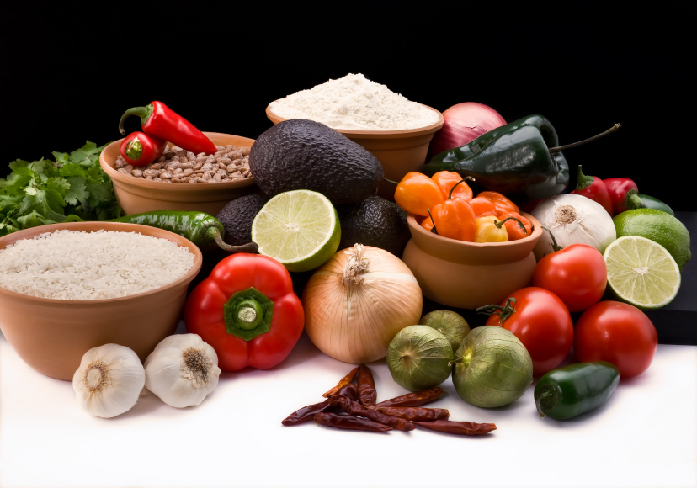
Recipe for: Cheese Stuffed Portabello Mushrooms

4 large portabella mushroom caps½ cup finely shredded Parmesan cheese, divided
¼ tsp salt2 T kalamata olives, finely chopped
¼ tsp black pepper, divided½ tsp Italian seasoning
1 cup part-skim ricotta cheese¾ cup marinara sauce
1 cup spinach, fresh, finely chopped

Preheat oven to 450⁰ F and spray rimmed baking sheet with cooking spray. Place mushroom caps, gill side up, on prepared pan. Sprinkle with ½ of the pepper. Roast 20-25 minutes. Meanwhile, mash ricotta, spinach, ¼ cup Parmesan cheese, olives, Italian seasoning, and remaining pepper in a bowl. Microwave marinara on high until hot, 30 seconds-1 minute. When mushrooms are tender, pour out liquid. Return mushrooms to pan, gill side up. Spread 1 T marinara on each cap. Mound 1/3 cup ricotta mixture on top and sprinkle with remaining Parmesan cheese. Bake until hot, about 10 minutes, and serve with remaining marinara.

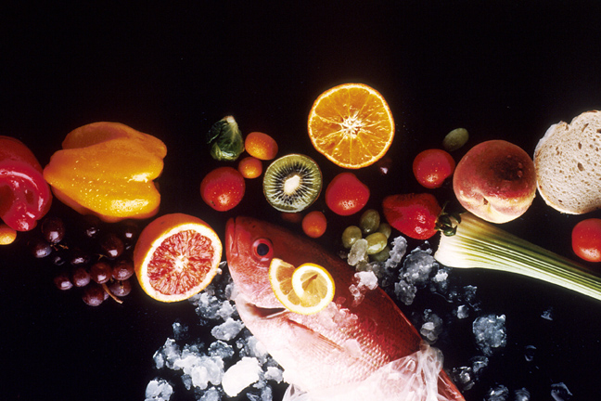
Recipe for: Slow Cooker Black Bean-Mushroom Chili
4 cans black beans, drained and rinsed5 ½ cups mushroom or vegetable broth
1 T extra virgin olive oil1 6-oz can of tomato paste
¼ cup mustard seeds2 limes, cut into wedges
2 T chili powder1 ¼ cups grated Monterey jack cheese
1 ½ tsp ground cumin½ cup reduced fat sour cream
½ tsp ground cardamom½ cup fresh cilantro, chopped
2 medium onions, coarsely chopped
1# mushrooms, sliced
¼ cup water

Combine oil, mustard seeds, chili powder, cumin and cardamom in a 5 to 6-quart Dutch oven. Place over high heat and stir about 30 seconds. Add onions, mushrooms, and water. Cover and cook, stirring occasionally, about 5 to 7 minutes. Uncover and stir often until juices evaporate and vegetables are lightly browned, 10 to 15 minutes. Add broth and tomato paste; mix well. Place beans in slow cooker; pour the hot vegetable mixture over beans. Cook on high 5 to 8 hours. Garnish each serving with cheese, sour cream, cilantro, and lime.

Recipe for: Garlic-Rosemary Mushrooms
1 oz bacon, chopped
1 ½ lb mixed mushrooms, sliced
2 medium garlic cloves, finely chopped
1 ½ tsp rosemary, fresh, chopped
¼ tsp salt
Ground black pepper, to taste
¼ cup dry, white wine

Cook bacon over medium heat in large skillet until just beginning to brown, about 4 minutes. Add mushrooms, garlic, rosemary, salt and pepper and cook, stirring occasionally until almost dry, 8 to 10 minutes. Pour in wine and cook until most of the liquid has evaporated, about 30 seconds to 1 minute.

Recipe for: Mushroom and Wild Rice Frittata

6 large eggs½ tsp black pepper, divided
1 lb mixed mushrooms, sliced¼ tsp ground nutmeg
1 cup canned wild rice2 tsp olive oil
1 cup red onion, chopped½ tsp salt, divided
1 T fresh rosemary, minced½ cup Parmesan cheese, finely shredded
2 T parsley, fresh, chopped

Beat eggs in a large bowl with parsley, ¼ tsp salt, ¼ tsp pepper, and nutmeg. Position rack in upper third of oven and preheat broiler. Heat oil in 10-inch ovenproof skillet over medium heat. Add onion and remaining salt and pepper; cook, stirring until softened, about 3 minutes. Stir in rosemary, add mushrooms and cook until mushrooms release their liquid and pan is dry, about 6 to 8 minutes. Reduce heat to medium-low; stir in wild rice. Pour egg mixture evenly over rice mixture. Partially cook until set around the edges. Sprinkle with cheese. Place pan under broiler about 2 minutes until top is browned. Let stand 5 minutes before serving.

