Mushrooms

What’s so great about them?
Mushrooms are full of cancer-fighting, immune-enhancing, anti-inflammatory compounds called phytochemicals.
Mushrooms are one of the few foods that can naturally contain vitamin D. This is important for bone health and the immune system.
Mushrooms contain little to no sodium (depending on type) and one portobello mushroom contains as much potassium as a banana…a good combination for those watching their blood pressure!
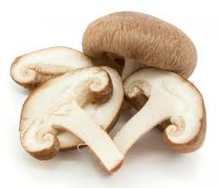
Mushrooms

What’s so great about them?
Mushrooms are full of cancer-fighting, immune-enhancing, anti-inflammatory compounds called phytochemicals.
Mushrooms are one of the few foods that can naturally contain vitamin D. This is important for bone health and the immune system.
Mushrooms contain little to no sodium (depending on type) and one portobello mushroom contains as much potassium as a banana…a good combination for those watching their blood pressure!
Mushrooms

What’s so great about them?
Mushrooms are full of cancer-fighting, immune-enhancing, anti-inflammatory compounds called phytochemicals.
Mushrooms are one of the few foods that can naturally contain vitamin D. This is important for bone health and the immune system.
Mushrooms contain little to no sodium (depending on type) and one portobello mushroom contains as much potassium as a banana…a good combination for those watching their blood pressure!
Did you know…?
Although often considered a vegetable, mushrooms are actually not even a plant. They are a fungus, giving them unique health benefits.
China is the world’s leader in commericially produced mushrooms.
Mushrooms are considered the meat of the vegetable world due to their meaty taste and texture.
The antibiotic, penicillin, was developed from a mushroom-like fungus.
There are over 30 species of mushrooms that glow in the dark.
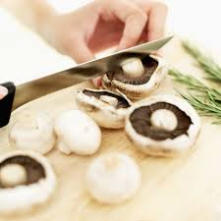
Created by Kathryn Hoff, MS, UW-Stout Dietetic Intern 2015

Did you know…?
Although often considered a vegetable, mushrooms are actually not even a plant. They are a fungus, giving them unique health benefits.
China is the world’s leader in commericially produced mushrooms.
Mushrooms are considered the meat of the vegetable world due to their meaty taste and texture.
The antibiotic, penicillin, was developed from a mushroom-like fungus.
There are over 30 species of mushrooms that glow in the dark.
Created by Kathryn Hoff, MS, UW-Stout Dietetic Intern 2015

Did you know…?
Although often considered a vegetable, mushrooms are actually not even a plant. They are a fungus, giving them unique health benefits.
China is the world’s leader in commericially produced mushrooms.
Mushrooms are considered the meat of the vegetable world due to their meaty taste and texture.
The antibiotic, penicillin, was developed from a mushroom-like fungus.
There are over 30 species of mushrooms that glow in the dark.
Created by Kathryn Hoff, MS, UW-Stout Dietetic Intern 2015

