
The Warning Signs of poor nutritional health are often overlooked. Use this checklist to find out if you or someone you know is at nutritional risk.

- I have an illness or condition that made me change the
kind and/or amount of food I eat. Yes = 2
- I eat fewer than 2 meals per day. Yes = 3
- I eat few fruits or vegetables, or milk products. Yes = 2
- I have 3 or more drinks of beer, liquor, or wine almost
every day. Yes = 2
- I have tooth or mouth problems that make it hard for me
to eat. Yes = 2
- I don’t always have enough money to buy the food
I need. Yes = 4
- I eat alone most of the time. Yes = 1
- I take 3 or more different prescribed or over-the-counter
drugs a day. Yes = 1
- Without wanting to, I have lost or gained 10 pounds
in the last 6 months. Yes = 2
- I am not always physically able to shop, cook and/or
feed myself. Yes = 2
TOTAL
If your nutrition score is…
0-2 Good! Recheck your score in 6 months.
3-5 You are at moderate nutritional risk. Ask for information on how to improve your eating habits & lifestyle. Recheck in 3 months.
6 or more You are at high nutritional risk. Bring this checklist the next time you see your doctor, dietitian or other qualified health professional.

Street Address
City, ST ZIP Code
(543) 555-0132 (800) 555-0132
(543) 555-0133 fax
web site
“I eat few fruits, vegetables,
or milk products.”
DETERMINE
YOUR
NUTRITIONAL
HEALTH
Nutrition
Screen
Brochure

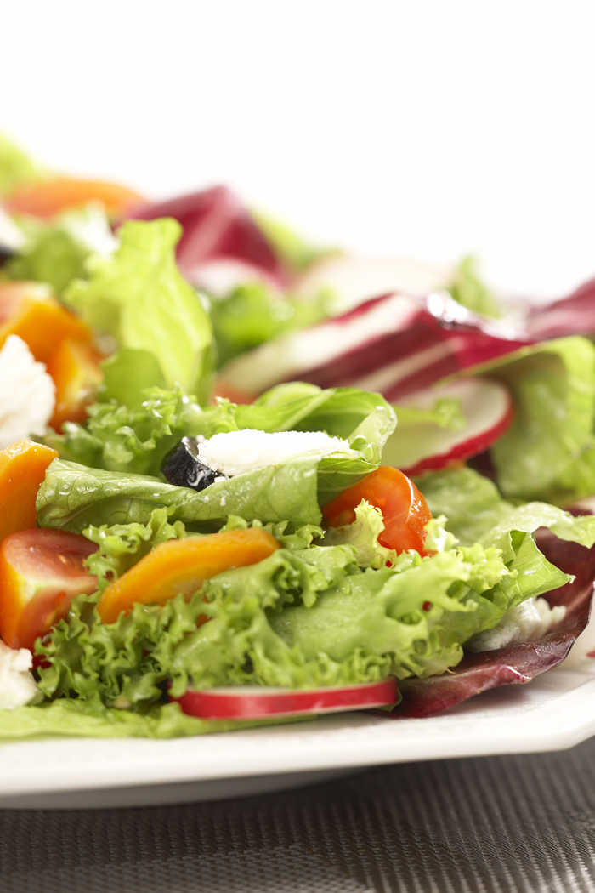
Dairy Products:

Dairy products are a good source of calcium & vitamin D which help keep our bones strong.
You should be getting at least 2-3 servings each day.
There are a variety of dairy products besides milk that you can try such as yogurt, cheese, cottage cheese, and frozen yogurt.
If you are lactose intolerant, use products labeled as “lactose free” or try using soy milk.
One serving of dairy is:
1 cup milk or yogurt
1 cup calcium and vitamin D fortified juice
1 oz cheese
½ cup ice cream
To increase your dairy intake try some of these tips:
Add a slice of cheese to your sandwich or salad or just eat plain!
Use yogurt in desserts, on baked potatoes instead of sour cream or add cereal to your yogurt for a crunchy texture.
Add grated cheese to your favorite casserole, on top of mashed potatoes or veggies, etc…

Fruits and Vegetables:

You should be getting at least 5 servings each day.
Use a variety of frozen and canned vegetables as they don’t spoil as quickly.
Snack on fresh fruits or vegetables that require little preparation time like grapes, baby carrots, bananas, and applesauce.
At breakfast, have a glass of 100% fruit juice or top your cereal with banana slices or frozen berries.
Remember that a serving of fruit or vegetables is usually ½ cup or about the size of your fist or a tennis ball.

Addressing Your
Nutritional Concerns

Fruits, vegetables, and dairy products are a very important part of daily nutrition. They are an excellent source of the vitamins, minerals, and fiber that work together to protect our body and help us stay healthy and strong.

Fruits and vegetables are an excellent source of fiber which has been shown to help reduce cholesterol and may aid in controlling blood sugar levels and cancer prevention. Fiber also promotes good bowel health & can help with relief of constipation. Great sources of fiber include: whole grain cereals & breads, apples, broccoli & legumes. Be sure to drink more fluid as you eat more fiber! Contact our office for more information:

aGENCY nAME
PHONE:
Email:
Wisconsin Elderly Nutrition Program 2008

