
The Warning Signs of poor nutritional health are often overlooked. Use this checklist to find out if you or someone you know is at nutritional risk.

- I have an illness or condition that made me change the
kind and/or amount of food I eat. Yes = 2
- I eat fewer than 2 meals per day. Yes = 3
- I eat few fruits or vegetables, or milk products. Yes = 2
- I have 3 or more drinks of beer, liquor, or wine almost
every day. Yes = 2
- I have tooth or mouth problems that make it hard for me
to eat. Yes = 2
- I don’t always have enough money to buy the food
I need. Yes = 4
- I eat alone most of the time. Yes = 1
- I take 3 or more different prescribed or over-the-counter
drugs a day. Yes = 1
- Without wanting to, I have lost or gained 10 pounds
in the last 6 months. Yes = 2
- I am not always physically able to shop, cook and/or
feed myself. Yes = 2
TOTAL
If your nutrition score is…
0-2 Good! Recheck your score in 6 months.
3-5 You are at moderate nutritional risk. Ask for information on how to improve your eating habits & lifestyle. Recheck in 3 months.
6 or more You are at high nutritional risk. Bring this checklist the next time you see your doctor, dietitian or other qualified health professional.

Street Address
City, ST ZIP Code
(543) 555-0132 (800) 555-0132
(543) 555-0133 fax
web site

“I eat fewer than 2 meals
per day”
DETERMINE
YOUR
NUTRITIONAL
HEALTH
Nutrition
Screen
Brochure

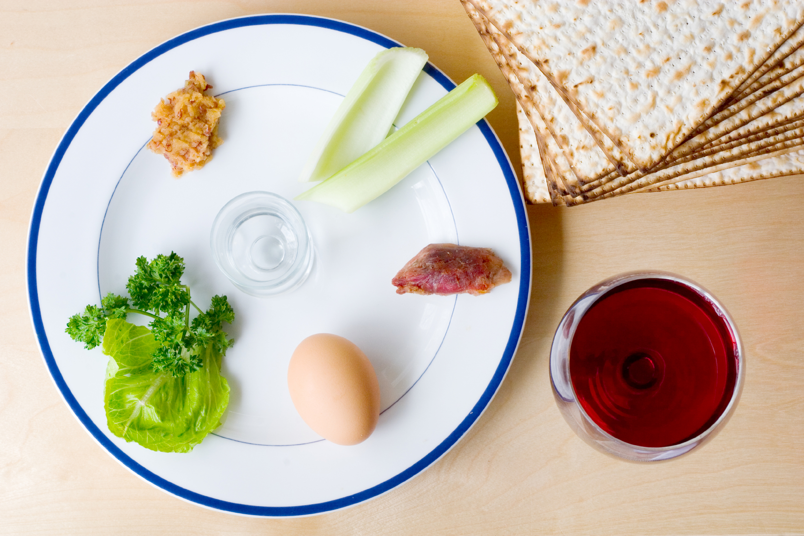
If you get full easily or have a small appetite:

Eat smaller meals & snacks throughout the day.
Place only small servings of food on your plate so eating doesn’t seem so overwhelming.
Choose foods rich in calories and nutrients.
Choose nutrient dense drinks like milk, milkshakes or juice.
Keep snacks on hand so you can nibble on them throughout the day. Try things like granola, dried fruit, and cheese & crackers.
Make meal times enjoyable and relaxing. Stress can make you feel anxious and not as hungry.

Addressing
Your
Nutritional
Concerns

Nutrition is a very important part of life as we age. If you are eating less than two meals per day, you probably aren't getting enough calories; protein, vitamins, and minerals that your body needs to give you energy and keep you healthy.

If you don’t eat enough calories and protein you could be at risk for becoming nutritionally depleted. Poor nutritional status can lead to undesirable outcomes such as: illness(es), longer wound healing, weakness, memory problems and compromised immune system. Please contact our office if you are concerned about your nutritional well-being.

aGENCY nAME
PHONE:
Email:
If you have difficulty preparing meals or don’t like to cook:

Have easy-to-prepare foods like fresh fruit, string cheese, frozen dinners, instant soup or cereal mixes, yogurt, and whole grain cereals on hand.
Peel, chop, or mix foods while sitting at the table.
If you feel particularly good one day, make extra and freeze for leftovers.
Have friends, family or church members bring meals to your house.
Check with your local Aging Office or Aging & Disability Resource Center (ADRC) and ask about Meals on Wheels or the nearest Senior Dining location.

Wisconsin Elderly Nutrition Program 2008

