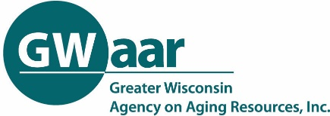
GOAL DEVELOPMENT WORKSHEET
Utilize the public input you received to form goals for your plan. The questions below will help you create a well-thought-out goal. Once you complete the questions you will be able to use the answers to write your goal using the template below. Remember to keep the goal SMART – Specific, Measurable, Achievable, Relevant and Time Bound.
- What are you trying to improve? What problem are you trying to solve?

- What is the current status of your problem or situation? Is it getting better or worse?

- What factors are hindering your progress? (preventing you from succeeding)

- What factors are supporting your efforts?

- Who are your partners in helping you succeed? (who could you work with to make this better)

- What are some strategies or steps that could help? (ideas to fix the problem)

- What do you hope to see as an outcome or result?

- How will you measure your progress? How will you know that you have achieved the results you wanted?

GOAL TEMPLATE
Focus area: |  | Due Date
Goal statement:
Plan for measuring overall goal success – How will you know that you have achieved the results you want? Use data.

Specific strategies and steps to meet your goal: | Measure (How will you know the strategies and steps have been completed?) | Due Date
Strategy 1:
Action step:

Action step:
Action step:
Strategy 2:
Action step:

Action step:
Action step:
Strategy 3:
Action step:

Action step:
Action step:
Annual progress notes

