Refilling Date Labels:

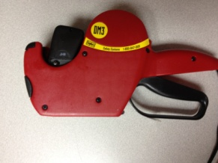

Open top roller storage and both paper guides located on the bottom.

Lay stamper on a flat surface - date knob facing down

toward surface.

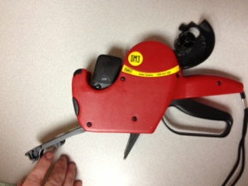

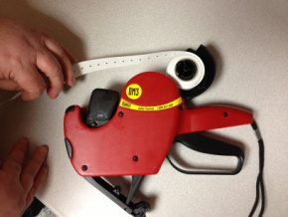

Insert stickers thru machine and grasp stickers as they appear thru the bottom paper guide section.

Place new roll on spindle and advance roll 6-8 inches.

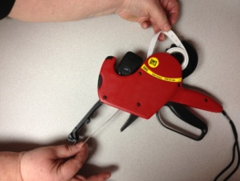

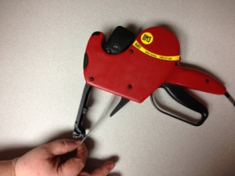

Pull 10-12” of sticker strip thru machine and turn the stamper so that it is facing upward.

Close the roller storage section.

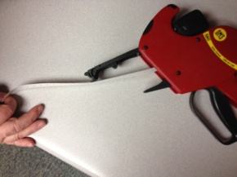

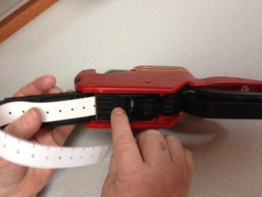

Carefully center stickers and close paper guide located towards handle.

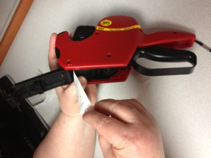

Hold flap firmly and remove stickers from sheet and discard them.

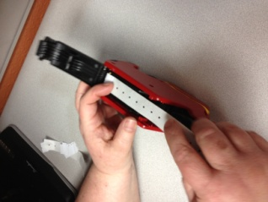

Carefully center paper.

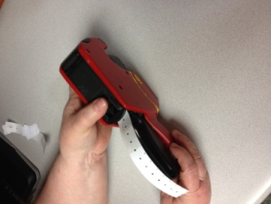

Close front door. Stamper is now ready to use.

Refilling Ink Roller:

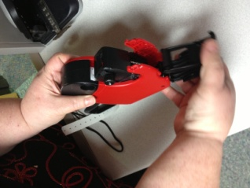

This section should only be opened to put a new ink roller on the machine.

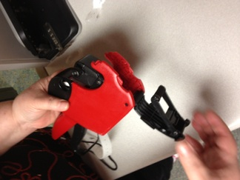

Grasp roller and remove old ink roll. Replace.

Ink Roller

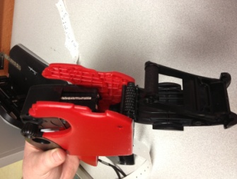

Setting the Date:

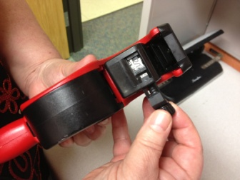

Setting the date:

1. pull/slide button out
2. adjust month & day

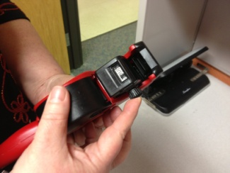

Setting the date:

Last step is to push the button back in.