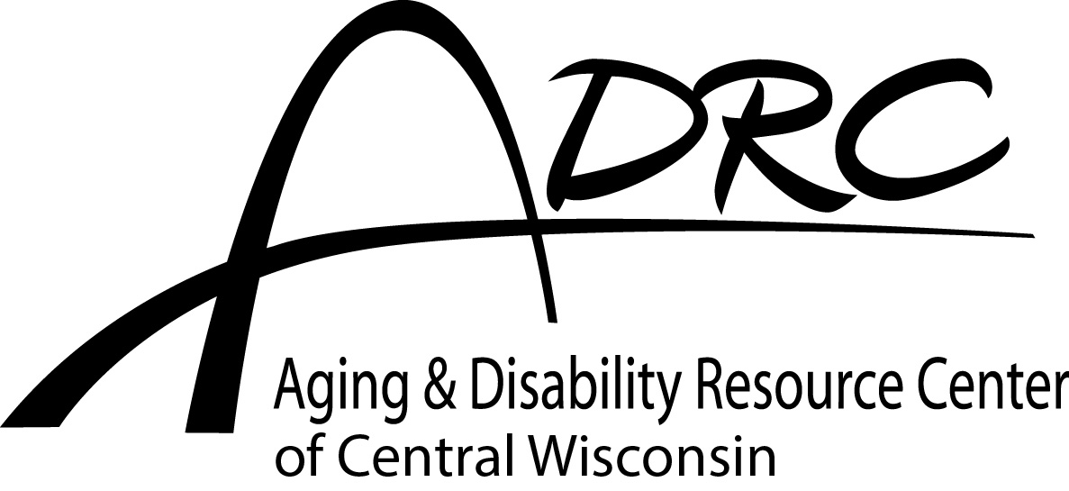
Congregate
Wausau

Welcome to Senior Dining!

Who Can Participate?
- Persons age 60 or older of all income levels are welcome to enjoy the delicious meals and friendly atmosphere in the dining room.
- A spouse or domestic partner who attends Senior Dining with their spouse or domestic partner who is age 60 or older.
- An adult with a disability who lives with an eligible older individual participating in Senior Dining.
- An adult with a disability, under age 60, who lives at Riverview Towers.

Please make Meal Reservations & Cancellations
One business day in advance by 12:00 p.m.
If you cancel your meal after this time, the meal may be wasted.

To Reserve or Cancel a Meal-
- Inform the dining site manager or host/hostess
- Or Call the dining site 715.842.7266

Contributions: The Suggested Contribution is $3.50 per meal.

We rely on contributions to continue the Senior Dining service &
request that you give a contribution that is within your means.
No eligible person is denied service due to inability to pay.

Did you know?
Our full meal cost is $8.50 per meal. Some of these Nutrition Program costs are covered by local, State and Federal grant dollars, however we rely on participant contributions
to cover 30% of our program costs

- If you would like a monthly report indicating the number of meals you ate, we will send one in the mail. It will be sent to you, or to another specified person. Please let us know if you are interested.
- If you participate in the Food Share (Food Stamp) Program, you may choose to use your Food Share benefit to give a contribution. Please ask us if you are interested in this option.
- Checks can be made payable to ADRC-CW.
- Checks can be made payable to ADRC-CW.

R/Nutrition/Senior Dining/2016 Congregate Welcome Letter WR & MF

Please see other side for more details

Menus: Each month, copies of the ADRC-CW Independent Living Monthly magazine are available. This publication includes the monthly menu and dining site activities.

Holidays & Inclement Weather:
- We are closed for service the following holidays: New Year’s Eve, New Year’s Day, Memorial Day, July 4th, Labor Day, Thanksgiving (Thurs & Fri), Christmas Eve, and Christmas Day.

- Meal service is subject to cancellation in bad weather. Tune in to local radio & TV stations for “ADRC-CW Nutrition Program-Wausau” cancellation notice.

Consumer Information Updates: When you begin using the Senior Dining service, and once a year after that, we will ask you to fill out a Registration Form (if you need assistance completing it, we will help). Older American Act funds support the Elderly Nutrition Program, and completion of Registrations Forms is a program requirement.

Dining Atmosphere
The ADRC-CW Elderly Nutrition Program staff and volunteers promote a friendly, inviting and safe environment for consumers to enjoy a nutritious meal while socializing with others.

ADRC-CW Staff offer the following: a safe environment and a nutritious meal; respect for everyone involved in the program; confidentiality; follow-up with individuals who may have reserved a meal, but may not keep their meal reservation.

In return, we ask the following of our Customers: respect others by honoring individuals and their opinions, listen to understand their point of view, refrain from gossip and don’t accept when others choose to do so; refrain from abusive, vulgar, demeaning, or offensive shouting; maintain personal hygiene.

Thank you for dining with us! We welcome your opinions and comments anytime!

Wausau (715) 261.6070 Toll Free (888) 486-9545

R/Nutrition/Senior Dining/Senior Dining Welcome Letters

