Resources to help engage, educate, register, and mobilize voters.
Compiled by Greater WI Agency on Aging Resources, Inc.
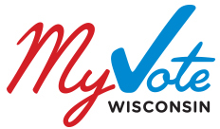 State of WI Elections Commission https://myvote.wi.gov/en-us/
When to vote, Where to vote, What’s on my ballot, How to register to vote, Absentee voting

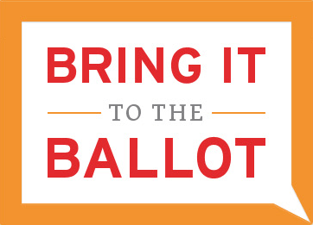 State of WI Elections Commission http://bringit.wisconsin.gov/
Do you have the right ID? How do you get an ID card? What are the exceptions to the law? Locate a DMV near you.

http://votesmart.org/
Politician’s bios, votes and positions taken, ratings, speeches and funding
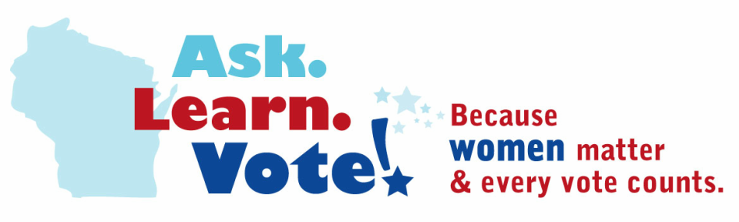
Wisconsin Alliance of Women’s Health http://www.asklearnvote.org/
Ask! candidates their views and find out what is important to them. Use the Know your Candidates form template.
Learn! about your representatives and how their positions on issues.
VOTE! Pledge to vote, How to vote, Voter’s Bill of Rights

www.nonprofitvote.org
How to stay nonpartisan, resource library for engaging voters, staff & candidates, WI specific voting info, webinars
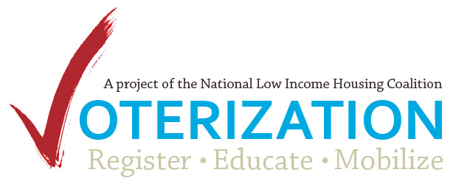 http://nlihc.org/library/voterization
Voterization - engaging low-income, racial minority, student, seniors, and persons with disabilities to vote.
Voterization Plan template is a three step process: registration, education and mobilization.
Voterization Narrative Guide will help non-profits legally and effectively engage voters.
Webinars about voter engagement challenges, education and mobilization.
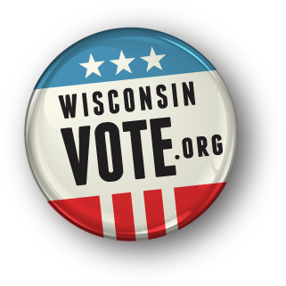WI public TV and WI Public Radio
Candidate and races guide http://www.wisconsinvote.org/candidates-and-races

http://www.lwvwi.org/
Voter ID flyers, How to vote, When to vote

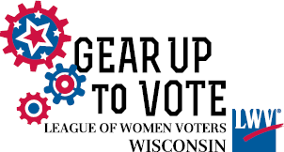 http://gearuptovote.com/
Schedule of Gear Up to Vote events, Voter Resources

Other useful websites
Voter Information Center - http://www.gab.wi.gov/voters FAQs, 24 minute video on Voting in WI.
Municipal Clerk information and communications
http://www.gab.wi.gov/clerks/directory, http://www.gab.wi.gov/clerks/recent-communications

