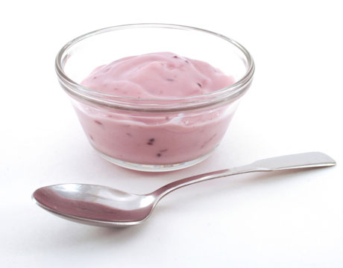

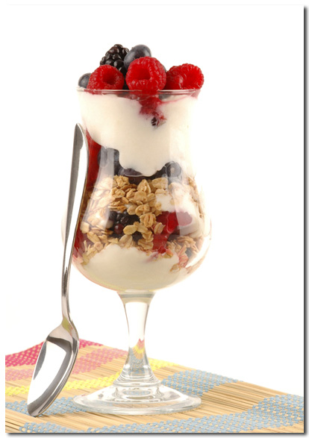

Beneficial Bites
Beneficial Bites
- Pina Colada Yogurt: Add canned, crushed pineapple and flaked or shredded coconut to plain yogurt.

- Mochaccino Yogurt: Add coffee and chocolate syrup to plain yogurt.

- Berries and Cream Yogurt: Add chopped berries and
vanilla extract
to plain yogurt.

- Orange Burst Yogurt: Add chopped orange segments or mandarin oranges and orange marmalade to plain yogurt.

Put a little “culture” in your life…
- Yogurt is basically a form of curdled milk. It doesn’t sound good, but tastes wonderful!

- In Yugoslavia, yogurt is sold on street stands.

- Plain yogurt can take the place of sour cream in baked recipes.

- You can also substitute yogurt for some of the oil or butter in muffin, brownie, or cake recipes.

Health Facts
Yogurt
- Yogurt provides your body with cultures, or colonies, of “good” bacteria for intestinal health.

- Yogurt is a good source of calcium to prevent osteoporosis.
Make your own flavors
Written and created by Robyn Verschay, UW-Stout Dietetic Intern, 9/2009

Fun Facts

