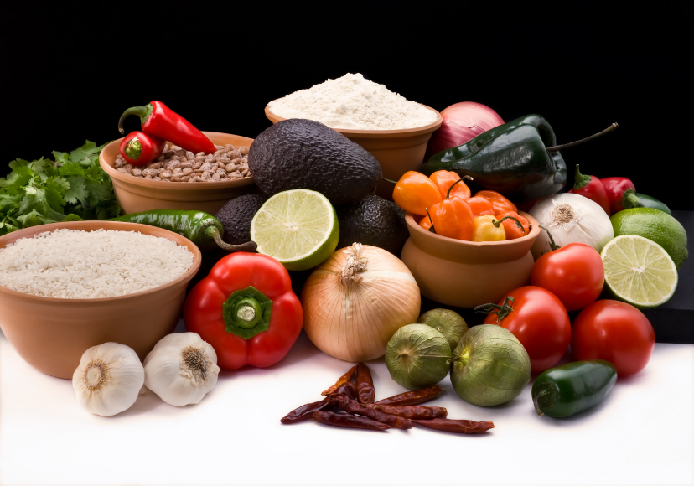
Recipe for: Honey Mustard Yogurt Dressing

1 cup plain yogurt
3 tablespoons sweet honey deli-style mustard
2 teaspoons honey
1 teaspoon salt
1 teaspoon sugar

Stir all ingredients together until well blended. Chill
Serve as a dip with vegetables or add a little liquid to make it thinner to serve over mixed greens. Enjoy!

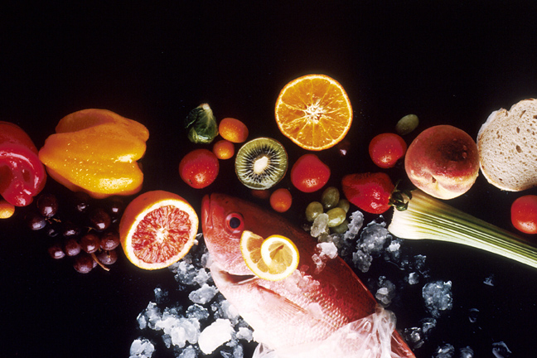
Recipe for: Cranberry Dream Shake

½ cup Cranberry Juice Cocktail
1 cup Pink Lemonade
1 ½ cups Vanilla Frozen Yogurt

Scoop frozen yogurt into blender first then add juice and lemonade. Blend for a few seconds just until liquid is incorporated.

Try adding ½ cup crushed ice to blender for a “blizzard” experience!
Recipe for: Berry Frozen Yogurt
3 cups fresh raspberries or strawberries
1/3 – 2/3 cup sugar
2 cups plain or vanilla yogurt
½ t. vanilla extract

Process berries, sugar, yogurt and extract until smooth in blender or food processor.

Pour into sturdy and durable deep dish or bowl and place in freezer. As it begins to freeze around edges, stir vigorously with whisk to break up frozen areas (hand-held mixture will produce best results but whisk is fine). Return to freezer. Continue to check mixture every 30 minutes stirring vigorously as it freezes. It will likely take 2-3 hours before ready to serve.

Best if made same day you plan to serve.

Recipe for: Assorted Yogurt Smoothies

Caribbean Blast Sweet Summer Tropical Freeze
1 cup Vanilla Yogurt 1 cup Vanilla Yogurt 1 cup Plain Yogurt
1/3 cup Pineapple Chunks* ½ cup Frozen Strawberries ½ cup Pineapple Chunks*
1/3 cup Fresh Papaya Chunks ½ cup Frozen Peach Slices ½ cup Mango, peeled, cubed
½ Medium Banana ½ Medium Banana1 T Honey
Scant ¼ cup Coconut Milk 1 T Wheat Germ ¼ cup Orange Juice
Up to 1 cup crushed ice (no ice needed) Up to 1 cup crushed ice

Choose your smoothie flavor and place all ingredients for that smoothie in blender. Process until smooth and serve immediately.

