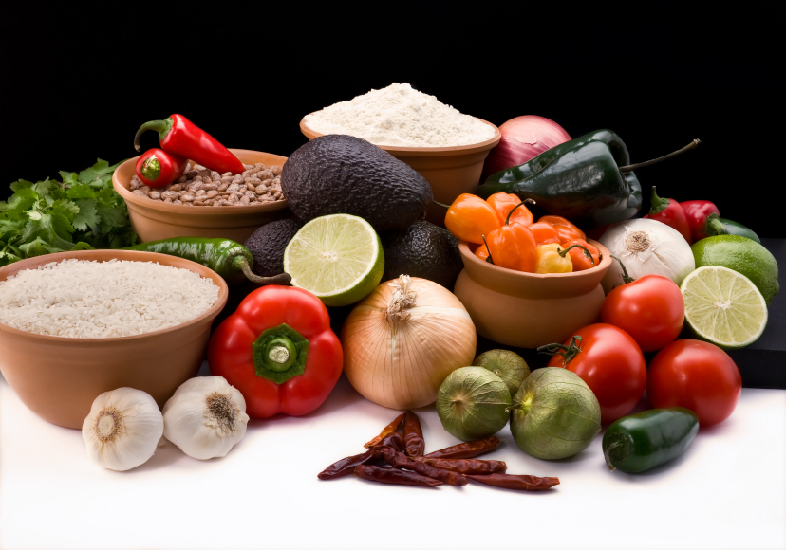
Recipe for: Yogurt Spinach Dip
1 cup Chopped Fresh Spinach
1 cup Plain Yogurt
1 cup Mayonnaise
2 t. Seasoning Salt
¼ t. each of Dried Parsley, Basil, Oregano, Ground Mustard, Garlic Powder

In a medium bowl, combine all ingredients. Chill before serving. Great with vegetables, crackers or your favorite chunks of bread.

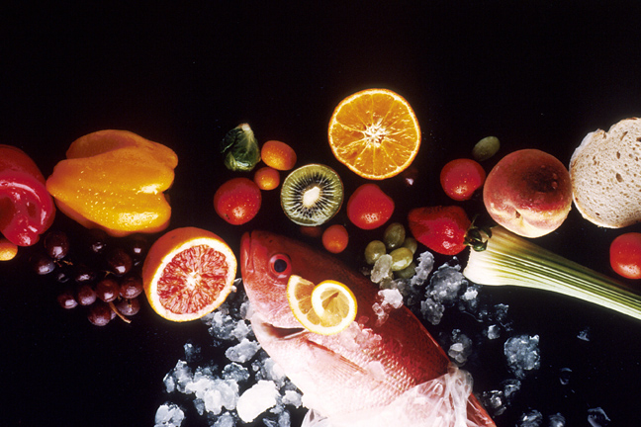
Recipe for: Chocolate Frozen Yogurt

3/4 c. granulated sugar
2 tsp. cornstarch
1 can (12 oz.) fat-free evaporated milk
1/2 c. semisweet chocolate chips
1 c. plain lowfat yogurt
1 tsp. vanilla extract

Stir together cornstarch and sugar in a saucepan. Stir in evaporated milk and chocolate chips. Cook over medium heat until chocolate melts and mixture has thickened slightly. Stir constantly to prevent burning. DO NOT BOIL. Remove from heat and add yogurt and vanilla. Refrigerate until chilled.

Pour into sturdy and durable deep dish or bowl and place in freezer. As it begins to freeze around edges, stir vigorously with whisk to break up frozen areas (hand-held mixture will produce best results but whisk is fine). Return to freezer. Continue to check mixture every 30 minutes stirring vigorously as it freezes. It will likely take 2-3 hours before ready to serve. Best if made same day you serve.
Recipe for: Quick Yogurt Yeast Rolls

2 – 2 ¼ cups unbleached all-purpose flour 1 pkg (.25 oz) yeast
1 T sugar ½ t salt
¼ t baking soda ¾ cup plain yogurt
¼ cup water 2 ½ T butter

In large bowl, whisk together ¾ cup of the flour with the yeast, sugar, salt and baking soda. Mix well. Heat the yogurt, water and butter to 120-130°F, but do not simmer. Add yogurt mixture to the flour mixture and blend well. Beat with electric mixer at medium speed for 4 minutes. Gradually stir in enough of the flour to make a stiff dough. Knead on floured surface until dough is smooth & elastic.

Place dough in greased bowl and grease the top. Cover and let rise until doubled. Punch down, divide into 12 rolls and place on greased baking sheet. Cover & let rise until almost doubled (about 20 minutes). Bake at 400° for 20 minutes or until nicely browned. Remove from pan and brush with butter.

Recipe for: Cucumber Salad

1 T sugar
1 ½ t. salt
1 cup plain yogurt
3 T diced red onion
2 T apple cider vinegar
4 ½ cups thinly sliced pared cucumbers

Blend together sugar, salt, yogurt, onion and vinegar in large bowl. Add cucumbers; mix well. Cover and chill 2 hours before serving.

