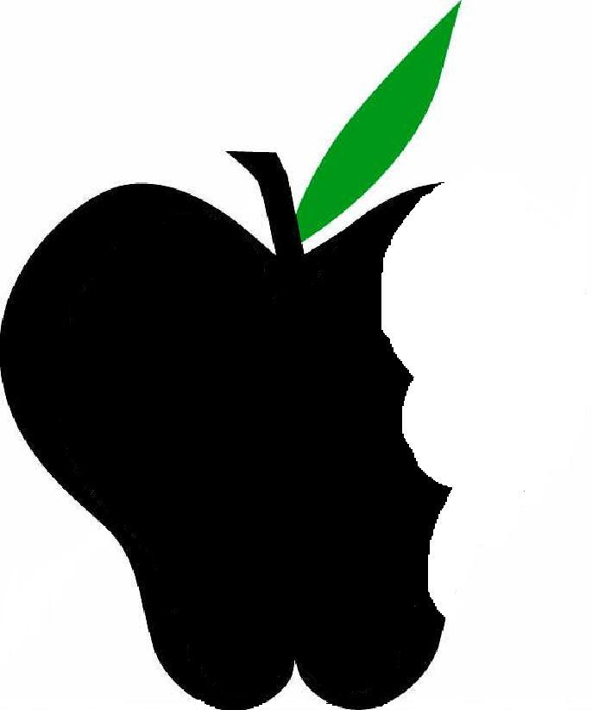
Beneficial Bites
. . . another

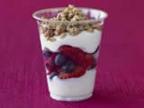

Join
Tiffany Hahn
Thursday July 29 @ 12:15
Dallas Village & Senior Hall
Did you know…
Eating yogurt can help you to lose weight.
Yogurt helps keep your bones strong.
Eating yogurt can help you to have fresh breath.
Come and build your own yogurt parfait, sample homemade yogurt and see how easy it is to make, plus compare frozen yogurt to ice cream and sherbet!

There is no cost to attend and no registration is needed.

