
Beneficial Bites

Wild Rice

Fun Facts

Health Benefits

- Wild rice contains twice as much protein as brown rice!
- Wild rice contains up to 30% more antioxidants than white rice. Which means wild rice can help protect against disease
- Wild rice is high in fiber which keeps your digestion smooth and helps lower cholesterol
- Wild rice is high in phosphorus and zinc, which are important for ensuring strong bones and joints as we age

Created by Allison Freeman, MS, Dietetic Intern 2015

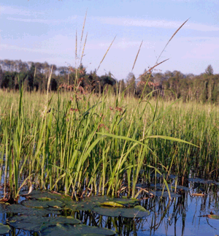

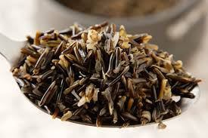

- Wild Rice is Minnesota's State Grain. It is not actually rice, but an annual water-grass seed
- Even today, the wild rice grown on Minnesota state waters is regulated and must be harvested in the traditional Indian way.
- It is very fussy to grow with many chances for something to go wrong and for the crop to be lost which is why it is more costly.

Try Wild Rice in

- Pilafs
- Salads
- Stuffing
- Casseroles
